Auguste 3, 2021

California Air Resources Board
1001 I Street
Sacramento, CA 9814
VIA Website Download at: https://www.arb.ca.gov/lispub/comm2/bcsubform.php?listname=nwl-2021-tech-ws&comm_period=1
RE: Comments on Natural and Working Lands, 2022 Scoping Plan Update
Dear Air Resources Board and Staff:
Please accept these comments from Green Diamond Resource Company on the Natural and Workings Lands, 2022 Scoping Plan Update as presented in the Technical Workshop on July 20, 2021. Slide page numbers refer to the July 20, 2021, on-line presentation.
The key point is that the proposed NWL scoping plan that combines 8 different land types adds considerable uncertainty to the overall analysis even though forests are unique in high annual sequestration rates AND generating a renewable supply of products that generate considerable climate benefits outside the ‘natural and working lands’ where they continue to store carbon and also replace more emission-intensive products such as cement, steel, and natural gas.
Slide 13 describes how a geospatially explicit inventory outputs uses ‘disturbed acres’, rather than annual net sequestration rates as the reporting metric across both undisturbed and disturbed acres. The thousands of remeasured forest plots across both undisturbed and disturbed acres that are published in the annual AB 1504 reports (Christensen et al. 2021) are far more accurate than transforming the satellite-based areas into net sequestration estimates.
The ARB proposed scoping plan explicitly does not use the most statistically robust information on the annual carbon fluxes in forests from the annual AB 1504 reports provided to the California Board of Forestry and Fire Protection (BOF) that are based on on-the-ground remeasurements. (Christensen et al. 2021). Satellite derived analysis may look to deliver more wall to wall estimates, but the accuracy of estimates of small annual growth increments in undisturbed acres has been shown to be questionable (Holland et al. 2019). Slide 24 suggests that ARB is explicitly ignoring the BOF in terms of state agency communications even though they publish legislatively required AB 1504 reports that uses thousands of remeasured forest and woodland plots to provide statistically accurate estimates of net carbon sequestration. The data from the latest AB 1504 report is very different than the ARB’s contractors claim of large declines in terrestrial carbon shown in slides 14, 30, and 51.
The empirical evidence is very clear that maximizing sinks in fire and beetle prone forests of California is NOT a great strategy for maintaining high annual rates of carbon sequestration from the atmosphere into terrestrial stocks. As figure 4.4a from the AB 1504 reports produced annually for the California Board of Forestry and Fire Protection show, the relatively high inventory USFS FS unreserved forestlands have lower initial carbon sequestration, much higher losses to mortality, and very little conversion of in-forest carbon to carbon in harvested wood products.
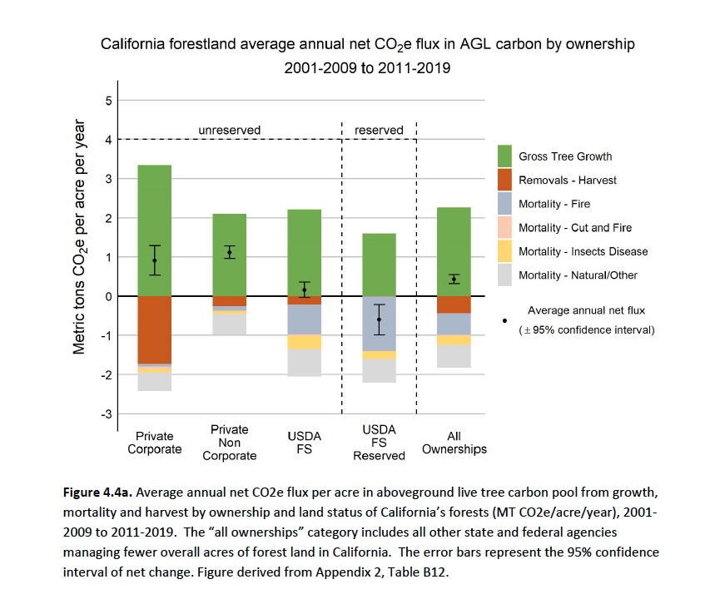
(Christensen et al. 2021)
It is quite clear that the Private Corporate managers of California forestlands are clearly implementing Best Management Practices (BMPs) when it comes to maintaining high annual carbon capture rates and also produce harvested wood products that can replace cement, steel and natural gas. As the State of California considers investing in more activities to reduce net emissions, it would benefit from the practical insights of land and product managers with proven track records.
Only counting and setting targets for natural biomass carbon in the forest but not in products throughout the supply chain is a major problem in the NWL Scoping Plan as it goes against the IPCC reporting standard that the US EPA (U.S. Environmental Protection Agency 2020) meets in their annual reports. ARB accounting of forests and forest products simply does not align with US EPA accounting that is done to current IPCC standards. State level reports for California, Oregon, and Washington (Christensen et al. 2020, Christensen et al. 2021, Christensen et al. 2019) provide statistically robust estimates of carbon fluxes for both forest in our state as well as in the two states that are the largest exporters of wood products to California. Since the scoping plan ignores the direct carbon sequestration in harvested wood products as well as the indirect benefits when those products replace emission intensive products, it misses the potentials that many researchers have pointed out on the significant potential climate benefits gains that could come from technological innovations in the use of harvested wood (Hepburn et al. 2019). This may be covered by E3 in their larger social systems analyses or in ‘Engineered Carbon Removal’ accounting, but it falls through the NWLscoping plan cracks.

Under IPCC accounting where the climate benefits of products are counted and assumed to be potentially increase with technological innovations and better prices (Hepburn et al. 2019, Smith Pete et al. 2016, Smith P., J. Nkem, K. Calvin, D. Campbell, F. Cherubini, G. Grassi, V. Korotkov, A.L. Hoang, S. Lwasa, P. McElwee, and E. Nkonya 2019), the potential climate benefits of more managed forests are even better. The potential to store even more carbon in wood buildings with existing technologies is well described in the attached article from the July 31, 2021 edition of the New York Times. Under ARB accounting sectors, the benefits of using more harvested wood in engineered wood products could be accounted as an engineered, rather than natural, sector solution.
It also appears that the Rheyys model is an odd choice for ARB as it seems to be mainly a research grade hydrologic model that has mainly been used for small-scale research sites. Given the hydrologic focus and the use of water-based geographic units, it seems likely that carbon sequestration ,mortality, fire and other mortality related emissions etc. rates, will simply be assigned rather than empirically measured. Using watershed-based units and regions will make it difficult if not impossible to test ARB’s estimates against other existing data systems based on more logical vegetation and ownership attributes (USEPA 2020).
Summary
As ARB moves forward with the scoping plan for the NWL sector, it would be significantly improved if it used the most statistically robust data for each vegetation type and followed IPCC reporting standards for both carbon sequestration in forests as well as in forest products.
Sincerely.

William Stewart
billstewart@berkeley.edu
University of California Berkeley

References
Christensen GA, Gray AN, Kuegler O, Siemann D. 2020. Washington Forest Ecosystem Carbon Inventory: 2002-2016. Portland, OR: USFS PNW Research Station and Washington Department of Natural Resources.
Christensen GA, Gray AN, Kuegler O, Tase NA, Rosenberg M, Groom J. 2021. AB 1504 California Forest Ecosystem and Harvested Wood Product Carbon Inventory: 2019 Reporting Period. DATA UPDATE. California Department of Forestry and Fire Protection agreement no. 8CA04056. 455pp. Pages 455. Sacramento, CA: Calfire and BOF.
Christensen GA, Gray AN, Kuegler O, Yost AC. 2019. Oregon Forest Ecosystem Carbon Inventory: 2001-2016 in U..S. Forest Service PNRS, ed. Portland OR.
Hepburn C, Adlen E, Beddington J, Carter EA, Fuss S, Mac Dowell N, Minx JC, Smith P, Williams CK. 2019. The technological and economic prospects for CO2 utilization and removal. Nature 575:87-97.
Holland TG, Stewart W, Potts MD. 2019. Source or Sink? A comparison of Landfire- and FIA-based estimates of change in aboveground live tree carbon in California’s forests. Environmental Research Letters 14.
Stewart W, ed. In Press. Reforestation Practices for Conifers in California. UCANR also at https://www.fvmc.org/.
Smith P, et al. 2016. Biophysical and economic limits to negative CO2 emissions. Nature Clim. Change 6:42-50.
Smith P, J. Nkem, K. Calvin, D. Campbell, F. Cherubini, G. Grassi, V. Korotkov, A.L. Hoang, S. Lwasa, P. McElwee,, E. Nkonya NS, J.-F. Soussana, M.A. Taboada. 2019. Interlinkages Between Desertification, Land Degradation, Food Security and Greenhouse Gas Fluxes: Synergies, Trade-offs and Integrated Response Options in P.R. Shukla JS, E. Calvo Buendia,, V. Masson-Delmotte H-OP, D. C. Roberts, P. Zhai, R. Slade, S. Connors, R. van Diemen, M. Ferrat, E. Haughey,, S. Luz SN, M. Pathak, J. Petzold, J. Portugal Pereira, P. Vyas, E. Huntley, K. Kissick, M. Belkacemi, J. Malley, eds. Change and Land: an IPCC special report on climate change, desertification, land degradation, sustainable land management, food security, and greenhouse gas fluxes in terrestrial ecosystems

U.S. Environmental Protection Agency. 2020. Inventory of U. S. Greenhouse Gas Emissions and Sinks: 1990 – 2018.

Wooden Buildings Reach for the Sky
By Gabriel Leigh, July 31, 2021, Section A, Page 12 in The New York Times International Edition.
VAXJO, Sweden — Stockholm and its suburbs are filled with construction cranes these days, reflecting a growing population combined with a housing shortage. But few of its developments are as extensive as Hagastaden, just to the north of central Stockholm where it meets the neighboring municipality of Solna.
Here, it looks as if an entirely new city is being built. The 237-acre, or 96-hectare, development is a collection of housing, offices, institutions and public space projects conceived as a model of livability and sustainability, part of the Stockholm “Vision 2030” plan.
One section in particular is notable: two city blocks where a concrete foundation has been laid above a tangle of tunnels that funnel rail and road traffic to the north. It is an impressive feat of engineering, but the real significance is what is now rising from it, one of the largest apartment complexes built from timber in the world. Cederhusen (or Cedar House) is the latest example of a growing practice of building big with what’s known as C.L.T., or cross-laminated timber.
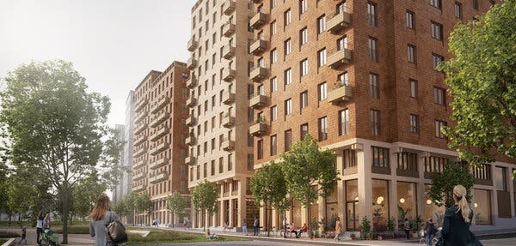
A rendering of the completed Stockholm complex, dubbed Cederhusen, or Cedar House.Credit...General Architecture
It is a showcase for the industry of how far the technology has come. Concrete is necessary for the foundation, but after that it is all wood, up to 13 stories at its highest point. The first block of two Cedar Houses is nearly complete and a second block is scheduled to start construction soon. The tunnels below the development can only support so much weight. But because timber is about a fifth as heavy as concrete, the structure above the tunnels could be higher.
Using timber also has environmental benefits, the industry says. “This is tech that we already have that can be used today, and it is a fast track to lowered emissions,” said Mathias Fridholm, the director of Svenskt Tra (“Swedish Wood”), an industry organization that promotes timber and wooden products. “But it’s not only the climate,’’ he added. ‘‘The whole building sector needs to be modernized and a good way of doing that is through a higher degree of industrialization. “Wood is in many ways an excellent material for building in dense cities, because we can prefabricate all the elements in factories, instead of on-site.”
Mr. Fridholm said that prefabrication would speed construction and reduce disruptions such as constant truck traffic at the building site and road closures. Because timber is lighter than concrete, floors can be added to existing buildings if there is a need for expansion, he said.
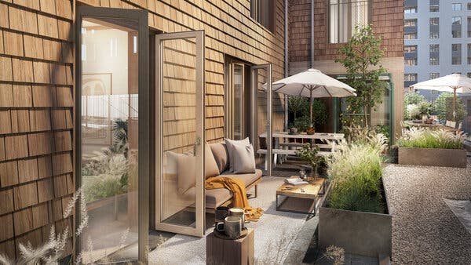
A rendering of an outdoor space at Cedar House, which is being constructed north of central Stockholm.Credit...General Architecture
Timber accounts for roughly 20 percent of new multistory buildings in Sweden, but that figure is on the rise. That is happening in part because of companies like Folkhem, the real estate developer behind Cederhusen, which decided in 2012 to build exclusively in wood. The company is hoping projects like this, and around a dozen others in its portfolio, will help to tip the scales.
“This project is going to be really important because it’s a whole two blocks in inner Stockholm where you can choose to buy an apartment made out of timber,’’ said Anna Ervast Oberg, a project manager at Folkhem. ‘‘So it’s going to be a symbol of the possibilities and the techniques and industrial capability that we have.”
Over a plate of cinnamon buns in the small construction site offices at the Cederhusen site, Ms. Oberg said that just changing the structure of a building to wood from concrete would result in an immediate 50 percent reduction in emissions. She said that if you looked at the carbon emissions over the lifetime of a typical concrete building, roughly 70 percent would be just from the roughly two years that it is under construction. “And then of course we can optimize the building further,” Ms. Oberg said. “We have other aspects like shorter construction time, less transport. Those make the numbers even better.’’
She added: ‘‘What we have to do now is to stop the emissions, very fast. This gives us a hint of where we should be focusing, where we can make the biggest difference.” C.L.T.’s list of benefits is long. It is exceptionally strong and light. It is also breathable, meaning it holds heat but doesn’t need plastic layers to manage moisture, as concrete does. Concrete also requires sand, a finite resource that increasingly requires damaging procedures like drudging up the seabed, while managed forests can be replanted. As a bonus, a city built out of wood becomes an urban carbon storage facility.
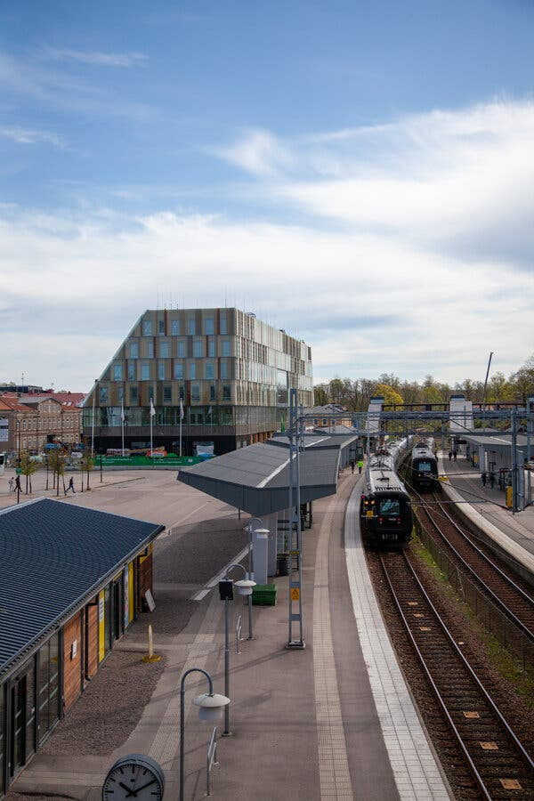
A flagship project in Vaxjo, now in the final stages of completion, is a glass-paneled timber structure at the center of town that houses the new main train station, City Hall and a shopping center.Credit...Gabriel Leigh
Before 1995, this sort of thing wasn’t even allowed in Sweden, the result of rules established many years ago after fires ravaged primarily wooden cities across Europe. But adoption of European Union rules meant an end to the former two-story building limit. The technology has been steadily developing since then, to the point that those in the industry say fire risk is on par with other materials. Recognizing that, building regulations are now function-based rather than material-based, which is to say that as long as developers can prove the building withstands critical threats, like fire, it doesn’t matter what it is made of.
As for height, the sky is theoretically the limit, according to Folkhem executives. But, they add, because timber is lighter, it needs added stabilization as it climbs. Above floors in the mid-teens buildings need added ballast, often in the form of concrete slabs. As the technology progresses, that may change. The current record holder is an 18-story wooden building in Brumunddal, Norway. For scale, the building is just a little shorter than the Statue of Liberty.
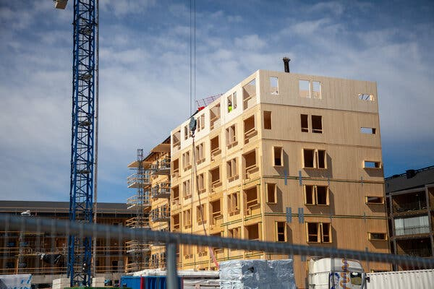
A construction site in Vaxjo, Sweden, using prefabricated cross-laminated timber panels that are assembled on-site.Credit...Gabriel Leigh
All this works especially well in a place like Sweden which has well-managed forests, and plenty of them. Seventy percent of Sweden’s land is forest, double what it was 50 years ago.
One of the biggest apartment complex developments so far in Sweden, according to Folkhem, used around 211,000 cubic feet, or 5,975 cubic meters, of wood for the construction. That wood, the company said, was estimated to take around 20 minutes for the Swedish forests to regrow.
Building single family homes out of timber is, of course, nothing new. The majority of homes in Sweden are wooden, as in many places around the world. What is new is the push to build larger buildings, office structures or apartment blocks as well as infrastructure like bridges, using timber frames instead of concrete or steel. But although timber use is on the rise, concrete still dominates in the construction industry.
Tomas Nord, a senior lecturer at Linkoping University in Sweden, has spent years studying the timber industry. “It should be obvious that it’s superior to concrete,’’ he said of wood. ‘‘It’s efficient and fast. You can build exactly what the customer wants in the factory. It’s a renewable material. It’s strong, durable and light.”

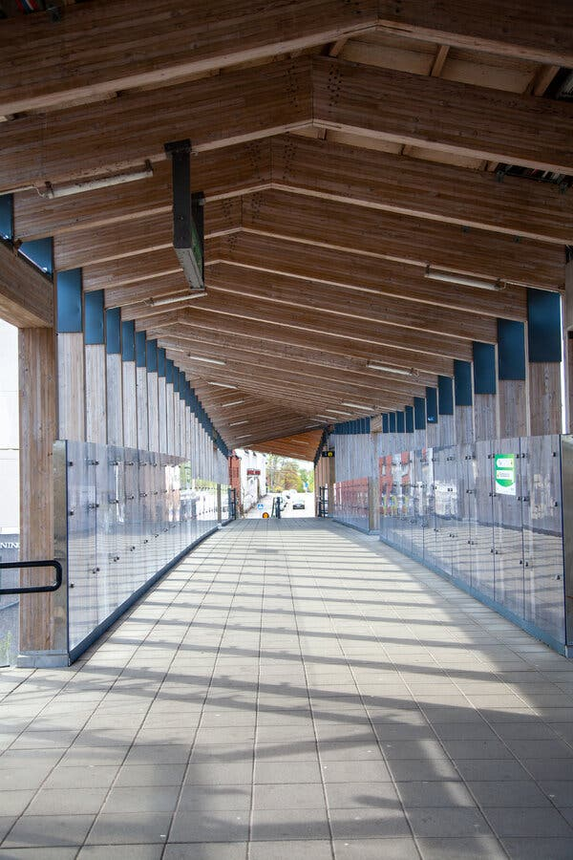
A timber-frame pedestrian bridge over train tracks in Vaxjo.Credit...Gabriel Leigh

Mr. Nord added: ‘‘The challenge is down to the industry structure, the value chains that we have built up over years. In any mature industry, you have an idea about how you have to operate to be profitable. Then if you say we have to change, there’s going to be resistance to that. ”Those in the timber industry say that they are optimistic. “We’ve gone from zero to 20 percent market share since 1994,’’ said Mr. Fridholm of Swedish Wood. ‘‘And it won’t take long to get to 30 percent.” “The building industry is quite medieval,” Ms. Oberg said with a laugh. “But in the last few years it’s come to a tipping point. We see a lot of [timber] projects being built in Sweden. Other countries are doing the same. ‘‘It’s down to the climate change becoming so obvious,’’ she said. ‘‘But it also has been years lobbying, talking to politicians, working with their rules and regulations, building up competence among engineers and so on. And now we have a complete foundation, and we have reference projects, that show that it’s possible.”

Those projects range from simple seven-story apartment buildings to more striking examples. One company has plans to build timber windmills as tall as 500 feet, or 150 meters. A test version, standing at about 100 feet, was erected in 2020, and commercial production is expected to begin next year. The northern Swedish city of Skelleftea, another timber pioneer, has had an air traffic control tower built from wood since 2004.
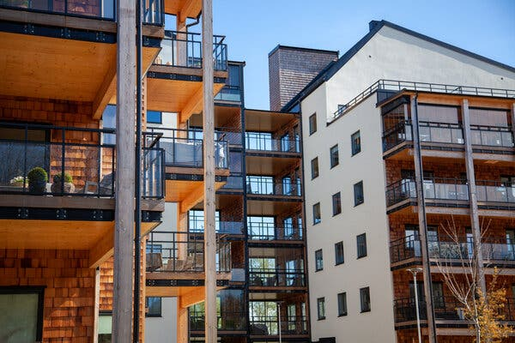
A timber-frame apartment complex just outside central Vaxjo. The city of 94,000 sits in the middle of timberlands in southern Sweden and has made wooden buildings central to its development strategy since the 1990s.Credit...Gabriel Leigh
The development isn’t happening only in Sweden, of course. New projects are going up around the world. Norway, in particular, has had a huge increase in wooden buildings. The construction company Veidekke, based in Oslo, recently built two identical structures in Trondheim, Norway, one in timber and one in concrete. “What happened was they could make three more stories on the timber house and still save two million kroner [about $230,000] on the foundation work because it was easier to make,” Ms. Oberg said. “They also looked at the health of the construction workers and saw that the hours people were sick was much less in the timber project. Injuries were less, and construction time was shorter.”
The small city of Vaxjo, population 94,000, sits in the middle of the timberlands of Smaland Province, in southern Sweden. Among municipalities in Sweden, many see Vaxjo as the leader in timber construction, as wooden buildings have been at the center of the city’s strategy since the 1990s. The city government reached its target for at least 50 percent of all new buildings to be timber-framed as of last year, and the municipality says it is now working on new and more ambitious plans for building with wood.
When I visited Vaxjo last summer, Catharina Winberg offered to show me around the city. At the time Ms. Winberg was a local politician and chairwoman of the Vaxjo Kommun Foretag, which oversees much of the building as well as energy production in the city. (Earlier this year she left her position to return to the private sector.)
What I saw was impressive. Whole sections of land outside of the city center have been designated as timber-only development areas. Around town were dozens of construction sites for timber apartment buildings, schools and more, many of them using energy-saving measures, in varying states of completion. “We really believe in wood as a material — it’s circular, it’s renewable, and it’s healthy,’’ Ms. Winberg said. “And we have the resources close by, so we might as well take advantage of that.”
She added: “We started to work with this very early, and that has generated a lot of interest. People want to learn about our strategy and see what we’ve done. So we think it’s very important how we carry this on because there’s so many looking to us now.” The latest flagship project in Vaxjo, now in the final stages of completion, is a glass-panelled timber structure at the center of town that houses the new main train station, City Hall and a small shopping center, with a hotel scheduled to be erected.
“I think people today are longing for things that are genuine,’’ Ms. Winberg said. ‘‘And this is a very genuine place to live, with genuine buildings. They’re made of the forest that we have around us. ‘‘We have a housing shortage in this country, but if we didn’t, you could just choose,’’ she said. ‘‘Do you want a concrete building or a wooden building. What do you choose? That’s quite easy I think. But we’re not quite there yet.”
The industry is getting closer as a new law in Sweden will require a comprehensive climate declaration for every new building starting in 2022. The calculation comprises the total impact from start to finish of construction, including materials and transportation. The thinking is that once everything is taken into account in a systematic way, the benefits of timber should become even more apparent.
And recent developments in the world may help the Swedish timber industry’s goals. “One thing that I think people will start thinking more about now is you cannot take globalization for granted,” said Mr. Fridholm of the forest industry group.
“Today from Swedish sawmills, 70 percent is exported to other countries,’’ he said. ‘‘In the foreseeable future people will start thinking about what resources we have in Sweden that we maybe should use better than we do now. And the eyes will fall on the forest. What is the best way of utilizing that? We can build with wood and store the carbon there. We can support ourselves with that.”

