Rajinder Sahota
Division Chief
Industrial Strategies Division
California Air Resources Board

RE: Achieving Carbon Neutrality in California: A Report by E3

Dear Ms. Sahota,

Southern California Edison (SCE) appreciates the opportunity to provide comments on the draft report: Achieving Carbon Neutrality in California, presented by E3 at CARB’s workshop on August 19, 2020.
We are in full agreement with the presenters that meeting California’s carbon neutrality goal will be challenging and that the cost and feasibility of achieving the last 20% of greenhouse gas emission reductions from the economy is uncertain in any potential scenario. Given this uncertainty, it is difficult to determine whether a particular scenario presented by the E3 study is preferable from a cost perspective.
Nevertheless, and despite this uncertainty, we agree that to achieve the carbon neutrality goal focusing on the least-regret areas described in the E3 study namely, energy efficiency, transportation and building electrification, zero-carbon energy, non-combustion GHG emissions reductions, and R&D in carbon removal technology is required.
This approach is compatible with our perspective, SCE’s Pathway 2045, on how to achieve the state of California goals of cleaning our electricity grid and achieving carbon neutrality by 2045. We believe the right questions being asked, the analysis is well framed and, as we mentioned before, the study pays great attention to the least regrets area.
Finally, we are very supportive of the actions taken by the Air Resources Board on addressing the mandate given by Executive Order B-55-18 to achieve carbon neutrality, which includes developing a framework for implementation, recommending measures, and setting targets, among others and we believe that this study is aligned with these prerogatives.

Sincerely,
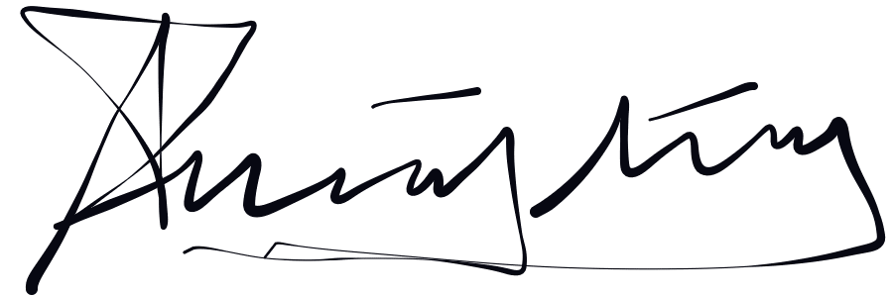
Ignacio Fernandez
Senior Advisor, Air & Climate Policy
Southern California Edison
8631 Rush Street, Rosemead, CA 91770
Ph: 626-221-0065
Email: ignacio.m.fernandez@sce.com

