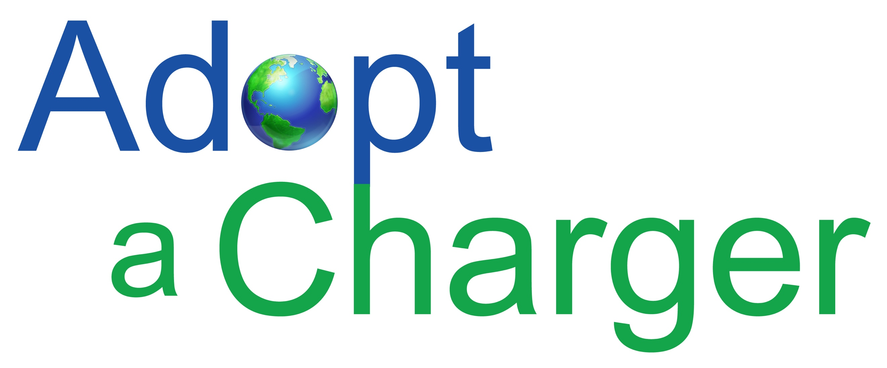

Mr. Mark Williams, Mailstop 3E
Air Resources Board
P.O. Box 2815
Sacramento, California 95812
Electronic submittal:
https://www.arb.ca.gov/lispub/comm2/bcsubform.php?listname=vw-zevinvestsup-ws&comm_period=1

RE: Support for Electrify America First 30-month ZEV investment plan

Adopt a Charger (AAC) is a 501(c)3 nonprofit organization started in 2011 to accelerate the adoption of electric vehicles by expanding EV charging infrastructure. Our unique business approach, finds sponsorship to install EV chargers at popular destinations like National Parks, State Parks, museums, and universities. Unlike “no charge to charge” programs, these chargers are offered fee free to all PEV drivers regardless of the make and model. AAC recognizes the importance of infrastructure for outreach and education purposes, and by encouraging drivers to plug in at these high-profile locations; we raise awareness of PEV, and help make the connection that these cars run on electricity. It also enables the EV curious to have direct interaction with owners, who are the best sales people for the cars. We have helped organizations in California, Washington State, Michigan, Ohio, Kentucky, Illinois, Missouri, Alabama, Maryland, Pennsylvania, and Iowa with EV infrastructure projects. Our focus is to increase usage of PEV and show more Americans that going electric is possible today.
Adopt a Charger shares Governor Brown’s goal of selling 1.5 million ZEV in California by 2025, and realizes the need for adequate infrastructure to support it. We have met with Electrify America (EA) to discuss support of EV charging at California State Park Properties, which supports Governor Brown’s 2016 ZEV Action Plan that prioritizes charging at the Parks. I have been working to install charging at the Parks since 2011, these locations are difficult to commercialize and installations are very expensive. These destinations offer the perfect opportunity to go beyond just charging cars and educate the public. Another important aspect of these chargers at the parks is it supports the greening of the fleet and enable the Park’s transition of their light-duty fleet to plug-in electric vehicles. They will also provide workplace charging for the 6,000 employees of the State Parks, which is low-hanging fruit when it comes to the adoption of PEV. The EA investment complements the CEC grant that was awarded to Adopt a Charger in 2014 on behalf of the State Parks. The Parks just completed a district-wide survey and is be able to prioritize the next round of parks to receive funding.

I support efforts by EA to invest in disadvantaged communities. Adopt a Charger is working with a group to design a MicroGrid for the city of Carson, California. I appreciate EA’s interest in selecting areas that are prime for EV adoption, and avoiding stranded assets. Disadvantaged Communities (DAC) like the City of Carson, which is located in LA County, an area that leads the country in the adoption of PEV, have a high likelihood of success. This area is surrounded by high penetration of PEV according to the CVRP heat map. CSU Dominguez Hills is a great example of the growing demand for PEV in Carson. The existing (11) L-2 chargers are in constant use, and there are plans to install (28) more EVSE to address demand.

According to the CARB DAC guidance document for SB350, there is a better likelihood of success if the City has already completed a master plan and bike lane strategy, which Carson has. Also from the CARB guidance "vocational training, pre apprenticeship, and apprenticeship programs for clean transportation; increasing access and advanced knowledge and skills to acquire good quality clean transportation jobs" Carson High School currently has an Auto Shop class that offers vocational training, and is currently working on a battery operated pick up truck. LAUSD has prioritized EV charging at all schools in their territory. They also have an Environmental Science and Engineering & Technology program to promote STEM. Kids are exposed to PEV at school through curriculum, and teacher ownership. They bring the information home to their families. In December 2015, US Department of Transportation launched Smart City Challenge, asking mid-sized cities across America to develop ideas for an integrated, first-of-its-kind smart transportation system that would use data, applications, and technology to help people and goods move more quickly, cheaply, and efficiently. The ITEP response to the transportation Challenge is to give area high school students the opportunity to learn and develop a simple vehicle running on electric energy driven go cart. Students would develop and manufacture a clean energy vehicle. The students and their schools would then demonstrate their vehicle at a closed-track event at to be held at Port of Los Angeles.

A CVRP study showed that the #1 factor for PEV adoption in DAC is fuel savings. SB350 also supports the Plus Up Program administered by South Coast AQMD. Carson residents can qualify for up to $9,500 in rebates and incentives toward the purchase of PEV. Carson Nissan dealer is educated on the program and was telling kids about it at the Carson High event.

Carson is strategically located along major freeway corridors. 405, 110, and 91. HOV lane factored heavily. HOV access for Carson residents to commute on the 110, 405, and 91 carpool lanes is an important benefit. There is a Metro Express Lane Walk in Service Center located in Carson, making the process of getting a transponder for the 110-carpool lane easier.
There has been a tremendous amount of engagement between stakeholders and VW. By providing appropriate oversight on the settlement, and fostering transparency, CARB can maximize the potential of this opportunity to support current PEV drivers and stimulate future sales.
Respectfully,
Kitty Adams, Executive Director
Kitty.Adams@adoptacharger.org

