September 15, 2017
TO: CARB

RE: Comments for 2017 Draft Funding Guidelines for Agencies That Administer California Climate Investments Draft 2017 Funding
https://www.arb.ca.gov/lispub/comm2/bcsubform.php?listname=draftguidelines-ws&comm_period=1

At the CARB community meeting in Oakland on August 28, 2017, I believe the most compelling statement by an attendee was “do no harm”.
While many projects have benefits, they can also have negative impacts. In some cases, the negative impacts can outweigh the benefits.
Instead of a single column checklist, I would urge CARB to adopt a two column matrix; one column for benefits and a second column for negative impacts. This would provide a more comprehensive picture of the proposed project. This would be somewhat similar to the CARB Draft Guidelines Table 2.A-11 Step 3 Section B. It is also similar to the draft CalSTA TIRCP guidelines Section 8 (Project Application) Item 9 for a transit project’s impacts on other transit (both favorable and unfavorable). I would also urge CARB to require that an assessment of previous GGRF projects by a local agency be included with any new application from that local agency.
Regarding meaningful community engagement, I would urge CARB to require that administering agencies vet organizations to assure that they are bona fide community representatives and that they are not acting as surrogates for a local agency seeking GGRF grants. Once the grant has been awarded, I would urge CARB to require administering agencies and local agencies to set up a formal community process to address both the benefits and the negative impacts of the project.
I support CARB’s efforts to (whenever feasible) have selected GGRF projects and executed grant agreements/contracts follow the revised guidelines. However, I am deeply disappointed that CARB continues to assert that each administering agency is responsible for its GGRF program design, project selection and project implementation. As GGRF are CARB’s Cap and Trade revenues, I would urge CARB to take a more proactive role in these areas. While CARB may have a robust community engagement process, GGRF administering agencies may not. I would note the major differences in the community outreach by CARB at its August 21st meeting and that of CalSTA at its August 18 and August 21, 2017 TIRCP guidelines workshops. If CalSTA and a local agency are both unresponsive to community concerns, there would be no process to address those concerns if CARB did not take some form of jurisdiction.
In closing, I am also including my recent comments to CalSTA regarding the draft guidelines for TIRCP funding.
August 23, 2017

TO: CalSTA TIRCP Draft Guidelines Comments
www.tircpcomments@dot.ca.gov

The one major issue which the draft guidelines fail to address is emerging transportation technologies and their impacts on established transportation modes. These emerging technologies include, but are not limited to, transportation network companies/ride hail, commuter shuttle buses, car share, moped share, bike share and autonomous vehicles. On page 11, the draft guidelines state “…integration across other modes of transportation…”, but do not explicitly include emerging technologies.

In San Francisco, each of these emerging technologies has demonstrated the ability to significantly increase congestion, vehicle miles traveled (VMT) and greenhouse gases. They have also demonstrated the ability to decrease transit ridership by directly competing with it.

Project evaluation criteria should be revised to calculate the current and future effects of these emerging technologies. The criteria should also be revised to factor in future technologies.

Below is a posting on the San Francisco Municipal Transportation Agency’s website regarding this issue.
Quote:

https://www.sfmta.com/about-sfmta/blog/preparing-transportation-innovations-san-franciscos-way

Preparing for Transportation Innovations, San Francisco's Way
by
Ed Reiskin
Thursday, August 3, 2017
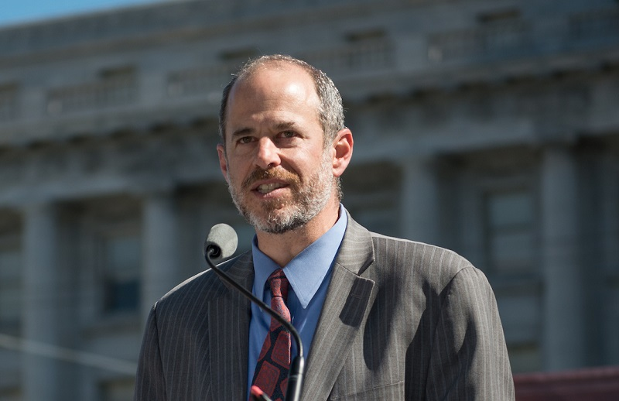
From the SFMTA’s Director of Transportation:
Not since the advent of streetcars and automobiles have we seen such tremendous change in the ways people get around in cities. After decades of little change to transportation technology, recent advancements raise important questions that we all need to address.
Technological advances underlie most of the innovation that’s happening in transportation. New smartphone apps and payment systems make it a lot easier to get directions, plan and pay for trips and receive real-time transit updates with a couple of clicks. These changes are coming to all forms of transportation. Even the vehicles that move us are getting smarter and more sophisticated, allowing us to more easily detect problems and navigate our streets while keeping us safer.
Transportation innovations are happening at speeds that were unimaginable just a few years ago. While we can’t fully predict what changes the future will bring, nor how fast they will come, we can make sure city policies shape and dynamically plan for them in this evolving environment. Rather than be reactive, we should ensure innovative changes happen in a way that respects our unique city, its communities and values.
To that end, we at the San Francisco Municipal Transportation Agency and the San Francisco County Transportation Authority have developed a framework of guiding principles we can apply to emerging mobility services and technologies. Based on relevant city policies, the Emerging Mobility Guiding Principles framework (PDF) was approved by the SFMTA Board of Directors at its meeting last month.
Our idea is to develop consensus on the principles that are important for our city to adhere to as we evaluate and guide innovative transportation changes developed by us or by others.
These principles include safety, transit priority, equity, accessibility and sustainability. They also factor in congestion, accountability for transportation providers, impacts for workers and consumers, as well as financial impacts.
Technology-based transportation changes are already having a significant impact on our city. For-hire transportation services such as Uber and Lyft, which are regulated by the California Public Utilities Commission, have brought convenience to their users, but that convenience could impact congestion, safety and sustainability if not incorporated responsibly.
A recent SFCTA report indicated that our city sees more than 170,000 ride-hail trips each day, and that’s a very conservative estimate. Most of the cars providing those trips are coming from outside the city, and some of the increased traffic congestion we are seeing is likely related to that. Aside from adverse impacts on air quality, added transit delays and traffic congestion, more motor vehicle trips statistically leads to more traffic crashes.
In a future that promises more technological advances, the convenience that new technologies and services are bringing to some should not have negative impacts on San Francisco as a whole. We can help move the city forward by establishing principles based on city policies, and we can better evaluate and guide these kinds of services so that they complement our transportation system and support the city’s goals.
We have seen how new technology-driven services can do that, and we’ve led groundbreaking efforts to facilitate them. Since June alone, we've approved two new on-street parking permit programs for shared vehicles and electric mopeds, and we helped shepherd the San Francisco launch of the new, quickly-expanding regional Ford Go Bike bike-share system. These kinds of affordable, shared mobility options are proven to help reduce the need to drive and make streets less congested.
In our growing city and in these interesting times, we want to ensure that all people, especially those with the fewest options and the greatest needs, can get to where they’re going safely and reliably. We have to manage the ways cars are used to benefit the greatest amount of people in the most equitable way. That may require some hard trade-offs, but we have strong San Francisco values to guide us and a lot of exciting technology with the potential to make it better for all of us to get around the great city that is San Francisco.
This article also appeared in the San Francisco Examiner.

End quote.

In the current draft guidelines, “novel approaches” (page 5) or innovation refers mainly to ticketing. There are a number of positive innovations for Light Rail Vehicles (LRV) which could be included in this section of the draft comments e.g. holographic versions of railroad style crossing arms, onboard photo enforcement cameras for California Vehicle Code 21756 (A), the use of low floor and ultra low floor LRVs with wider doors for faster loading and high intensity LEDs on all sides of LRVs.

Additionally, the current draft guidelines do not state requirements for community involvement or the community’s ability to express their concerns directly to CalSTA.

For San Francisco communities, there have been instances when the community has attempted to address its concerns directly to the CalTrans California Traffic Control Devices Committee (CTCDC) and were advised to contact their local transit agency. This creates a closed loop between CalSTA, CalSTA committees and the local transit agency. In this closed loop, communities can at times be excluded. Instead of a closed loop, evaluation criteria could include a series of checks and balances which would enable communities to address their concerns directly to CalSta.

Additionally, the current draft evaluation criteria do not require a site inspection as part of the process. Besides evaluating a written proposal, the draft guidelines could stipulate that a site visit be conducted to confirm that validity of what is being proposed and to place the proposal in context.

This avoids the possibility that a municipality’s long term transit capital plans are outdated or based on the assumption that the transportation sector would be stable and relatively unchanged over the life of the plan. It would also reveal if those long term capital plans are reality-based or are based primarily on the agency’s positioning itself for grant applications. To achieve CalSTA goals and obtain grants, an agency could inadvertently implement strategies that have negative impacts on their communities and businesses.

The following are examples:

GOAL: Reduce travel times (page 4).
STRATEGY #1: Reduce number of transit stops. However, this could create longer walk distances for seniors and be a Title VI issue.
STRATEGY #2: Implement transit only lanes. However, this could lead to implementation where there is no clearly demonstrated purpose and need.

GOAL: Increase ridership (page 3).
STRATEGY: Decrease amount of seating on LRVs by changing from transverse seating to longitudinal seating. However, this could affect seniors and be a Title VI issue.

GOAL: Improve safety.
STRATEGY #1: Use boarding islands at LRV stops. However, boarding islands slow down emergency response vehicles, are difficult for drivers to see in foggy weather and are an incomplete solution as LRV passengers must walk from the boarding island to the sidewalk by crossing an active lane of traffic.
STRATEGY #2. Use of extensive signage on street surface rather than symbols. However, excessive street signage can confuse drivers and create a distraction.

GOAL: Improve accessibility to economic opportunities (page 5).
STRATEGY: Improve travel time to downtown business district. However, implementing transit changes can have negative impacts on neighborhood serving small businesses. This can affect a Mom and Pop business’ ability to remain viable. In the less that six (6) months since transit changes have been implemented along the Taraval neighborhood commercial corridor in San Francisco, one long time dry cleaning store has gone out of business. This is directly related to transit changes which significantly reduced onstreet parking. A newer clothing business has relocated away from Taraval Street for the same reason. A long time restaurant may also be closing. All these merchants have seen a drop off in business related to loss of onstreet parking on Taraval due to transit changes.

Eileen Boken
Coalition for San Francisco Neighborhoods**
** For identification purposes only.

