March 8, 2013

Mary Nichols,
Chair
California Air Resources Board
1001 I Street
Sacramento, CA 95184

Re: Local Governments Proposal for CARB Auction Revenue Investment Plan

Dear Ms. Nichols:

The City of Santa Monica, along with a coalition of cities, counties, special districts and associations supports a proposal for investing cap and trade auction revenue in local governments in an effort to achieve the greenhouse gas reduction goals of AB 32 that is consistent with the provisions of AB 1532 and SB 535. We respectfully request that this proposal be considered for inclusion in the Investment Plan.

The underlying principle of our proposal is that the state would be best served if it employed local governments as a delivery tool for a range of investments, and that the Investment Plan should create a program for local governments to access a portion of the funds generated from the Cap and Trade auctions.

Local governments are already engaged in many of the same type of GHG reduction activities contemplated in the Governor’s Budget and are best able to identify and implement projects to reflect local needs, leverage other funding and achieve the greatest reductions of Greenhouse Gases. The City of Santa Monica has already achieved a 14% citywide reduction in greenhouse gas emissions below 1990 levels through programs that improve energy efficiency, divert waste, increase urban greening, upgrade fleets and facilities, and plan for cleaner more efficient communities, but funding to continue these projects is dwindling.

Another advantage for local governments is that we have a greater understanding of the local economy, providing an advantage over the state to leverage private capital and allowing auction revenue funds to go further.

Our coalition would like to work with CARB and the Administration to create an effective approach to maximize GHG reductions and propel California’s communities forward through expenditure of auction revenue. As mentioned above, local governments can be a key facilitator for the state to achieve these goals, and request you consider the following principles in creating a local government program:

- Allocate auction revenue for local assistance grants and other financial assistance to develop and implement GHG emission reduction projects;
- Administer the program in coordination with the Strategic Growth Council
- Develop standards and guidelines for grant funds that achieve one or more of the following:
- Promote public-private partnerships to implement energy efficiency and clean energy projects with financing incentives for residential and commercial facilities.
- Decrease air or water pollution
- Reduce the consumption of natural resources or energy
- Provide opportunities to achieve greenhouse gas emission reductions in ways that increase localized energy resources
- Increase the reliability of local water supplies
- Increase solid waste diversion from landfills
- Increase electric vehicle infrastructure
- Achieve greenhouse gas emission reductions in ways that reduce vehicle miles traveled.
- Prevent conversion of agricultural, forest, and open space lands to uses that result in higher greenhouse gas emissions
- Prioritize projects that have the ability to be implemented regionally, leverage additional public and/or private funding, achieve co-benefits, are replicable and consider geographic and socioeconomic issues.
- Provide opportunities for jurisdictions with either small or large populations.
- Provide funding for both:
  - The development and implementation of innovative projects that create new systems or technologies to be deployed at a local or regional level
  - Implementation of existing, proven GHG emission reducing or sequestering projects, especially those projects and programs already adopted by local agencies. These projects should receive funding on a competitive basis.

We respectfully request that you consider these principles and allow us an opportunity to work with you to refine these concepts so that local governments can continue helping the state meet the goals of AB 32.

Sincerely,

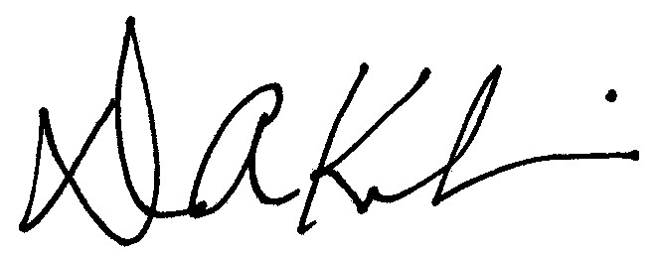

Dean Kubani
Director, Office of Sustainability and the Environment

