October 26, 2018

Mary Nichols
Chair
California Air Resources Board
1001 I ST
Sacramento, CA
ITM Power Comments
Electrify America’s Cycle 2 Proposed Investment Plan

Dear Chair Nichols,

ITM Power Inc. (ITM) appreciates the opportunity to submit comments to the California Air Resources Board (ARB) regarding Electrify America’s (EA’s) Cycle 2 Investment Plan and urges the rejection of the current plan for the reasons listen in this letter.

ITM Power Inc. chose to incorporate in California (CA) when coming to the USA due to its leadership role in emerging technology and climate goals. The CA support of the hydrogen industry has been strong over the past few years and we continue to be optimistic about continuing support for the future despite a few recent funding setbacks.

As you are aware there are 2 main types of Zero Emission Vehicles (ZEVs)- battery electric (BEV) and fuel cell electric (FCEV) for California to be successful in meeting its long term climate goals BOTH technologies must play a role and be given support. Hydrogen is vital for the clean vehicle future, this is particularly true of vehicles that travel long range or require high amounts of motive power to move goods or people – vehicles which battery technology is not ideally suited towards and vehicles which, when powered by fossil fuels, provide the most air pollution for disadvantaged communities.

Any credible analysis looking at decarbonizing a transportation sector the size of CA concludes the same thing – batteries alone cannot do it. The medium and heavy duty industry cannot be decarbonized using only BEV technology and hydrogen must play a role.

ITMs optimism for CAs future market falters significantly when we look at the EA investment plan. Phase 1 invested zero dollars in hydrogen siting that existing funding was adequate and further funding was not necessary. This was in stark contrast to the ARB projection of both station and hydrogen supply shortfalls. It was inferred that hydrogen may be targeted in future phases.
Phase 2 is also in danger of providing zero dollars for hydrogen which ITM feels is a critical problem that will significantly harm the states climate goals.

Funding for ZEV infrastructure is starting to show a worrying trend in CA. a trend which, if not addressed, could lead to a transportation sector that is unable to fully decarbonize using only 1 technology.

The recent assembly rejection of the Governor’s budget request to allocate an additional $72 million to hydrogen infrastructure deployment in Fiscal Year 2018/2019 causes the following statement in EAs report to be wide of the mark:

“the California Energy Commission and CARB recently found in their joint ‘2018 Annual Evaluation of Fuel Cell Electric Vehicle Deployment & Hydrogen Fuel Station Network Development’ that this additional support would be sufficient to meet the needs of hydrogen fuel cell vehicle drivers, writing ‘due to the anticipated acceleration in hydrogen fueling network growth, sufficient fueling capacity and coverage should be available by 2025 to enable FCEV deployments at a rate of two to three times greater than currently-reported plans’.”

Without the additional funding the FCEV infrastructure is in desperate need of further support in order to avoid customers experiencing station availability issues due to lack of coverage.

Charging infrastructure, under a combination of SB 350, ARFVTP, and Electrify America’s Cycle 1 investment plan, received over $1B of investment despite the fact that BEVs can already be charged using existing technology at most people homes.
Hydrogen receives only $20M per year for light duty hydrogen plus some additional funding for ad hoc vehicle projects such as $41m for the Toyota/port of LA goods movement project. This massive discrepancy will lead to critical problems in the future.

EA cited a lack of sustainable business case for hydrogen as a reason to not allocate funds to the technology however very recent developments in the states legislature have occurred which ITM feel have not been considered by EA, ITM urge the board to recommend EA review these before going ahead with a phase 2 plan for funding.
Changes such as SB100, SB1369 and the recent station capacity credit structure under the Low Carbon Fuel Standard (LCFS) will have a significant impact on the viability of hydrogen infrastructure in CA. ITM Power and other industry companies and organisations would be happy to educate and engage with EA on this topic.

ITM urges the board to reject the current plan and require EA to provide a balanced funding plan that supports both types of electric vehicle technology infrastructure.

ITM looks forward to working with the ARB and Electrify America for phase 2.

Kind regards,
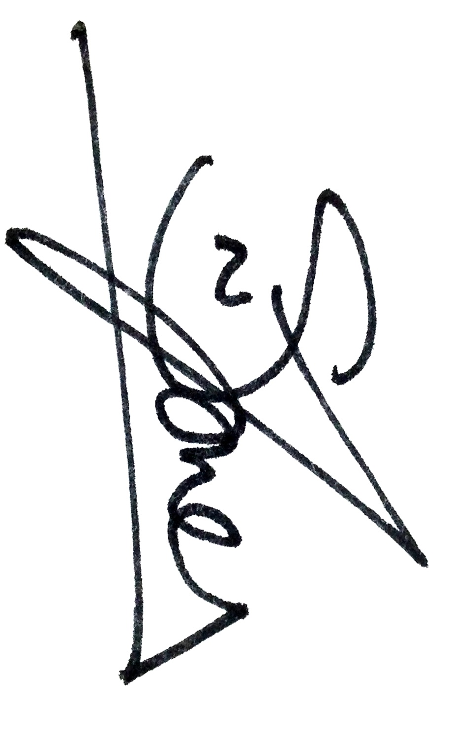

Steve Jones

Managing Director
ITM Power Inc.
+1 (714) 453 8141
sj@itm-power.com

