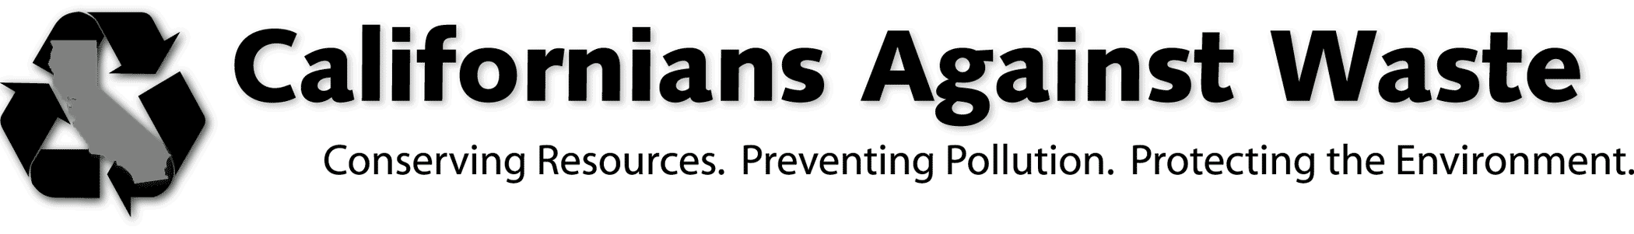

921 11th Street, Suite 420 ● SACRAMENTO, CA 95814 ● (916) 443-5422 FAX: (916) 443-3912 ● www.cawrecycles.org
September 1, 2015

Mary Nichols, Chairman
California Air Resources Board
1001 I Street
Sacramento, CA 95814

RE: Support for Increased Funding for Recycling, Composting, and Recycled Content Manufacturing in the Second Investment Plan
Chairman Nichols:
Californians Against Waste would like to strongly commend the Air Resources for identifying the waste sector as an opportunity for investment of allowance revenue proceeds.
Recycling is a proven and cost-effective greenhouse gas reduction strategy with the potential to meet multiple policy objectives and support economic growth. We strongly support funding for diverting organic wastes from landfills to composting and anaerobic digestion facilities, and hope to see additional funding be directed to reduce emissions through recycling and recycled content manufacturing.
Organic Waste Composting and Anaerobic Digestion
We support the draft investment plan’s focus on the greenhouse gas reduction potential of diverting organic waste, and the potential co-benefits of these policies to meet multiple state policy goals.
Composting and digestion reduces greenhouse gas emissions in two important ways, by minimizing the emissions from disposal and by creating a soil amendment that results in further greenhouse gas reductions when applied. First, composting reduces fugitive methane emissions by keeping materials out of the landfill. Landfills are designed to be anaerobic, meaning that once waste has been dumped, very little air remains below the surface. Landfill gas is generated as a byproduct of the digestion of organic materials by organisms that thrive in these anaerobic conditions. Food waste, paper, grass, and other organic matter is readily digested and turned into landfill gas—50 percent of which is methane, a short-lived climate pollutant 33 times more potent than carbon dioxide. While most modern landfills are required to capture some of their methane emissions, significant quantities continue to escape into the atmosphere, nearly 7 million tons of CO2 per year according to the state’s greenhouse gas inventory.
Even more significantly, the composting process produces a valuable soil amendment that continues to reduce emissions when used in agriculture or landscaping. An analysis by ARB staff has estimated that in addition to reducing landfill emission, the application of compost saves .42 net tons of CO2 per ton composted through soil carbon storage, and decreased water use, fertilizer use and soil erosion. In addition, emerging research from the Marin Carbon Project has shown an amazing potential for the application of compost to fundamentally change soils to allow ongoing carbon sequestration.
Additionally, supporting the burgeoning anaerobic digestion industry supports multiple policy priorities, including creating a ultra-low-carbon fuel that reduces emissions in the transportation sector, and generating renewable energy through distributed generation.
Based on our experience with this sector and other recycling industries, we believe direct and ongoing incentives to composting and digestion facilities would provide the most effective opportunity for investments in the long run. We look forward to working with you on developing the details of your proposal to maximize the effectiveness of the investments in this sector.
Recycling Market Development
Recycling market development was not included discussed at length in the draft investment plan,but investment in recycled content manufacturing is a proven greenhouse gas reduction strategy that yields dividends in terms of economy-wide greenhouse gas reductions, as well as jobs. Recycled content manufacturing avoids emissions from raw materials extraction, primary processing, transportation, and refining. Recycling also promotes forest carbon sequestration, and directly reduces direct manufacturing emissions by displacing virgin materials which require more energy for processing, and generate more waste. Re-introducing discards with intrinsic energy value back into manufacturing processes also creates more local jobs by supporting in-state processing and manufacturing with recycled feedstock.
Recycling is also one of the most cost-effective means of reducing greenhouse gases, often ranking as “cost-negative” in analyses that evaluate the cost effectiveness of various greenhouse gas reduction strategies. For instance, in implementing the Mandatory Commercial Recycling program, CalRecycle found that “implementation of the statute’s requirements (both for businesses and jurisdictions) will result in an estimated statewide average annual cost savings of $40 million-$60 million for the 2012-2020 time period.” In addition, the existing GGRF investments in recycling have proven to be among the most cost-effective of any agency’s investments.
Existing GGRF investments in recycled content manufacturing have focused on grants, and, while these investments have been successful, we believe the money would be better spent by developing material-specific direct incentive payments for California-based processors of recycled materials and manufacturers that use this material. This model has been proven successful through various programs run by CalRecycle—most notably the Plastic Market Development program—and, unlike competitive grants, creates a level playing field. This allows all processors and manufacturers to do cost-effective long range planning based on a greater use of recycled feedstock, which not only cuts greenhouse gases but also creates California jobs.
Given the enormous opportunities for greenhouse gas reductions through increased recycling and composting, investing cap-and-trade funds to expand and diversify California’s existing recycling and composting infrastructure is a smart environmental and economic investment.
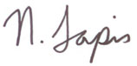Sincerely,
Nick Lapis
Legislative Coordinator
cc: Scott Smithline, Director, CalRecycle

