**Comments of Johns Manville and Add Insulation**

**September 1, 2015**

The Department of Community Services and Development (CSD) will be administering a residential energy efficiency upgrade program to be funded from the AB 32 auction revenue.  This includes funds earmarked for disadvantaged communities under SB 535.

CSD is currently administering the Low-income Weatherization Program (LIWP) that is funded by both the State and the US Dept. of Energy.  In the LIWP, weatherization assistance is determined exclusively by the income of the homeowners or home occupants.  In contrast, under SB 535 entire disadvantaged communities are eligible for assistance funding.  While there is some overlap between low-income and disadvantaged communities, the latter is a much more expansive concept that combines pollution burden and population characteristics.  As CalEPA describes in [DESIGNATION OF DISADVANTAGED COMMUNITIES PURSUANT TO SENATE BILL 535 (DE LEÓN)](http://www.calepa.ca.gov/EnvJustice/GHGInvest/Documents/SB535DesCom.pdf), disadvantaged communities are designated by their CalEnviroScreen score, which is summarized in Figure 1 on page 5 (copied below):

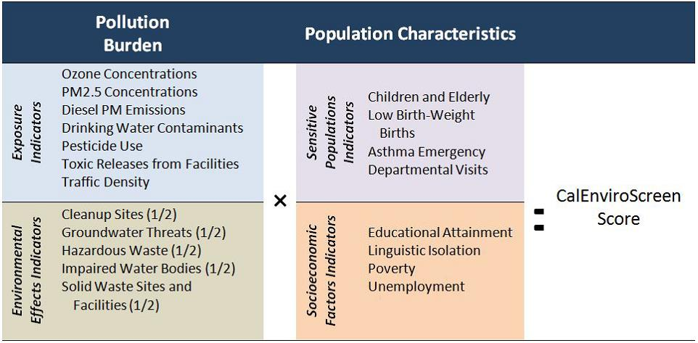

In order to be consistent with both the spirit and the letter of SB 535, CSD must go well beyond merely increasing funding to the existing LIWP.  Rather, CSD – or some other State agency – must open up energy efficiency funding under SB 535 to entire disadvantaged communities.  Also, if the State is going to meet its GHG emissions reduction goals, it must seek out and fund more innovative projects and approaches that promise greater energy savings (and emissions reductions) at potentially lower cost than traditional approaches.

We stand ready to build on successful approaches already proven in the field to assist the State in achieving its climate goals and, in so doing, providing maximum benefit to all disadvantaged communities.

Thank you,

Johns Manville

Bruce Ray

Add Insulation

Steve Troth