February 14, 2014

Re: Potential Amendments to the California Cap on Greenhouse Gas Emissions and Market-Based Compliance Mechanisms

Dear Air Resources Board Staff:

The Renewable Energy Markets Association (REMA) appreciates the opportunity to provide comments on the California Air Resources Board’s (ARB) potential amendments for the Cap and Trade program. REMA represents the collective interests of both for-profit and nonprofit organizations that sell or promote renewable energy products through voluntary markets, including renewable technology, renewable electricity, and renewable energy certificates (RECs), to individuals, companies, and institutions throughout North America.

REMA thanks ARB Staff for its continued work on improving and implementing the regulation, especially as it pertains to Section 95841.1 and voluntary renewable electricity. REMA believes this part of the regulation is generally sound, and so its comments on the latest revisions are more focused on technical changes to aid implementation. REMA encourages ARB Staff to adopt the following or effectively similar revisions, which are designed to ensure that the Voluntary Renewable Electricity set-aside functions smoothly as intended.

§ 95802 (a) (322) Retire, Retired, Retirement – This definition contemplates only the retirement of allowances. However, the regulation also references retirement in the context of renewable energy credits (e.g. §95841.1 and §95852). REMA recommends that Staff (a) clarify that this definition pertains only to allowances and (b) add a REC-related retirement definition, if deemed necessary.

§ 95841.1(a) Voluntary Renewable Electricity – First, REMA recommends the insertion of the following language into the third sentence “…will begin in 2014 for 2013 generation and allowances, and continue in the same manner for subsequent years.” This inclusion would provide additional support for, and reiterate the intent of, the vintage matching window implied in (b)(1).

Second, REMA recommends deleting the phrase “if created,” as the California Energy Commission’s (CEC) RPS eligibility requirements for facility certification inherently create RECs. This removes the opportunity to presume there isn’t an explicit requirement to demonstrate REC creation and ownership, thereby reducing the potential for double counting.
§ 95841.1(b)(1)(A) Voluntary Renewable Electricity –The requirement that “MWhs delivered to the California Grid” conflicts with §95841.1(a) that states that electricity must be “directly delivered to California.” The area of California’s grid is smaller than that of the political border and also extends outside of California into Nevada. REMA recommends a consistent definition that uses “delivered into California.” This is more consistent with the rest of the regulation.
§ 95841.1(b)(1)(B) Voluntary Renewable Electricity – REMA recommend’s changing the statement, “pursuant to the California Energy Commission’s Guidelines for California’s Solar Electric Incentive Programs in effect for the year in which the system was installed” to “year in which the system received its approval of incentive,” or something similar. This change would avoid potential eligibility problems for facilities that would have been verified and received an incentive according to the then-current CEC solar guidelines edition and installed during the subsequent edition. REMA anticipates that the existing language would seem to inadvertently prevent the eligibility of systems, for example, that were approved for an incentive in November of 2008 and installed in January of 2009.

§ 95841.1(b)(2)(A) Voluntary Renewable Electricity – Similar to the above revision, REMA recommend’s changing the statement, “pursuant to the California Energy Commission’s Guidelines for California’s Solar Electric Incentive Programs in effect for the year in which the system was installed” to “year in which the system received its approval of incentive.”
We encourage ARB staff to consider the recommendations above and incorporate them into the state’s strategies to promote GHG reductions, increase renewable energy, and avoid double counting. REMA would like to thank the ARB again for allowing REMA to play a role in its rulemaking process and hope to work closely together as this issue further develops.
For additional questions or clarification on REMA’s recommendations, please contact Joseph Seymour, REMA Policy and Governmental Affairs Coordinator, at jseymour@ttcorp.com.

Sincerely,

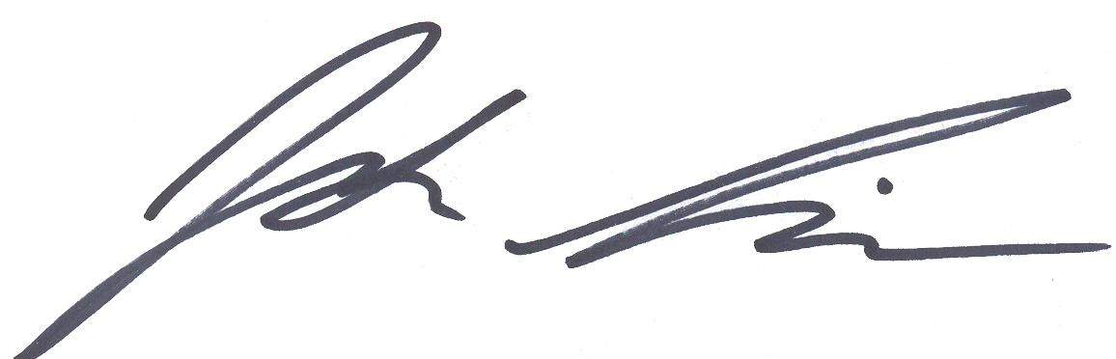

Josh Lieberman
REMA General Manager
202-457-0868, x322
jlieberman@ttcorp.com

