**June 29, 2015**

**Re: Auction Proceeds Funding Guidelines**

To Whom It May Concern:

We are writing as a coalition of twelve regional organizations across the state that are working together to address issues in many areas including those that are targeted through Cap and Trade investments, to recommend changes in the Auction Proceeds Funding Guidelines. The California Stewardship Network (CSN) was formed in 2008 as an alliance of regional organizations committed to the economic, environmental and social wellbeing of our regions and state. Our member regions represent powerful innovation centers where business, community and government leaders work together, and form partnerships to achieve collective impacts throughout the state.

Inclusive Development of Funding Guidelines

The Auction Proceeds Funding Guidelines are critical to the administration of the Greenhouse Gas Reduction Fund. Release of the Draft Guidelines occurred on June 16th with only one workshop scheduled less than a week later. We understand ARB’s desire to give guidance to the agencies funded by the GGRF. However, the potential for the Funding Guidelines to shape how agencies engage communities and implement effective programs cannot be overstated.

* **The timeline for developing and refining these guidelines must be extended to allow for meaningful participation from all interested stakeholders in all areas of the state.**

Clarity and Transparency in Application Process

Funding agencies each have their own process for allocating Greenhouse Gas Reduction Fund grants. Project evaluation criteria and application processes are obscured from applicants and community members by the separate criteria and decentralized coordination. Substantive questions about regional equity have arisen during initial grant processes and more clarity is needed about processes, tools and metrics to ensure equitable distribution of funds. Further, the inability to access active applications to all agencies hampers the community’s ability to influence their project parameters and impedes collaboration between agencies.

* **All twelve agencies administering grants should post the criteria used to rank applications and post applications received to a centralized and public website to increase transparency and enable community engagement and agency collaboration.**

Meaningful Accountability for Co-Benefits

While the primary goal of the Greenhouse Gas Reduction Fund is to reduce greenhouse gas emissions, maximizing additional economic co-benefits must be a natural outgrowth of those efforts (*see, e.g.,* Health and Safety Code § 38501(h). More specifically, AB 1532 (Perez), requires an investment plan that ensures Cap and Trade proceeds reduce GHG emissions while maximizing job creation, public health and other so-called “co-benefits”. With some intentionality behind defining and evaluating co-benefits, California can leverage auction proceeds to help foment a production-based (versus consumer-oriented) clean technology economy that maximizes direct, indirect and induced job creation, significantly improve the health of our state’s disadvantaged communities and, of course, also improve air quality and public health.

* **Agencies should develop metrics for co-benefits and require applicants to reference those metrics in their applications. Reports on the metrics should be used to inform each agency’s future rounds of funding. Agencies must give priority to applications that identify more than one co-benefit to enhance the environmental, economic and social effects of these investments.**
* **Reports on the metrics should be used to inform each agency’s future rounds of funding.**
* **Agencies must give priority to applications that identify more than one co-benefit.**
* **Agencies should incorporate priorities established in Governor Brown Executive Order E-30-15, specifically direction to identify climate impacts by sector and region, incorporate climate adaptation into priorities, and coordinate investments with other agency priorities.**

Robust Community Engagement Processes

Assembly Bill 32 requires that public and private investment be directed toward the most disadvantaged communities in California to provide an opportunity for community institutions to “participate in and benefit from statewide efforts to reduce greenhouse gas emissions.”[[1]](#footnote-1) SB 535 requires that “funding guidelines developed for administering agencies… shall include guidelines for how administering agencies should maximize benefits for disadvantaged communities.” To abide by these legislative mandates, agencies and applicants should do everything possible to ensure that Greenhouse Gas Reduction Fund investments are funding those efforts that respond to real community needs, most notable of which is to improve access to economic opportunity for low-income families, and are bolstered by robust community input. It is these projects that are likely to also provide substantial co-benefits (public health, jobs and economic, transit equity).

* **All agencies administering Greenhouse Gas Reduction funds should provide technical assistance to community based organizations to promote the inclusive engagement of and shared collaboration within disadvantaged communities, including residents, local public benefit organizations, and local business establishments, as the job providers in these communities. When necessary, ARB should exercise its authority to distribute cap and trade revenues to fund grants that will help agencies adhere to AB 32’s “participation” requirement via agency- or board-level technical assistance.**
* **Applicants should receive priority if they can demonstrate input from residents, social institutions, and local businesses within the census tract their project targets to illustrate community support for the application, in addition to outlining their community engagement process in the development of the application.**

Thank you for your consideration of these comments. We look forward to working with you to ensure the success of this important program.

Sincerely,

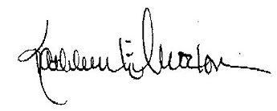

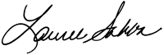

Lauree Sahba, **CSN** Chair Kathleen Moxon, **CSN** Vice Chair

COO, San Diego Economic Director

Development Corporation Redwood Coast Rural Action

C:\Users\Joanna\AppData\Local\Microsoft\Windows\Temporary Internet Files\Content.Outlook\H1G440VC\PCG_Digital Sig (00000002).png 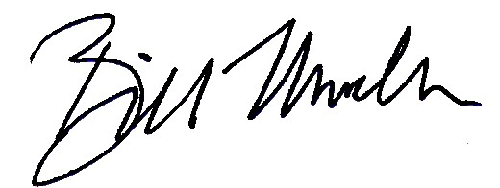

Paul Granillo, **CSN** Immediate Past Chair Bill Mueller, **CSN** Past Chair

President & CEO CEO

Inland Empire Economic Valley Vision, Sacramento

Partnership

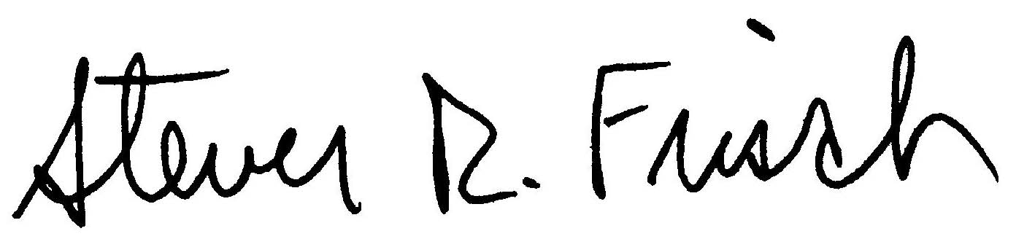 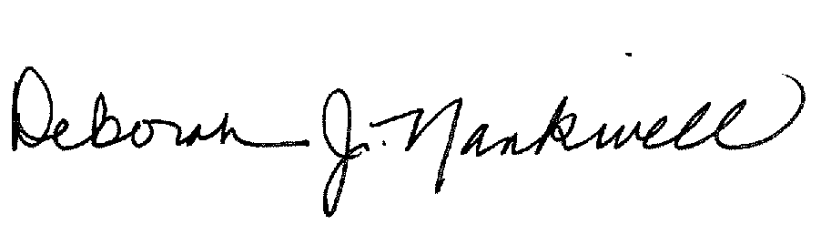

Steven Frisch Deborah Nankivell

President CEO

Sierra Business Council Fresno Business Council

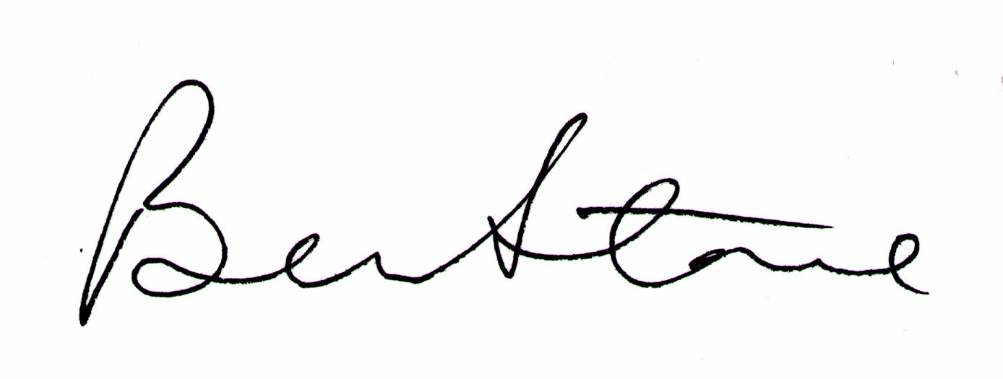 

Ben Stone Bruce Stenslie

Executive Director President & CEO

Sonoma County Economic Ventura County Economic

Development Board Development Collaborative

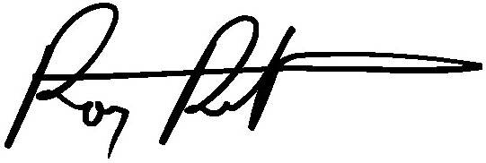 cid:image004.jpg@01D0B26A.533E8C70

Rory Rottschalk Bill Allen

Principal in Charge President & CEO

Culp and Tanner Los Angeles County Economic

Development Corp



Michael Manchak

President & CEO

Economic Vitality Corporation

San Luis Obispo

1. Cal. Health & Safety Code §38565 [↑](#footnote-ref-1)