June 8, 2015

Mary D. Nichols
Chair
California Air Resources Board
P.O. Box 2815
Sacramento, CA 95814
Submitted via electronic mail.

Re: Written comments from the National Biodiesel Board on proposed Regulations for the Commercialization of Alternative Diesel Fuels.

Dear Chair Nichols:

Thank you for the opportunity to comment on these regulations. We sincerely value the job you and all ARB board members and staff undertake in protecting the state’s environment and public health.

By way of background, the National Biodiesel Board (NBB) serves as the trade association for the U.S. biodiesel and renewable diesel industries. The NBB represents more than 90 percent of domestic biodiesel and renewable diesel production. In addition to governmental affairs activities, the association coordinates the industry’s research and development efforts.

Before delving briefly into a few key regulatory areas, I would like to express our appreciation to the Air Resources Board (ARB) for the cooperation we have received over the past several years. Biodiesel has encountered unique regulatory challenges as a result of being the first alternative diesel fuel to ascend to commercial scale. I am pleased to report that, in each situation we have encountered, ARB staff have diligently worked through whatever issues presented themselves with great skill, integrity, and professionalism. It has been a pleasure to work with staff on numerous matters of precedent-setting importance.

Renewable Diesel and NOx Emissions from Biomass-Based Diesel Fuels.
The report notes that 40 percent of renewable diesel is currently blended at the refinery level as a “blendstock” used to make finished diesel fuel and therefore should not be counted as an offset to biodiesel emissions. We fail to understand the logic of this position. Whether a California refiner or a downstream wholesaler blends renewable diesel seems irrelevant to us. The salient point is that renewable diesel is being used in California and should be considered as an offset to similar biomass-based diesel fuels such as biodiesel.
Limited Producer/Importer Exemption
It appears that the provision is written such that a producer or importer may apply to sell B20 to fleets by January 1, 2017 and that this exemption is in effect for that producer and for only those fleets specified until such time as the Executive Office determines that biodiesel has met the sunset requirements under the regulation. If our reading is correct, we would prefer a provision that allows qualified producers to apply for an exemption annually or every two years, reflecting an updated list of fleet customers. This added flexibility would not impact the efficacy of the provision since the volume limitations would remain in place.

Table A.7 and A.8
The distillation method should be changed from ASTM D86 to ASTM D1160. ASTM D86 is appropriate for blends, but not pure biodiesel.

The viscosity specification should be increased from 4.1 to 6.0, consistent with the requirements of D6751. Viscosity has not been identified as a property important to biodiesel emissions. Moreover, most biodiesel will display a viscosity level in excess of 4.1.

Additive Testing
Page 45 [(G)2] seems to suggest that any additive used to meet the requirements of the program would require testing to ensure the absence of negative emissions impacts. We would like to clarify that this requirement would only pertain to additives that are not already approved for use by the Air Resources Board.

Reporting
We suggest allowing producers the flexibility to report the properties of their fuel by either the saturation level of the biodiesel (low or high) or the type of feedstock.

Certification of NOx-neutral Biodiesel Blends
We would like to clarify that NOx-neutral blends of biodiesel using an additive may be certified at any blend level, i.e. B10, B15, or B20. The NBB plans to initiate an additive testing certification program, potentially at various blend levels.

Thank you, in advance, for your consideration of our views on these important matters. If I may be of any assistance, please feel free to contact me at any time at (573) 635-3893.

Sincerely,

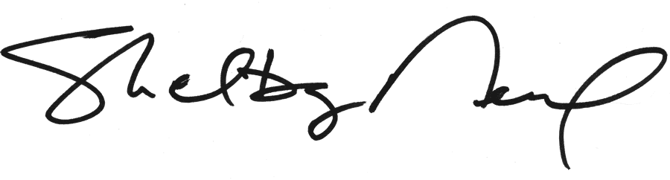
Shelby Neal
Director of State Governmental Affairs

