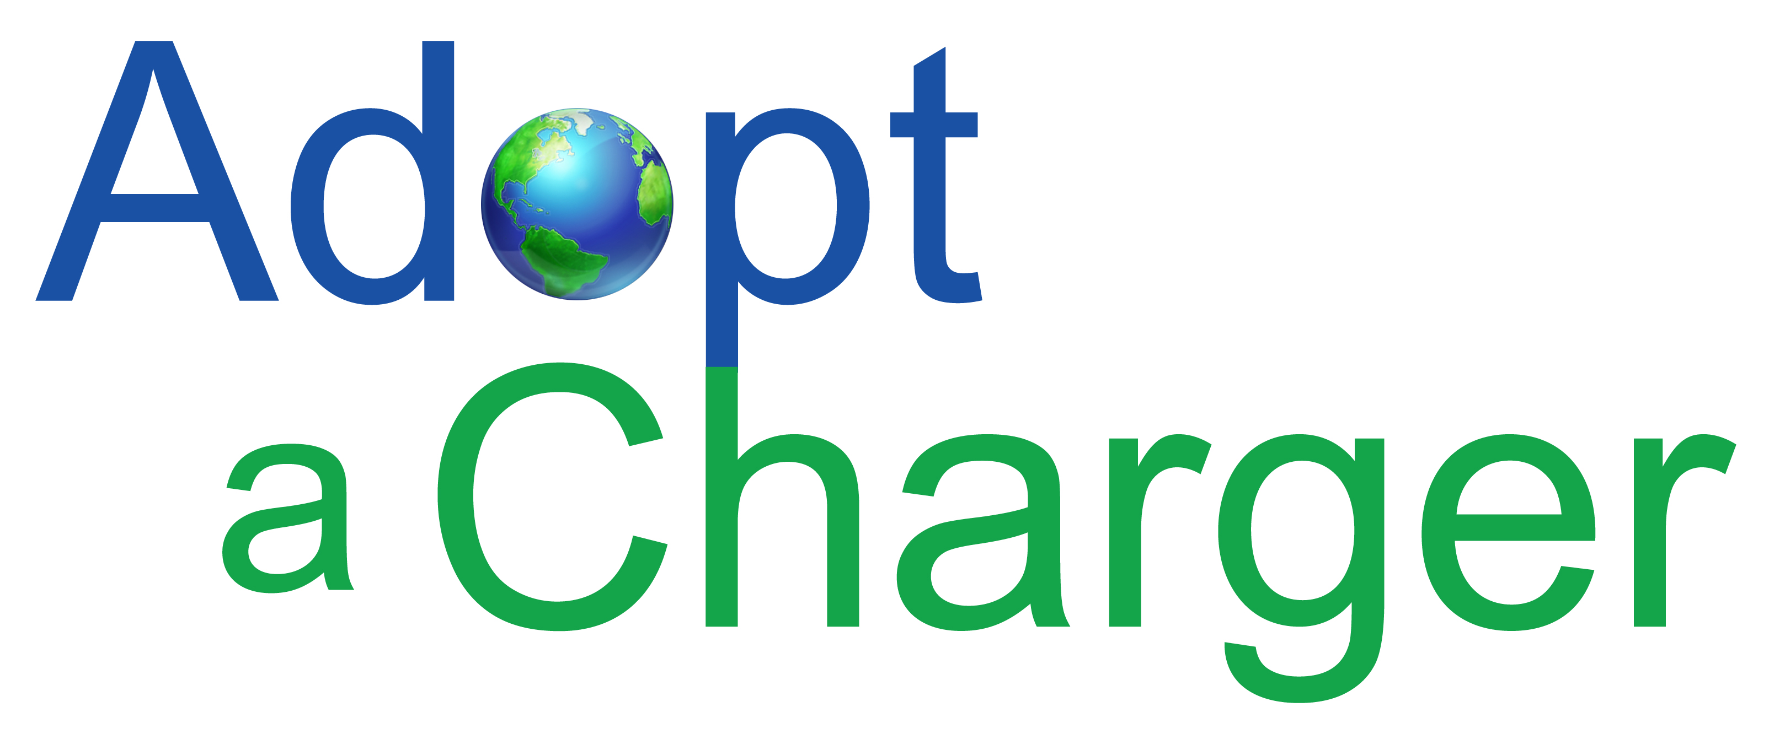

Mr. Mark Williams, Mailstop 3E Air Resources Board  
P.O. Box 2815  
Sacramento, California 95812

RE: Comments for consideration in California’s summary of guidance to VW as it develops its first draft California ZEV Investment Plan

Adopt a Charger (AAC) is a 501(c)3 non profit organization started in 2011 to accelerate the adoption of electric vehicles by expanding EV charging infrastructure. Our unique business approach, finds sponsorship to install EV chargers at popular destinations like National Parks, State Parks, museums, and universities. Unlike “no charge to charge” programs, these chargers are offered fee free to all PEV drivers regardless of the make and model. AAC recognizes the importance of infrastructure for outreach and education purposes, and by encouraging drivers to plug in at these high profile locations; we raise awareness of PEV, and help make the connection that these cars run on electricity. It also enables the EV curious to have direct interaction with owners, who are the best sales people for the cars. We have helped organizations in California, Washington State, Michigan, Ohio, Kentucky, Illinois, Missouri, Alabama, and Maryland with EV infrastructure projects. Our focus is to increase usage of PEV and show more Americans that going electric is possible today.

I share Governor Brown’s goal of selling 1.5 million ZEV in California by 2025, and realize the need for adequate infrastructure to support it. One of the biggest factors in considering the purchase of a PEV is the low cost of ownership. As a charging provider, my concern is not about the competitive aspect of the business landscape, and more focused on providing a service that is reliable, convenient, easy to access, ubiquitous, and affordable.

There has been a tremendous amount of engagement between stakeholders and VW. By providing appropriate oversight on the settlement, and fostering transparency, CARB can maximize the potential of this opportunity to support current PEV drivers and stimulate future sales.

Respectfully,

Kitty Adams, Executive Director

Kitty.Adams@adoptacharger.org