The definition of “minimum useful life” is the most important trigger in the ACF. It defines when companies must eliminate trucks. The current definition lacks clarity and is exceedingly confusing. Fortunately, this is an easy fix.

The definition of “Minimum Useful life” is given in Section 2015(b) Definitions under paragraphs (A) and (b). Current text and the proposed simple fix are given below.

*“…from the model year of the vehicle’s original engine, provided the original engine is still in the vehicle, with the model year as specified by the engine’s family number. ~~model year that the engine and emissions control system in a vehicle was first certified for use by CARB or United States Environmental Protection Agency (U.S.EPA)~~*

Using the term “… *first certified for use by CARB*…” creates all sorts of confusion. For example, ARB approves virtually all engine emission certifications the year before an engine model year for obvious reasons. One could construe “first certified” to the year on CARB EO for a given engine family, which would make all engines one year older that the actual model year.

Then you have carryover certification where an emission certification can be used for subsequent model years where an engine and emission standard do not change. Does “first certified” mean the current engine family model year or the year that engine family was first certified? This again is really confusing and could also accelerate the rate at which trucks must be eliminated.

Fortunately, there is super simple solution. The first character of the engine’s emission family number specifies the model year of that engine.

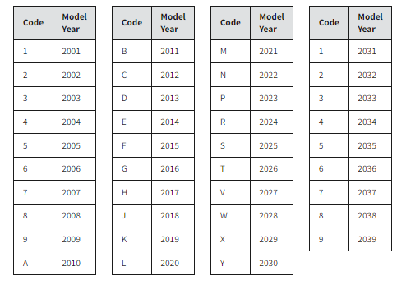

The proposed corrected text replaces highly confusing “first certified” year with the engine model year as given by the engine’s family number.

We note that the *Technical Analysis of End of Useful Life Scenarios,* 4/5/22, ARB, uses the date a vehicle was first purchased as that starting date for “useful life.” See p. 2.

Finally, more minor, the use of text “…*certified for use by CARB or United States Environmental Protection Agency (U.S. EPA)”* is unnecessary. Existing regulations prohibit the use of engines in vehicles that have not been certified by ARB/EPA. This text serves no purpose other than to make the regulation longer.