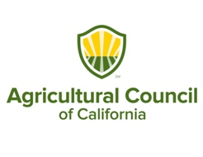



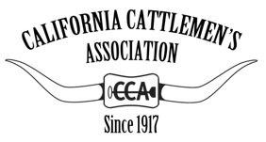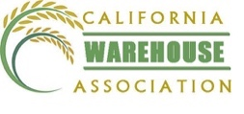









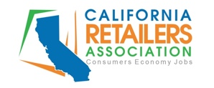

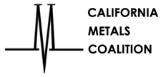

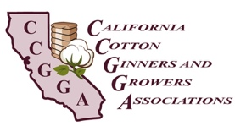











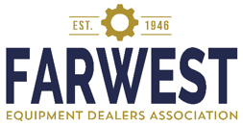

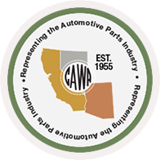

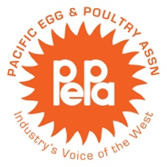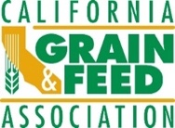



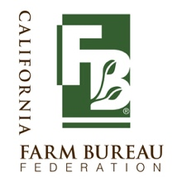































November 27, 2019

Clerk of the Board

California Air Resources Board

1001 I Street

Sacramento, CA 95814

*Via Electronic Submittal*

**SUBJECT: COMMENTS ON THE PROPOSED ADVANCED CLEAN TRUCKS REGULATION—LARGE ENTITY AND FLEET REPORTING REQUIREMENT**

The undersigned coalition, representing dozens of organizations and the thousands of businesses they represent is alarmed by the proposed large entity reporting requirement of the Advanced Clean Trucks draft regulation first published on October 22, 2019 and set for hearing before the California Air Resources Board (CARB) on December 12, 2019. The draft regulation will impose new costly and burdensome reporting requirements on entities, many of which have never been regulated by CARB before, and should be thoroughly vetted before adoption. While we appreciate the efforts of CARB at data collection prior to implementation of an end-user purchase mandate, we urge you to slow down the effort and create a meaningful process that provides important dialogue and engagement with the businesses directly impacted by the reporting requirement to develop a policy that works for all impacted parties and is tailored to meet CARB’s goals of cost-effective electric vehicle rollouts.

Specifically, we request CARB:

* Bifurcate the large entity reporting requirement from the manufacturer requirement
* Schedule a series of public workshops to solicit feedback and data from the additional 10,000 businesses that are estimated by CARB to be affected by this new concept

The Large Entity Reporting Requirement at Section 2012-2012.2 is tacked onto the end of a complex truck manufacturing production mandate. Despite ongoing workshops on the manufacturer requirement since late 2016, the first conceptual document outlining CARB’s ideas around a reporting requirement were not made available until the end of the final public workshop on the Advanced Clean Trucks rule on August 21, 2019, roughly three years later. Rushing the regulation process (just three months), and the lack of public process, has resulted in fundamental flaws in the regulation that must be addressed prior to adoption to ensure a successful outcome for all parties.

Below is a partial list of our concerns on the reporting requirements.

**BURDENSOME REPORTING**

* Terms are vague, and require businesses to make guesses, “estimate,” and “use best judgement” and “approximate” the data they submit. As a result, the regulation may not result in usable or useful data, much of which can be gathered by other means.
* The compliance period for this rule begins on January 1, 2020, but the regulation will not be finalized until mid-2020. Businesses will not have time to develop a system for data collection or implement a record retention policy based on these date. Moreover, CARB cannot impose duties on regulated entities prior to finalizing of a rule.
* Many businesses do not maintain these types of records. How does CARB anticipate these businesses will comply? Using a “good faith effort” or guessing, as suggested by the Initial Statement of Reasons, cannot support valid data collection to be used for future rulemaking.

**VAGUE ENFORCEMENT**

* Violations of the Advanced Clean Trucks Large Entity Reporting Requirement are subject to general Civil Penalties of up to $37,500 per day for a data gathering exercise.
* How will the rule be enforced? How will we know that our best guesses are enough?

**INCREASED COSTS**

* CARB did not solicit feedback, and therefore significantly underestimated the cost of regulatory reporting compliance, especially when considering the regulation is subject to enforcement and there is no limit on civil penalties. Companies, especially those with many facilities, 24/7 operations, and multiple points of facility entry will be required to develop a tracking system to meet this rule.

**DATA SECURITY RISKS**

* Data gathering through a vague, hard to enforce regulation subject to significant civil penalties will not result in effective or useful data and will simply burden the business community without any real benefit to CARB or the public.

**UNCLEAR GOALS**

* Why is the regulation asking about cars, SUVs, and mini-vans?
* Why is CARB not asking about existing electric vehicles or other low-emissions technology?
* How do these guesses help with EV rollout?

Thank you for the opportunity to comment on the proposed reporting requirements. We again urge you to bifurcate the large entity reporting requirement from the manufacturer requirement and schedule a series of public workshops to solicit feedback and data from affected businesses like ours. We plan to submit a more detailed list of our concerns during the comment period, and many or all of our coalition plans to attend the CARB meeting on December 12 to express these concerns. However, we look forward to working with you to address our concerns and discuss our reasonable recommendations prior to the first board meeting.

Sincerely,



Leah Silverthorn, Policy Advocate

California Chamber of Commerce

On behalf of the following organizations:

African-American Farmers of California

Agricultural Council of California

American Pistachio Growers

Associated California Loggers

Brawley Chamber of Commerce

Burbank Chamber of Commerce

Calforests

California Association of Winegrape Growers

California Attractions and Parks Association

California Automotive Wholesalers Association – Representing the Automotive Parts Industry

California Business Roundtable

California Cattlemen’s Association

California Citrus Mutual

California Construction and Industrial Materials Association

California Cotton Alliance

California Cotton Ginners and Growers Association

California Farm Bureau Federation

California Fresh Fruit Association

California Fuels and Convenience Alliance

California Grain and Feed Association

California Metals Coalition

California New Car Dealers Association

California Retailers Association

California Seed Association

California Warehouse Association

CARE - Californians for Affordable and Reliable Energy

Chemistry Industry Council of California

Clean Energy Fuels

Coastal Energy Alliance

El Centro Chamber of Commerce

Farwest Equipment Dealers Association

Greater Coachella Valley Chamber of Commerce

Industrial Environmental Association

Kern County Farm Bureau

Long Beach Area Chamber of Commerce

Murrieta/Wildomar Chamber of Commerce

NAIOP Southern California Chapter

Nisei Farmers League

Northern District of the California Refuse Recycling Council

Oceanside Chamber of Commerce

Pacific Egg and Poultry Association

Personal Insurance Federation of California

San Diego Regional Chamber of Commerce

San Gabriel Valley Economic Partnership

San Mateo Area Chamber of Commerce

Santa Clarita Valley Chamber of Commerce

Santa Maria Valley Chamber of Commerce

Torrance Area Chamber of Commerce

Trillium

Tulare Chamber of Commerce

Ventura County Taxpayers Association

West Coast Lumber & Building Material Association

Western Agricultural Processors Association

Western Growers Association

Western Independent Refiners Association

Western Plant Health Association

Western States Petroleum Association

Western Wood Preservers’ Institute

cc: Alice Reynolds, Office of the Governor

Richard Corey, California Air Resources Board

Steven Cliff, California Air Resources Board

California Air Resources Board c/o [Evan.Kersnar@arb.ca.gov](mailto:Evan.Kersnar@arb.ca.gov)