10/25/18

The Honorable Mary Nichols
Chair, California Air Resources Board
1001 I Street
Sacramento, CA 95814

Re: Electrify America Cycle 2 ZEV Investment Plan – SUPPORT

Dear Chair Nichols:

On behalf of Local Government Commission, I am writing to convey our support for the adoption of Electrify America’s Cycle 2 ZEV Investment Plan. Local Government Commission is a nonprofit organization which works to build livable communities and local leadership by connecting leaders via innovative programs and network opportunities, advancing policies through participation at the local and state level, and implementing solutions as a technical assistance provider and advisor to local jurisdictions.

We commend Governor Brown and the California Air Resources Board for the work you have done over many years to address the challenge of climate change and human health risks associated with greenhouse gas emissions. If California is to make a real in addressing climate change we must take bold measures to encourage ZEV adoption. Equally important is ensuring that vehicles and charging infrastructure are accessible not only to early adopters of ZEVs but also to individuals in disadvantaged and low-income communities.

Electrify America has made progress in Cycle 1 in the early stages of its 10-year ZEV Investment Plan to build EV charging stations, implement an education and awareness program as well as advance mobility programs in the City of Sacramento, Electrify America’s first “Green City”. We commend these investments and appreciate the increased focus on disadvantaged and rural communities in the proposed Cycle 2 plan.

We respectfully urge CARB board members to approve Electrify America’s Cycle 2 ZEV Investment Plan.

Sincerely,

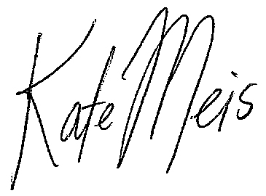
Kate Meis
Executive Director
Local Government Commission

