The California Air Resources Board (CARB) Draft 2022 Scoping Plan commits the transformation of an increasing proportion of the State’s refinery capacity to advanced biofuels production, using animal fats, vegetable oils and greases, in order to make both renewable diesel and sustainable aviation fuel (SAF). There are a number of false assumptions and environmentally harmful inclusions in the CARB Draft Scoping Plan affecting carbon dioxide emissions from multiple points within the well-to-wheel greenhouse gas analysis of transportation fuels, to which the State hopes to address. My 2022 Draft Scoping Plan comment, here, addresses these multiple CO2 emissions points within the fuel pathway, from before the refinery level (i.e., agricultural/upstream), then at the refinery level (midstream) and after the refinery (upstream).

These points are:

- The Draft Scoping Plan neglects to factor in the true high cost of biofuels agricultural production from both the overall indirect land-use perspective and the CO2 greenhouse gas emissions or “carbon intensity” perspective.

- The Draft Scoping Plan also neglects to address the significantly increased refinery CO2 emissions from the production of renewable diesel and SAF, due to the massively increased refinery-made hydrogen required for their production, when compared to petroleum refining.

- The credit-based scoring system which CARB uses to evaluate the well-to-wheel (WTW) carbon intensity of renewable diesel, does not include biofuels tailpipe emissions, as does CARB when considering the entire WTW score for petroleum-based fuels. The reason for this is because CARB considers biofuels plant-based emissions as only recently sequestered CO2 and therefore, they categorize all biofuels as almost entirely carbon neutral, form the tailpipe emissions perspective (which essentially discounted). CARB also entirely neglects the fact that an acre of large trees with forest biomass sequester orders of magnitude more CO2 per year than an acre of grass or soybeans.

- The Draft Scoping Plan assumes that Carbon Capture and Sequestration (CCS) would be a safe, environmentally beneficial, permanent, cost-effective and low-carbon credit certifiable alternative project with broad scientific consensus. None of these assumptions are universally determined as true across the scientific community.

Each of these points are addressed in the following comments (in parts I, II and III). However, in Part I, my comments will first address some salient points regarding the carbon intensity scores of biofuels, from both the land-use and (the interrelated) economic perspectives. These are contemporaneous points, apparently are not being considered by CARB, in terms of their certification of renewable diesel and SAF production for massive amounts of subsidization (as “apparent”, yet possibly questionable low-carbon fuels). I urge CARB to decertify almost all types of renewable diesel and SAF for low-carbon fuel accreditation and entirely discontinue support for underground industrial-scale CCS.

Recommendations:

1) In contrast to CARB’s current Low Carbon Fuel Standard (LCFS) well-to-wheel assessment of renewable diesel and well-to-wake assessment for sustainable aviation fuel (SAF), CARB should no longer exclude the tank-to-wheel (or -wake) carbon dioxide emissions in calculating the biofuels carbon intensity. [Simply because the CO2 consumed by plant growth is combusted in biofuel usage does not negate the forced, high CO2 agricultural production of biofuels, which greatly removes vast tracts of land from critical food production, increases food costs (over a wide variety of food stuffs) and especially, profoundly depletes the long-term and massive natural carbon sequestration of otherwise undeveloped lands.]

2) In contrast to CARB’s current practice and with full public transparency, CARB’s LCSF program should immediately re-evaluate the refinery-level carbon intensity of hydrogenated refinery biofuels, such as renewable diesel and SAF, which use increased amounts of fossil-fuel-derived hydrogen, when compared to California refineries’ current slate of heavy petroleum feedstock. [Importantly, parallel calculations should be made using both kg CO2/barrel (based on published individual refinery parameters) and g CO2/MJ (CARB’s current practice).]

3) Cap combined renewable diesel biofuels use and production in California to 2.0 billion gallons per year and ban SAF altogether, unless the biofuel production is from algae or other microorganism-based feedstock.

4) Plant-based biofuel feedstock produced on agricultural lands should only be used as biofuel for urban public mass transit, school busses and emergency electricity generation for hospitals or other public purposes, where non-CO2 emissions are a proximate health concern.

5) Accelerate applied research into scaling-up biofuel production from algae and other microorganism-based feedstock. Accelerate the use of algae and other microorganism-based feedstocks in order to entirely replace soil-based biodiesel and SAF feedstocks.

6) Rapidly accelerate applied research into electrolytic hydrogen production from non-nuclear renewable energy resources.

6) Ban underground carbon capture and sequestration for reasons of its proven energy inefficiency, lack of proof of safety (at a large scale) and its being an extremely costly diversion of resources and time needed for true low- or zero-carbon methods to become available (using the resources which CCS would otherwise be diverting). Immediately ban its use in enhanced oil recovery. Captured industrially-produced carbon dioxide should only be used for above ground manufacturing purposes, where CO2 is a non-replaceable ingredient in the manufacturing process (and the sequestration is long-term).

I.
The indirect land use change impacts of biofuels (also known as ILUC), “relates to the unintended consequence of releasing more carbon emissions due to land-use changes around the world induced by the expansion of croplands for ethanol or biodiesel production in response to the increased global demand for biofuels.” https://en.wikipedia.org/wiki/Indirect_land_use_change_impacts_of_biofuels

California’s current consumption of biomass-based diesel is around 1 billion gallons annually, with approximately 75% of that demand now being met through renewable diesel (i.e., 750-million gallons yearly). Yet, recently approved renewable diesel projects in Contra Costa County, at the Rodeo Phillips 66 Refinery and at the Martinez Marathon Refinery are each slated to produce 1.2-billion and 0.8-billion gallons per year by 2024, respectively. The 2020 CARB Scoping Plan for transportation is intended for the State to transition to 100% refining of fats, oils, and greases for “RD and SAF by 2040”. However, it is not unreasonable to state that CARB’s biofuels expectations for 2040 are guaranteed to result in more serious consequences than the amount of petroleum refining which CARB hopes to displace, for all the reasons stated in these comments (Parts I and II.).

The impact of a food-to-biofuels transition would be enormous and negative regarding both agricultural land-use impact and food security.

For the Phillips 66 Rodeo Renewed Project, if soybean oil were the singular renewable diesel feedstock, the land-use alone would be the size of the State of Indiana, or 38,000 square miles (although soy oil is expected to be merely the primary feedstock, among several others, including tallow and canola oil). This acreage is based upon 57 gallons of soybean oil produced per acre of soybean, which is the current U.S. average.

According to the 2009 PNAS journal article, “The water footprint of bioenergy” by Leenesa, Hoekstraa and van der Meerb, states that 13,676 (total) liters of water is required per liter of soybean oil feedstock (with 7,521 liters being blue water, i.e. groundwater and other irrigation water and 6,155 liters of green water, i.e., rain). Whether or not these figures have been challenged, the authors findings, even if off by a factor of two or more, must cause one to pause in believing the CARB’s agricultural (ILUC) carbon intensity score for renewable diesel is anywhere near accurate. Water scarcity absolutely translates to both higher costs and higher land-use carbon intensity for biofuels. https://www.pnas.org/doi/10.1073/pnas.0812619106

Additionally, according to the International Food Policy institute, the price increase in the four major traded vegetable oils has far outstripped inflation over all other recent price-inflated items, including petroleum products. Between January 2021 and the February 24th 2022 Russian invasion into Ukraine, the price of soybean oil increased by 50% and by June 2022 to 80% higher (than January 2021). According to the report, Africa, the Middle East and South Asia are particularly vulnerable to food insecurity if they endure the accelerating loss of available and affordable vegetable oils.

The IFPI report noted that one major “issue affecting global vegetable oil supplies and prices is the recent growth of biodiesel capacity. Driven largely by regulations that mandate their blending in fuel supplies and subsidies encouraging their use, global production of biodiesel fuels has grown over the past 20 years from less than 1% of total vegetable oil use in 2003 to almost 15% today.

CARB’s California mandate has certified renewable diesel for State Low Carbon Fuel Standard (LCFS) credits and hence, allows for the refiner’s acquisition of Federal Renewable Investment Number (RIN) credits and Blenders Tax credits. The IFPI report continues: “Biodiesel mandates are putting additional pressure on global vegetable oil prices. Because of mandates, demand for vegetable oils as a feedstock for biodiesel production is fairly unresponsive to changes in prices. As a result, price volatility tends to increase when supplies are short.” Both the Phillips 66 and Marathon refineries’ renewable diesel is expected to acquire up to $3.32 per gallon in credits, such as for beef tallow, although vegetable oils are expected to be the principal feedstock.
[Overcapacity Looms as More and More US Refiners Enter Renewable Diesel Market. Stratas Advisors (June 11, 2020) https://stratasadvisors.com/Insights/2020/06112020LCFS-RD-Investment]

However, since soy and other vegetable oil feedstocks for biofuels are most likely to come from outside of California, these figures for price, product sourcing and scarcity are not deemed prohibitive in CARB’s decision to promote renewable diesel and SAF through a credit-based system. While CARB uses the current Argonne GREET (Greenhouse gases, Regulated Emissions and Energy-use in Technologies) model Framework for CO2 greenhouse gas assessment, they inherently neglect the above-mentioned profound socially-destablizing externalities.

II.
Instead of being a feedstock for low-carbon fuel refining, animal fat and vegetable oil molecules are triglycerides (like physicians measure), and they, counterintuitively, are far more difficult to crack than petroleum oils. The most energy-intensive hydrocracking process for renewable diesel is the “hydrodeoxygenation” reaction, for which the refinery must greatly expand it hydrogen usage above current levels. Renewable diesel fuel produced from a wide array of vegetable oils and animal fats is referred to technically as Hydro-processed Esters and Fatty Acids (HEFA). The refining of renewable diesel and SAF is even more carbon intensive than refining high-sulfur heavy crude oil, with SAF being the highest. [Table I. and references 1-7]

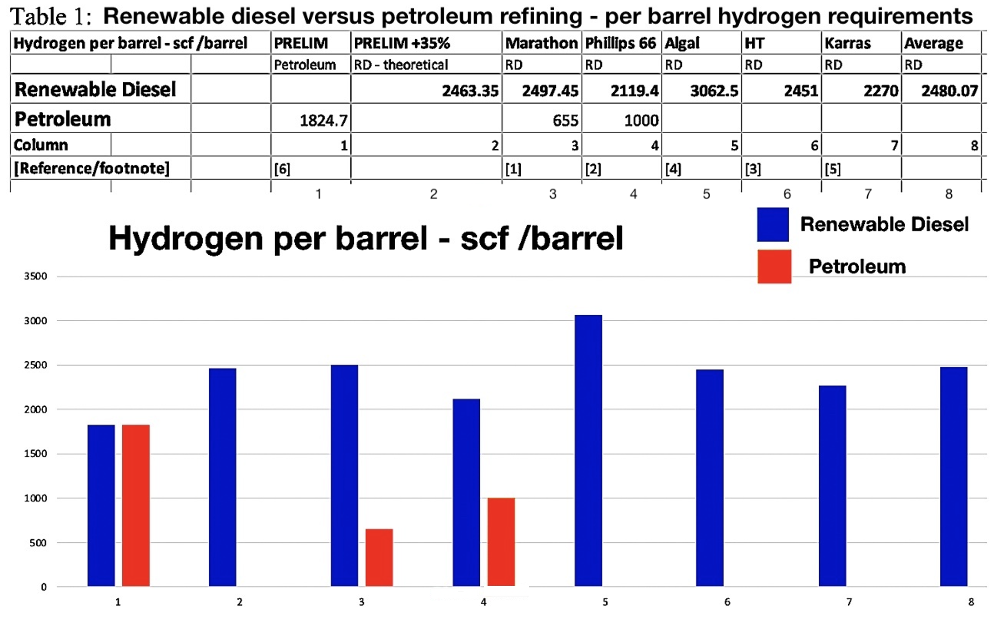

According to the Draft Environmental Impact Report (DEIR) projected CO2 data for the Marathon Renewable Project, Marathon claims a reduction in carbon dioxide greenhouse gasses of 60% for producing renewable diesel, compared to refining petroleum. However, that 60% CO2 reduction comes entirely from the 60% smaller daily refinery throughput specified by the project and is distinctly not from any decreased carbon intensity for refining renewable diesel, itself.

Similar for Phillips 66’s Rodeo Renewed Project’s decreased project throughput, according to the project’s DEIR data, the refinery will experience a minimum 33% decrease in throughput (from a 4-year pre-COVID average capacity utilization) of 105,000 barrels per day to a maximum of 80,000 bpd. However, for both refineries, the per barrel CO2 carbon intensities for renewable diesel will actually increase significantly (despite the decrease in throughput), because of the corresponding large increase in hydrogen needed for hydrocracking triglyceride oils.

For example, despite the shimmer of Marathon’s 60% decrease in throughput, a simple look at their 42% increase in total hydrogen production (made from fossil-fuels), combined with their simultaneous large decrease in throughput, results in a 32% per barrel increase in carbon intensity at the refinery level.

Again, similar to Marathon, post-Project refinery-wide, Phillips will be producing 35% more hydrogen than with petroleum refining and delivering a renewable diesel product with a 36%-to-55% increase in per barrel Carbon Intensity at the refinery level.

The projected Phillips 66 and Marathon Renewable Diesel products, when compared to the processing energy requirements for heavy petroleum refining, would be twice as carbon intensive as the average U.S. refinery’s processing of petroleum and as high or higher than the most carbon intensive refineries. [Table II and references 1-7]
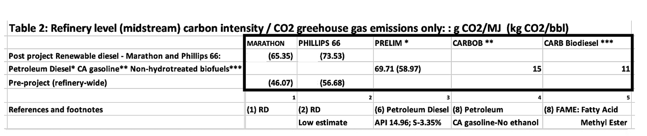

III.
Similar to CARB’s Draft 2022 Scoping Plan, the U.S. Senate’s Build Back Better bill also proposed large-scale Carbon Capture and Sequestration (CCS) of refineries, electricity plants and heavy industry. Total CCS proposals in the United States would require more CO2 pipeline to be installed than the total oil pipeline milage currently in place in the entire country. (8,9) https://www.eenews.net/articles/big-payout-more-co2-greens-split-over-dems-ccs-plan/

https://news.bloombergtax.com/daily-tax-report/carbon-capture-eyed-for-reconciliation-after-infrastructure-wins?utm_campaign=0000017b-076d-d723-a17f-17ef43810001&utm_medium=DTNW&utm_source=rss

There are five main reasons why CCS is actually a dangerous false solution: 1) it is not determined to be safe when deployed at a large-scale, 2) it is not determined to be permanent, 3) it is extremely energy-intensive (raising the total plant energy needs and CO2 production) just to accomplish effective sequestration or attempt to accomplish, 4) it would be enormously expensive, and 5) in the not-too-distant future, it will be considered an iconic “false solution” by redirecting massive financial and industrial resources away from promising green low-carbon technologies, in order to preserve fossil fuel-dependent industries.

Importantly, CO2 is slightly heavier than ambient air, so it tends to hug the ground, so a large enough leak in a source could pose a physical danger by asphyxiation. This is not theoretical. In the report “Gassing Satartia: Carbon Dioxide Pipeline Linked To Mass Poisoning.”, it states that on February 22, 2020 “it was just after 7 p.m. when residents of Satartia, Mississippi, started smelling rotten eggs. Then a greenish cloud rolled across Route 433 and settled into the valley surrounding the little town. Within minutes, people were inside the cloud, gasping for air, nauseated and dazed.” The cause was a CCS gas pipeline leak by a Denbury Inc, pipeline then known as Denbury Resources, which operates a network of CO2 pipelines in the Gulf Coast area that inject the gas into oil fields to force out more petroleum. The report also stated: “While ambient CO2 is odorless, colorless and heavier than air, the industrial CO2 in Denbury’s pipeline has been compressed into a liquid, which is pumped through pipelines under high pressure. A rupture in this kind of pipeline sends CO2 gushing out in a dense, powdery white cloud that sinks to the ground and is cold enough to make steel so brittle it can be smashed with a sledgehammer.” The CO2 leak also contained hydrogen sulfide, causing the rotten egg smell.

Illustrating a potentialLY fatal outcome of a large CO2 leak in a populated area, in 1986, in Lake Nyos Cameroon, a pocket of magma, which lies beneath the lake, leaked CO2 into the water, changing it into carbonic acids. Lake Nyos is one of only three lakes known to be saturated with carbon dioxide in this way, and therefore prone to “limnic eruptions”.

In 1986, possibly as the result of a landslide, Lake Nyos suddenly emitted a large cloud of CO2, which suffocated 1,746 people and 3,500 livestock in nearby towns and villages. Though not completely unprecedented, it was the first known large-scale asphyxiation caused by a natural event.

To prevent a recurrence, a degassing tube that siphons water from the bottom layers to the top, allowing the carbon dioxide to leak in safe quantities, was installed in 2001. Two additional tubes were installed in 2011.

Today, the lake also poses a threat because its natural wall is weakening. A geological tremor could cause this natural levee to give way, allowing water to rush into downstream villages all the way into Nigeria and allowing large amounts of carbon dioxide to escape.

California is, by far, the most earthquake prone place in the US and pipelines are not immune to earthquake damage, much less, other causes of pipeline leaks. This make CCS in California a potential unsafe endeavor, all the while, as CCS pilot projects have already been approved for refineries, (such as by WestCarb, a subsidiary of Shell Petroleum, for one Bay Area refinery).

Regarding the efficiency of CCS, according to Stanford Professor Mark Jacobson, in the 2019 research paper entitled: “The health and climate impacts of carbon capture and direct air capture”, he states that:

“Data from a coal with carbon capture and use (CCU) plant and a synthetic direct air carbon capture and use (SDACCU) plant are analyzed for the equipment's ability, alone, to reduce CO2. In both plants, natural gas turbines power the equipment. A net of only 10.8% of the CCU plant's CO2-equivalent (CO2e) emissions and 10.5% of the CO2 removed from the air by the SDACCU plant are captured over 20 years, and only 20–31%, are captured over 100 years. The low net capture rates are due to uncaptured combustion emissions from natural gas used to power the equipment, uncaptured upstream emissions, and, in the case of CCU, uncaptured coal combustion emissions. Moreover, the CCU and SDACCU plants both increase air pollution and total social costs relative to no capture. Using wind to power the equipment reduces CO2e relative to using natural gas but still allows air pollution emissions to continue and increases the total social cost relative to no carbon capture.” 91https://research.american.edu/carbonremoval/2019/11/13/jacobson-mark-2019-why-carbon-capture-and-direct-air-capture-cause-more-damage-than-good-to-climate-and-health/

The huge energy expenditure needed to capture CO2, compress it, build massive pipeline networks and then inject the CO2 deep underground will far outweigh any supposed greenhouse gas savings being proposed within the CARB Draft 2022 Scoping Plan. CCS is a far too expensive diversion from the real need to authentically decarbonize the economy at the appropriate, acceptable pace and in conjunction with real solutions with a better track record in terms of technology advancements and safety. While large scale CCS would cost hundreds of billions of dollars, in actuality, CCS should be considered an iconic false solution, with powerful backing by industry, certain benefitting building trades unions and many persons within the political sphere.

REFERENCES (To section II only]:

1) Marathon Renewable Project (Martinez CA; Image from MPC company PowerPoint Presentation, used for calculations) and

FEIR: Martinez Refinery Renewable Fuels Project Final ENVIRONMENTAL IMPACT REPORT MARCH 2022. https://www.contracosta.ca.gov/DocumentCenter/View/74460/Martinez-Refinery-Renewable-Fuels-Project-FEIR

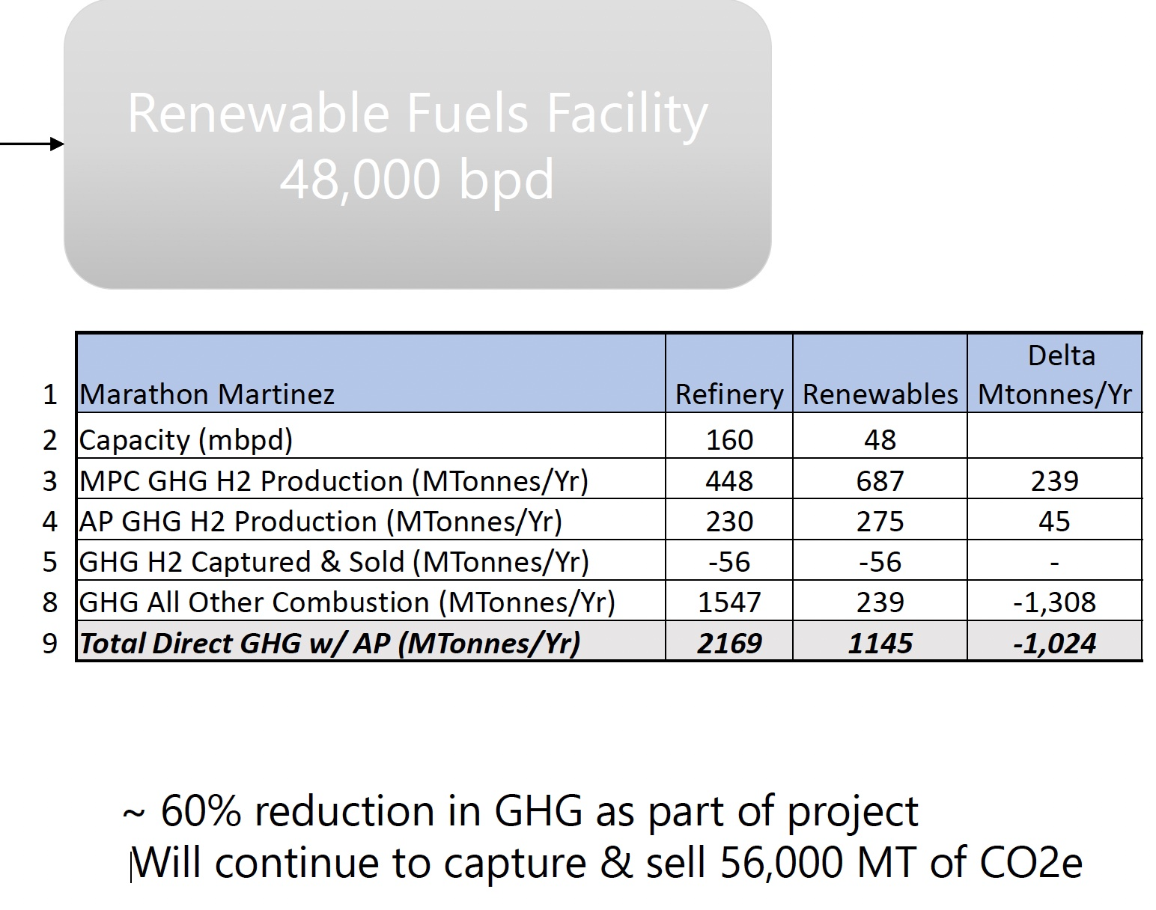

Post-project to pre-project hydrogen plant CO2:
962,000 MT/y from pre-project 678,000 MT kg/y

Post-to-Pre project hydrogen production increase (ratio):
962 MT/y / 678 MT/y = 1.42 + 42% (increase in post-project H2-plant CO2 emissions)

Pre-project hydrogen production per barrel:
678,000 MT kg/y / * 1,000 kg/MT / 365 d/y/ 9.3 gCO2/gH2 / 129,000 bbl/d* 423 scf/kg = 654.94 scf/bbl = 1.55 kgH2/bbl

Post-project refinery-made hydrogen per barrel (see reference 7 regarding SMR 9.3 g CO2/g H2):
962,000 MT/y * 1,000 kg/MT / 9.3 (g CO2/g H2) / 365 d/y / 48,000 bbl/d (Post-project) * 423scg/kg = 2497.46 scf/bbl = 5.9 kgH2 /bbl

Pre-to-Post project hydrogen production increase (project total):
962 MT/y / 678 MT/y= 1.42 + 42% (increase in total H2-plant CO2 emissions)

Pre-Project total annual refinery CO2 (Annual CO2 GHG-to-bbl/y ratio):
2,169,000,000 (kg CO2/y) / 47,085,000 bbl/y = 46.07 kg CO2/bbl 46.07

Post-project Carbon Intensity (CO2 GHG/y-to-bbl/y ratio and g CO2/MJ ):
1,145,000,000 kg/y / 17,520,000 bbl/y = 65.35 CO2 kg/bbl

- Phillips 66 Rodeo Renewed Project DEIR, CO2 emissions data:

Rodeo Renewed Project Draft Environmental Impact Report County File No. CDLP20-02040 State Clearinghouse No. 2020120330 October 2021. https://www.contracosta.ca.gov/DocumentCenter/View/72880/Rodeo-Renewed-Project-DEIR-October-2021-PDF

Rodeo Renewed Project FEIR Appendix B Air Quality and GHG Emissions Technical Data (PDF). https://www.contracosta.ca.gov/DocumentCenter/View/74540/Rodeo-Renewed-Project-FEIR-Appendix-B-Air-Quality-and-GHG-Emissions-Technical-Data-PDF

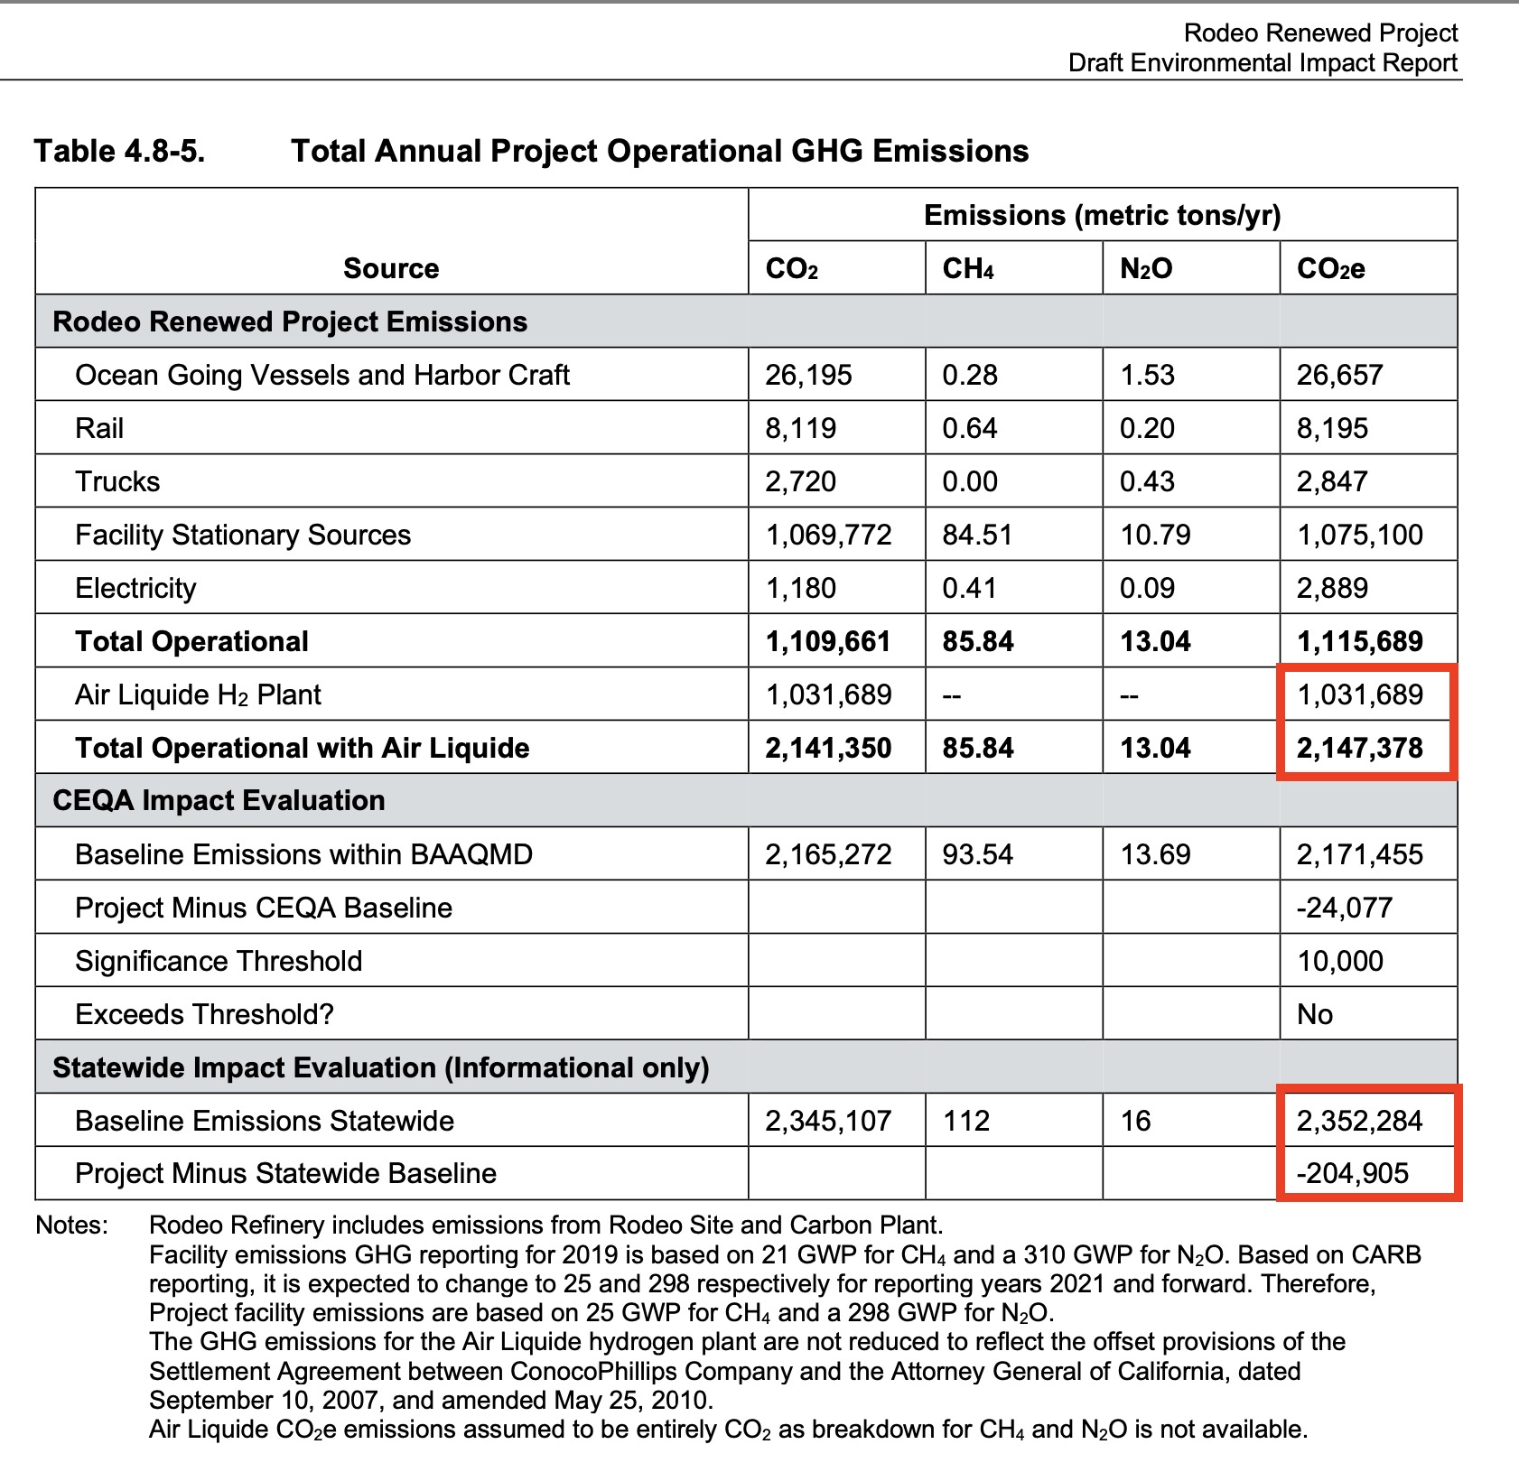

2c) Air Liquide Hydrogen Plant H2 production; Table 15; Attachment B, Appendix B:
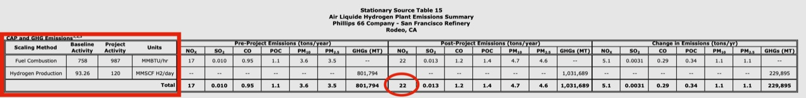
2d) Unit U110 Phillips 66 Hydrogen Plant H2 Production; table 13; Attachment B, Appendix B:
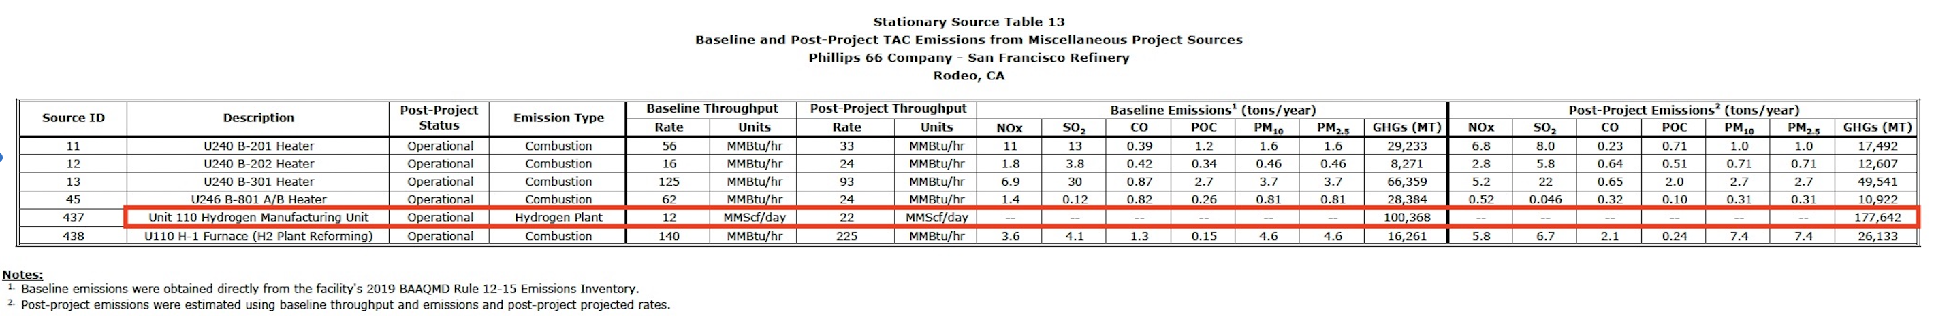

REFINERY THROUGHPUT; HYDROGEN PRODUCTION: REFINERY-WIDE: AND PER BARREL:

Pre-to-Post total refinery-wide project hydrogen production increase (total from Air Liquide and unit U110):
(120 mscf +22mscf ) / (93 mscf + 12 mscf) = 142 mscf / 105 mscf = 1.35 +35% (increase in H2 production)

Pre-project per barrel refinery-made hydrogen:
105,000,000 scf / 105,000 bbl/d = 1,000 scf/bbl [* 1/423 kg/scf] = 2.36 kg CO2/bbl

Post-project average per barrel refinery-wide hydrogen:
142,000,000 mscf / 67,000 bbl = 2119.40 scf/bbl [* 1/423kg/scf ] = 5.01 kg CO2/bbl

Pre-to-post average per barrel refinery-wide hydrogen production ratio:
2119.40 mcf /1,000 scf = 2.12 120% increase

REFINERY CO2 EMISSIONS AND PER BARREL CO2 EMISSIONS:

Post Project: total refinery CO2 per barrel (low estimate ie, Rodeo Renewed Project 67,000 bbl/d PLUS Nustar Soybean Oil Project 12,000 bbl/day):
Barrels: 80,000 bbl/d * 365 = 29,200,000 bbl/y
CO2 Refinery-wide total: 2,147,000 MT/y = 2,147,000,000 kg/y
Carbon Intensity (GHG-to-BPD ratio): 2,147,000,000 kg/y / 29,200,000 bbl = 73.53 kg CO2/bbl

Post Project: total refinery CO2 per barrel (high estimate; neglecting lower hydrotreating H2 needs compared to using hydrocracking CO2 GHGs):
Barrels: 67,000 bbl/d * 365 = 24,455,000 bbl/y
CO2 Refinery-wide total: 2,147,000 MT/y = 2.147,000,000 kg/y
Carbon Intensity (GHG-to-BPD ratio): 2,147,000,000 kg/y / 24,455,000 bbl/y = 87.79 CO2 kg/bbl

Pre-to-Post project per barrel change in Carbon Intensity (Relative %):
a. 73.53 / 56.68 = 1.3 = + 30% 30% increase in CI (low est.)
b. 87.79 / 56.68 = = 1.55 = + 55% 55% % increase in CI (high est.)

3) Hydrotreating in the production of green diesel. Rasmus Egeberg, Niels Michaelsen, Lars Skyum and Per Zeuthen. Haldor Topsøe.
“As the reactions also consume large amounts of hydrogen (for a 100% renewable feed, a hydrogen consumption of 300–400 Nm3/m3 is not unusual), higher make-up hydrogen and quench gas flows are needed even when co-processing quite small amounts.“
400 (Nm3/m3) = 400 (Nm3/m3) / 6.2 (bbl/MT) * 38 (scf/Nm3/m3) = 2451.61 scf/bbl
(2451 / 423 ) = 5.79 kg/bbl * 9.3 = 53.85 CO2 kg/bbl (hydrogen-production only)

300 (Nm3/m3) = 400 (Nm3/m3) / 6.2 (bbl/MT) * 38 (scf/Nm3/m3) * 0.75 [(300nM3/M3) / 400 (NM3/M3)]= 1838.70 scf/bbl = (1838.7 / 423) = 4.34 kg/bbl = 40.36 CO2 kg/bbl (hydrogen-production only).

4) PATENTED HYDROCRACKER HYDROGEN USAGE FOR AGAEL BIOFUELS REFINING COMPARED TO SOY OIL. [Pub.No.:US2010/0297749A1 ARAVANIS et al. METHODS AND SYSTEMS FOR BIOFUEL PRODUCTION. Pub.Date: Nov.25,2010] (12)

For comparison of algael oil hydrorefining to soy oil and heavy petroleum hydrorefining, a patented algael biofuels protocol was described for hydrocracking, plus hydroisomerization and feedstock hydrotreating, of 80 barrels per day throughput using 245,000 scfd of hydrogen plant H2. The total hydrogen volume required for the described “Integrated Biofuels Refinery” for algael oil is 3,063 scf per barrel, which would place the algael fuel hydrocracker hydrogen consumption at the upper (heavy petroleum) end of the 1,000-3,000 scf per barrel range. Similar large- and small-size algael biofuels hydrorefinery configurations were described in the patent.

5) Changing Hydrocarbons Midstream. Karras, Greg. Community Energy Resource. Table 2. https://www.energy-resource.com/_files/ugd/bd8505_757a3372387d46358c74d958d158fcb5.pdf

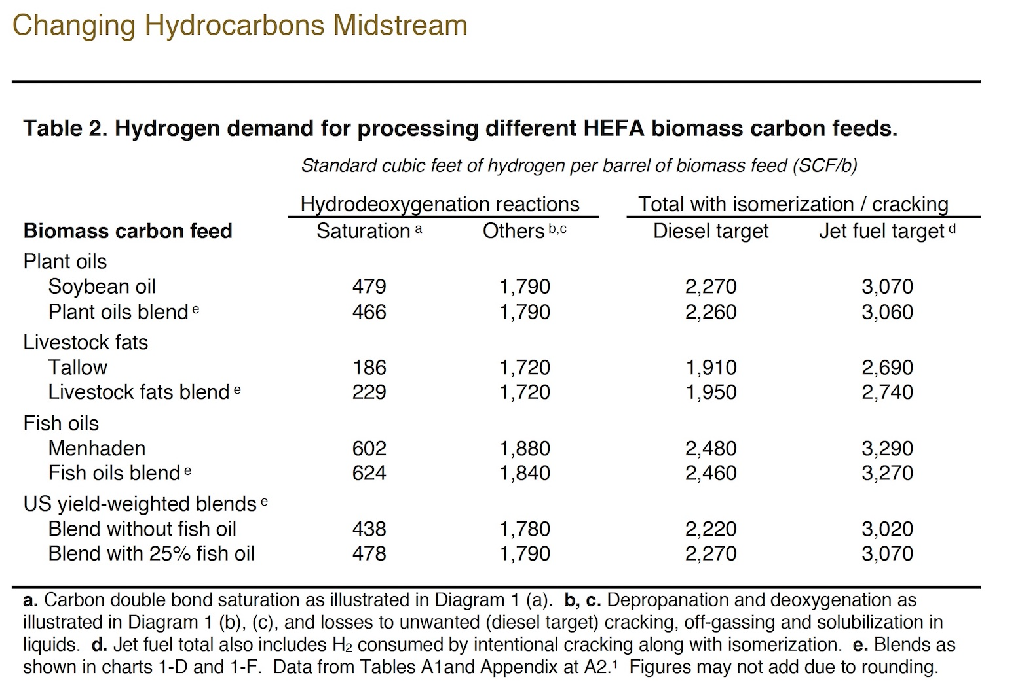

6) Petroleum Refinery Life Cycle Inventory Model (PRELIM) PRELIM v1.3. User guide and technical documentation. Jessica P. Abella et al. [Joule A. Bergerson]
https://www.ucalgary.ca/sites/default/files/teams/477/prelim-v1.3-documentation.pdf
PRELIM 1.3 Hydrocracker with heavy, high-sulfur petroleum feedstock:
14.96 API and 3.35% Sulfur
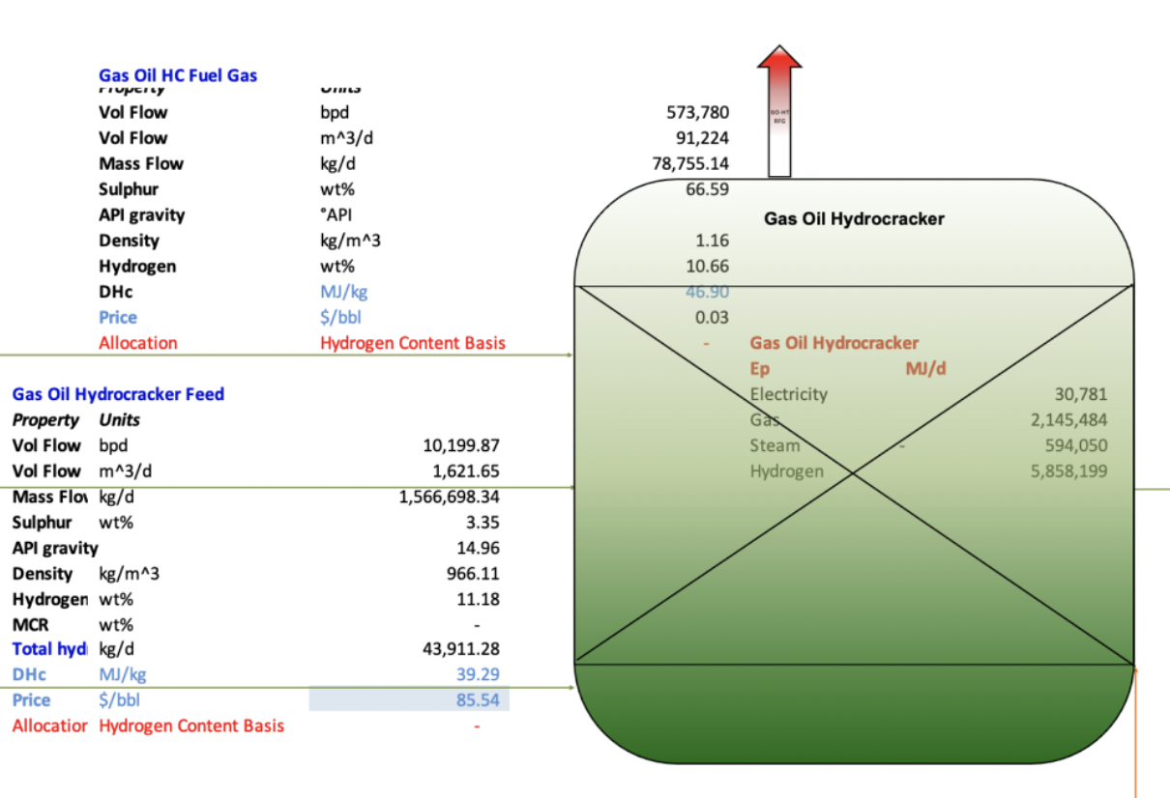
PRELIM 1.3 heavy petroleum Hydrocracker (Gravity API 14.96 and Sulfur 3.35%):

Hydrocracker carbon intensity (CI) per day (total):
5.858,000 (H2)+2,145,000 (NG)+594,000 (steam)+31,000(e) = 8,628,000 MJ/d

Share of total hydrocracker energy (CI) above hydrogen plant-only energy:
8,628,000 (total) MJ/ 5,858,000 H2 MJ = 1.47

Hydrogen required, per barrel:
(44,000 kg H2/d / 10,200 bbl/d = 4.3 kg H2/bbl) * 423 scf/kg H2 = 1824.70 scf /bbl

Hydrogen-plants daily CO2 emissions per day:
44000 kg H2/d * 1000 g/kg * 9.3 = 409,200,000 g CO2/d = 409,200 kg CO2 /d = 409.2 MT/d

Hydrocracking CO2 emissions per day (NOTE: total H2 plant plus hydrocracker unit):
44,000 kg H2/d * 1,000 g/kg * 9.3 gCO2/gH2 * 1.47 = 601,524,000 g CO2/d = 601,524 kg CO2 /d = 601.5 MT CO2/d

PRELIM CO2 emissions, per barrel: (44,000 / 10,200 * 1.47 = 6.34) * 9.3 = 58.97 kg CO2 /bbl
PRELIM Carbon Intensity: 601,524,000 g/d CO2 / 8,628,000 MJ/d = 69.71 g/MJ

7) Updates of Hydrogen Production from SMR Process in GREET® 2019. P. Sun, A. Elgowainy. (September 30, 2019)
https://greet.es.anl.gov/publication-smr_h2_2019

8) Big payout, more CO2: Greens split over Dems’ CCS plan. ClimateWire. Benjamin Storrow (12/16/2021) https://www.eenews.net/articles/big-payout-more-co2-greens-split-over-dems-ccs-plan/

9) Carbon Capture Eyed for Reconciliation After Infrastructure Wins
BloombergTax. (Aug. 2, 2021) https://news.bloombergtax.com/daily-tax-report/carbon-capture-eyed-for-reconciliation-after-infrastructure-wins?utm_campaign=0000017b-076d-d723-a17f-17ef43810001&utm_medium=DTNW&utm_source=rss

10) Jacobson, Mark (2019). Why Carbon Capture and Direct Air Capture Cause More Damage than Good to Climate and Health. Institute for Carbon Removal Law & Policy - American University. Jacobson, Mark. (November 13, 2019). https://research.american.edu/carbonremoval/2019/11/13/jacobson-mark-2019-why-carbon-capture-and-direct-air-capture-cause-more-damage-than-good-to-climate-and-health/

