COMMENTS FILED: HTTP://WWW.ARB.CA.GOV/LISPUB/COMM/BCLIST.PHP
January 16, 2017
Mary D. Nichols-Chair
California Environmental Protection Agency Air Resources Board
1001 “I” Street Sacramento, CA

RE: (2016SLCP) Public Comments on the Revised Proposed Short-Lived Climate Pollutant Reduction Strategy – November 2016
Dear Ms. Nichols
Traulsen, a division of the ITW Food Equipment Group, LLC, in Fort Worth, Texas, U.S.A., appreciates the opportunity to provide comments on the Air Resources Board’s Short Lived Climate Pollutant Reduction Strategy Draft as issued November 2016.
Traulsen is always anticipating our diverse markets needs and works proactively to seek other environmentally sustainable endeavors that promote responsible resource usage, energy savings and overall good stewardship practices. Our organization, together with the efforts of our 400+ employees, is taking steps to further reduce our greenhouse gas (GHG) output without bringing about a number of unintended consequences that could affect the ability for us to provide our customers, not just in California, but throughout the United States with safe, energy efficient and climate friendly equipment.
In choosing the refrigerants for our equipment classification, largely self-contained or “stand-alone” in nature, we are limited to those choices approved by the United States Environmental Protection Agency’s (US-EPA) Significant New Alternatives Policy Program (SNAP). Since our last comments were filed in 2015, the US-EPA has added several additional non-flammable alternatives for the Retail Food Refrigeration category, which also includes food processing and dispensing equipment types. These alternatives, R448A (GWP 1,387), R-449A (GWP 1,400) and R449B (GWP 1,412) are still well over the 150 GWP target that California has proposed and leaves a large gap between available refrigerants that are flammable vs those that are not.
Traulsen would like to point out that the US-EPA has not changed their opinions regarding the category listed as “Commercial Refrigeration”. The brunt of “fugitive” high GWP emissions originates from the remote supermarket type installations with greater than a 50 pound charge. Most equipment in the self-contained, stand-alone category has less than a 5 pound charge within a sealed system.
We continue to encourage California to focus on the broader concerns it seeks to correct in all future rulemaking, especially as it relates to requiring an aggressive 150 GWP or lower limit on the small self-contained “stand-alone” equipment category used in many commercial and institutional setting:
- The overall carbon footprint of all equipment in the sectors addressed by ARB should be considered -- meaning that the equipment’s energy efficiency gains should not be sacrificed in the process of adopting a strategy that is overly aggressive.
- All accelerated phase-down targets should be set based on commercially available technology today which is not already in use by the majority of the market.
- Food safety and public health are the highest priority of equipment designs.
- Current building codes are fragmented and out of date at the local, state and federal level and many jurisdictions do not allow certain flammable refrigerants or limit the amount of flammable substances used in servicing.
- A hybrid approach that deals with phase down targets and sensible GWP limits for remaining substances should be adopted regarding HFC’s rather than a total “ban” in sectors where the equipment application is broad.
- Any solution for the equipment end-user will be more successful with encouragement though incentives and other voluntary measures.
CONCLUSION
Traulsen continues to invest heavily in expanding its Green product line. However, our analysis shows that adopting too aggressive of a timeline industry-wide will bring about a number of unintended consequences:
- The equipment covered under the Commercial Refrigeration category is too broad. Self-contained, stand-alone commercial refrigeration category has far less impact in its contribution to overall GHG emissions than large, remote systems and air conditioning.
- Flammable, high pressure or caustic natural refrigerants while low in GWP require a redesign and have a system complexity within this market leading to a dramatic and sudden reduction in the variety of product applications offered in the marketplace. Many solutions have yet to have adequate technology reach the market.
- Both building codes and customer acceptance of the natural refrigerants, especially those that are flammable are still lagging throughout the United States.
- The US-EPA has not yet approved a number of low GWP HFO’s that are non-flammable in the Commercial Retail Food sector which would fill the gap between the current flammable low GWP offerings and those that would be more easily switched to.
An allowance for our small sector to continue our work in the consideration of the new blends that are under review can help reach the same desired outcome of the scoping plan. Therefore, Traulsen respectfully proposes that California balance the objectives by continuing to harmonize with the US-EPA for removal of HFC refrigerants used self-contained, stand-alone commercial refrigeration and blown foam products.
Should you have any questions about statements made in this document, we will be happy to follow up with additional confidential data in the matter.
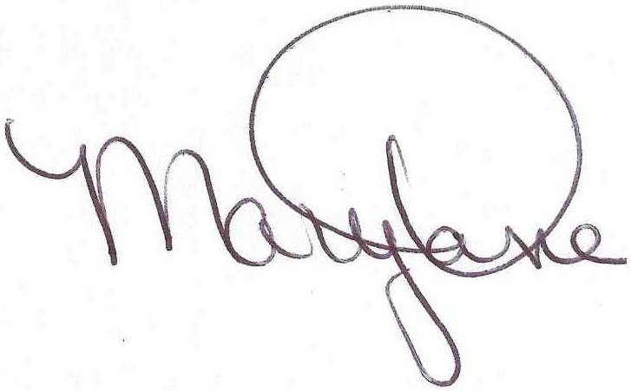
Sincerely

Mary Dane
Agency Approval Engineer
Traulsen/Kairak-ITW Food Equipment Group
4401 Blue Mound Rd.
Fort Worth, TX 76106

Final Rule, October 11, 2016 FR 70029.
Retail food refrigeration, or commercial refrigeration, includes equipment designed to store, display, process, or dispense chilled or frozen goods for commercial sale. This end-use includes these categories of equipment: stand-alone equipment, remote condensing units, supermarket systems, and refrigerated food processing and dispensing equipment. (https://www.epa.gov/snap/refrigeration-and-air-conditioning)

