November 13, 2015

The Honorable Matt Rodriquez Ms. Mary D. Nichols, Chair
California Environmental Protection Agency California Air Resources Board
PO Box 2815 1001 I Street
Sacramento, CA 95812 Sacramento, CA 95812

Re: Comments on Draft Cap & Trade Investment Proceeds Second Investment Plan

Dear Secretary Rodriquez and Chairman Nichols:

We appreciate the opportunity to provide comments on the proposed Cap & Trade Investment Proceeds Second Investment Plan on behalf of the League of California Cities, the California State Association of Counties, and the Institute for Local Government. Through a wide array of local initiatives, city and county leaders, in partnership with the state, have pioneered innovative approaches to reduce greenhouse gas emissions, conserve energy, water and other resources, and promote more sustainable communities.

For several years, our associations, in concert with other voices from local communities, have expressed our conviction that greater state support for effective local climate action (such as the voluntary local initiatives supported and recognized through the Beacon climate action, energy and sustainability program) is a fundamental key to the success of California’s ambitious efforts to reduce GHG emissions.

We were gratified to see that the draft Investment Plan includes a potential cross-cutting approach for a more holistic and integrated local climate action program (see pages 28-29.) The League of Cities, CSAC and ILG would like to work with the Administration and the Legislature to build on this concept to craft an effective program for local climate action. We believe that a cross-cutting local climate action program supported with a significant investment through the Greenhouse Gas Reduction Fund should reflect the following principles:

- A cross-cutting local climate action program should foster local creativity and innovation, empowering local communities to take advantage of GGRF funding from multiple sources so that combined projects that achieve greater GHG results and co-benefits can be realized.
- Local governments should play a pivotal role in identifying, proposing, and implementing cross-cutting GHG emission reduction projects and programs in their communities, based on local needs, readiness, priorities and circumstances.
- Effective methods to facilitate community participation, engagement and education should be incorporated into local agency efforts to identify, propose, implement, monitor and report on cross-cutting climate action projects and programs.
- The cross-cutting program should provide significant benefits to disadvantaged communities, but eligibility for participation should not be limited only to those communities.
- To avoid program delay, duplicative efforts or wide gaps in the ability of individual local jurisdictions to participate in the cross-cutting local climate action program, state support for the statewide Beacon program should be augmented. This would provide jurisdictions with a proven and effective shared platform for emissions inventories, tracking, monitoring, and reporting; documentation and dissemination of best practices; assistance with public engagement and convening; and peer learning and technical assistance.

Thank you for the opportunity to provide these comments. On behalf of our organizations and the thousands of local officials they represent, we look forward to continuing our collaborative partnership with your agencies and the Administration as we work together to implement effective programs to reduce GHG emissions and address the shared challenge posed by climate change.

Sincerely,

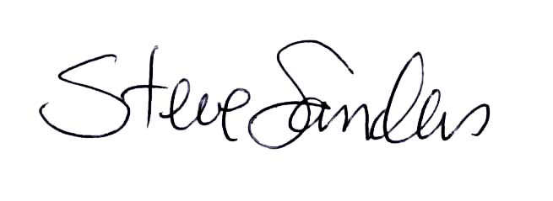
Cara Martinson Jason Rhine Steve Sanders
Legislative Representative Legislative Representative Program Director
CSAC League of California Cities ILG
cmartinson@counties.org jrhine@cacities.org ssanders@ca-ilg.org

