June 24, 2022

Clerk of the Board
California Air Resources Board
1011 I Street
Sacramento, CA 95814

RE: Notice of Public Meeting to Consider the Draft 2022 Climate Change Scoping Plan (scopingplan2022)

Comments Submitted Electronically via: https://ww2.arb.ca.gov/applications/public-comments

To: Liane M. Randolph, Chair
California Air Resources Board
1011 I Street
P.O. Box 2815
Sacramento, CA 95812

Dear Madam Chair:

These comments are submitted by the California Forestry Association (Calforests) and address the Air Resources Board (ARB) Draft 2022 Climate Change Scoping Plan and Appendix I, Natural and Working Lands (NWL) Technical Support Documentation.

Calforests is the preeminent trade association and advocate for the state’s forest industry. Collectively, our members – private forestland owners – manage nearly 3.5 million acres of forest land throughout the state and operate nearly the entirety of the state’s forest products infrastructure, including sawmills, veneer mills, biomass power plants and several Licensed Timber Operators.

Summary of Calforests Comments:

Calforests offers several comments, with a particular focus on the following subject matter:

- Disparities between State Department responsible for analyzing carbon stocks of forestlands
- Reforestation
- Consideration of forest biomass utilization
- Modeling efforts based on forest inventory data from 2001- 2014, when substantial inventory data covering 2015-2021exists and demonstrates that wildfires have already dramatically altered the landscape surpassing all forecasting
- Other (Funding Sources)

- Comments on the Draft 2022 Climate Change Scoping Plan and Appendix I, Natural and Working Lands Technical Support Documentation, are provided in groups of comments by each of the above five focus areas. Comments that are responding to a specific page(s) in the draft Scoping Plan or Appendix I are included below.

- Disparities between State Department responsible for analyzing carbon stocks of forestlands:
Calforests is aware of several ongoing state efforts relating to analyzing carbon stocks within the forested landscapes of California, with one of those associated with the Natural Working Lands effort that the DRAFT Scoping Plan relies upon. The other ongoing effort, which is an annual update on forest carbon stocks, is being conducted by the State Board of Forestry and Fire Protection.

While it is often the case that parallel efforts can generate varied outcomes based upon selected methods, models, or foundational data sources, the disparity between reported outcomes as they relate to annual rates of sequestration and storage, or emissions, is dramatic and widely disparate. In fact, the departure between these efforts reports a variance of nearly 80 million metric tons (MMT) of annual contribution of forestlands to the carbon ledger.
Significant investments made by the State on both ongoing assessments, as well as the expertise that exists within the supporting agencies, should produce better alignment as it relates to outcomes. Calforests, therefore, respectfully requests that clarity be provided on the variations of methods and metrics relied upon by the Air Resources Board (ARB) that have resulted in outcomes for forest impacts on atmospheric carbon that diverge dramatically from the ongoing work published by the State Board of Forestry and Fire Protection (BoF) (see ARB/BoF Forest Carbon inventory comparison at: https://bof.fire.ca.gov/media/cg5pu4ii/full-15 nwl_bof_forest_c_inventory_comparisons_v3.pdf ). Calforests believes this presentation outlines the opportunities to utilize forest biomass and why the ARB modeling assumptions are biased towards residues being left in the forest.

Calforests strongly urges that strong collaboration with the Board of Forestry and Fire Protection be developed to rectify the large disparity reported on the benefits or emissions of forests, and in doing so, take into consideration the above provided comments to assist in guiding that cooperative effort with new scenario modeling that more accurately represents the impact of forestlands on the state’s carbon balance sheet into the future.

- Reforestation

Calforests could not find any specific discussion regarding reforestation. We believe reforestation must be a key element of the modeling and reporting.

Reforestation plays a significant role in the practice of forestry. Silviculture, generally defined, is the practice of controlling growth, density, and structure for the purposes of propagating forests for the multi-use benefit include wildlife, timber, water resources, restoration, and carbon sequestration. Silviculture, particularly as it relates to certain even-aged prescriptions, include artificial reforestation, while some prescriptions, such as uneven-age, generally rely upon natural regeneration.

Regarding wildfire impacts, the benefit to long term carbon benefit commences with artificial regeneration, which is fully embraced by members of Calforests. Well stocked and well managed early successional stands of forests are of a significant benefit in terms of rates of, and capacity for, long term sequestration.
Therefore, Calforests respectfully requests that clarity be provided on the inputs into the model relied on to develop the preferred alternative and how those models accurately convey the long-term benefits of reforestation implemented on well managed timberlands in contrast to lands, particular those lands impacted through wildfire, which do not receive immediate artificial regeneration and maintenance.

- Consideration of forest biomass utilization:
Biomass material, or waste, in the vernacular of forest management, references the small diameter woody materials that is generated when management actions or natural disturbances occur.

The draft Scoping Plan indicates that the preferred treatment of forest biomass is to leave this material in place to decay or to open-burn the material in lieu of collection and use for alternative sources of wood-based products or energy. This finding appears to apply to both treatment of green forests as well as during restoration of burned forests.

While there are many issues facing forests in California, biomass is arguably the greatest challenge. Estimates indicate there are 100 million bone dry tons currently available for transportation, with an additional 20 – 50 million bone dry tons annually being generated as we work toward one million acres of fuels reduction annually.

Estimates of accumulations do not take into consideration the draft Scoping Plan recommendations to significantly increase the number of target acres for fuels reduction annually. The challenging hazard this material represents is staggering, and recommendations for onsite storage and decay or open burning of the majority of this material is not a good solution. Calforests incorporates by reference the CSG Blog posted by Sam Uden "Missed Opportunity: Draft Scoping Plan fails to address biomass pile burning and decay".

Assumptions relied upon to estimate: 1) forest biomass generated by project type and location, 2) collection and mobilization thresholds identified, and 3) the rate of collection of material deemed as “mobilized”, need to be revisited and accurately align with vulnerability that the forested lands, water, wildfire, recreational opportunities, air, and communities surrounding these landscapes currently face.

- Inventory data, wildfire data, and related data sources and analytics
Appendix I, pp. 1, 15, 18, 32, 40, 43, 44, 94-100
Draft Scoping Plan, pp. 63, 72, 90, 197
A shortfall in the NWL is the known climate actions that sequester carbon that were not included in this analysis “due to lack of time, data, science and other resources.” With these comments, we will outline many of the actions that data is directly available and need to be included in this analysis. These comments focus only on the “Forests” land type.
Using data from 2001-2014 renders modeling reliant upon these data limited in value. Data is readily available from the Forest Service Forest Inventory and Analysis (FIA) for 2015 through 2020 and significant information is available for wildfire disturbances 2015-2021. The extreme events of the beetle epidemic (2012-2016) and wildfires (2015-2021) has impacted statewide total CO2equivalent emissions. Incorporation of the most current available data sets would provide accurate outcomes and scenarios and therefore should be completed prior to adoption of a final Scoping Plan.
In order to achieve Scenario 2, 3, or 4, it would seem appropriate to include riparian zone management. Wildfire has devastated riparian zones throughout the Sierra Nevada Mountains. There should be no buffer and certainly not a 90-meter buffer on riparian features. Riparian corridors should receive a separate set of management practices compared to the general forest zone. These practices are well documented by the Board of Forestry and in National Forest Land Management Plans.
Unfortunately using LANDFIRE existing vegetation class for year 2014 renders modeling out of date. The adjustments to the existing vegetation class due to wildfire, insects, and disease are well-established for years 2015-2020 and even substantial data exists for 2021.
Figure 13: Total biomass carbon since 2014 has been dramatically altered by natural disturbances (wildfire, insects, and disease) 2015-2021. Forest inventory data (FIA) exists regarding the spatially explicit impact of disturbances on the landscape 2015-2021. This is demonstrated in the NWL Appendix on page 215 Figure 58: Annual burned area. The dramatic increase in percent change in burned area compared to what is relied upon for modeling appears apparent and should be incorporated and rerun for all the scenarios to increase accuracy. Appendix I, page 214 states that the actual contemporary increased burned area relative to the late 20th century “already far exceeds all model predictions for the entire 21st century.” This appears to provide ample evidence that the modeling is challenged and additional work for accuracy needs to be completed.
Appendix I, page 207, Figure 53: The projected net Ecosystem Carbon Balance is essentially irrelevant. It is explained that the research used is based on forecasting. Figure 53 does not identify the extreme events that the state now experiences regularly. Though difficult to model, extreme events are driving landscape level impacts and, therefore, driving carbon outcomes. Again, the most contemporary data sets must be recognized to support a new modeling effort. This modeling update should be completed to accurately reflect outcomes. As an example of landscape level impacts, Calforests provides the generated below table reporting acres burned state-wide between 2001-2021. While these data do include acres that may have experienced fire repeatedly, and are based upon fire perimeters, these data clearly demonstrate the escalating impact of extreme disturbances in recent years. It appears that capturing and reporting upon this rapid increase in impacts needs to be incorporated within the assessment.
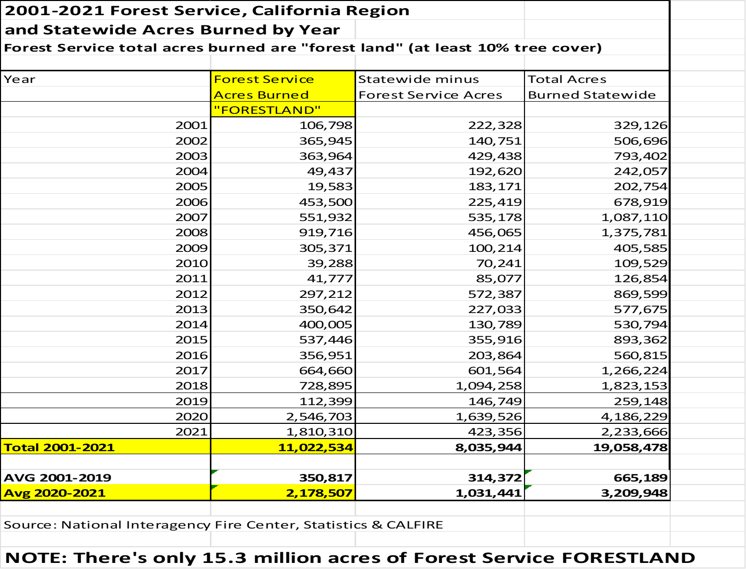
Appendix I, Figure 15 - The Climate data used indicates that it is already out-of-date and perhaps of limited utility, while it is known that data exists through 2020 . With 8 of the last 11 years being dry, precipitation and temperature observations would likely be altered measurably.
Appendix I, Figure 16: Disturbances 2001-2014 is out-of-date. Data for 2015-2021 is readily available.
Appendix I, pp. 94-100 – The Wildfire Emissions section estimates PM2.5 but appears to lack clarity as it relates to the carbon dioxide equivalent emissions reporting. Information is available to estimate CO2 equivalent emissions with decay rates on dead wood left on the landscape (December 2018. Covey etal. “Methane production and emissions in trees and forests.”) Consideration of these data should be included.
It is not clear if NWL modeling has properly accounted for emissions because the accounting of 1) annual vegetative growth, 2) type conversion from wildfire, insects, and disease, 3) decay of dead vegetation left in the forest (including the methane produced from decaying wood), and 4) biomass utilization, is not clear.
Appendix I, Figure 4-20 displays annual burned acres for 2015-2020. Data for year 2021 is also available. Further, ARB has made CO2 equivalent estimates of emissions reductions for each year. It does not appear that these data are displayed and relied upon in the Appendix I analyses. And are emissions from natural disturbances included in Figure 2.4 (page 71) and Figure 2.10 (page 90).
Appendix I, Figure 2-10 – The draft 2022 Scoping Plan reference scenario is likely not accurate in part due to the reliance upon legacy data through 2014 and then forecasting attempts to bring the reported outcomes and scenarios to current times. It appears that draft Appendix I shows that natural disturbances between 2015-2021 have already surpassed forecasting. This methodology is inconsistent and should be rectified.

- Other (Funding Sources)
Draft Scoping Plan, pp. 100, 125, 126, 182
Appendix I, pp. 174, 175, 179

The assumption that all funds for implementing actions are sourced from State funds is not correct. The federal government (Forest Service) has annual appropriations, plus $600 million of Emergency Disaster Relief, and Infrastructure Act funds that likely will be around $400 million/year for five years (2022-2226). The REMI modeling approach assumes only State funding; this needs to be changed to reflect federal funding as well. Further, the Scoping Plan is not clear if Cap-and-Trade funds are included within “State Funds”?

Draft Scoping Plan Table 3-11 does not incorporate the revenue that will be generated from sawtimber removal associated with mechanical thinning and harvest methods. Incorporating sawtimber revenue will likely show an overall net revenue, not fiscal deficits.

The text states Forest Service Transaction Evidence and Appraisal (TEA) was used to estimate “implementation costs” but does not indicate TEA was used to determine revenue from sawtimber removed for the different treatment methods. Hence, net revenue for clearcut, harvesting, and thinning methods is available and should be reflected in Table 62. In Appendix I, page 179, ARB staff state: “it is expected that costs associated with increased commercial harvests would be offset by the revenue generated from the commercial harvest.” The data should have been collected, calculation made, and displayed in Appendix I, Table 62.

Appendix I, pp. 214-215 - After thorough review by the ARB staff of the five studies on wildfire, Staff states “notably the actual observed contemporary increase in burned areas relative to the late 20th Century (1987-2000) already far exceeds all model predictions for the entire 21st century” as shown in Figure 58. Further the literature and observations show that high severity burn has increased from about 20% of total acres burned in 1985 up to 30% in 2010 (2012. Safford etal). Since 2010, the high severity burned percentage has steadily increased (2013 Rim Fire 38%, 2014 King Fire 47%, 2021 Dixie Fire 50%, and the Beckwourth Fire 69%. It is not clear that this data is incorporated in the modeling.

Prior to release of a final draft of the Scoping Plan, Calforests strongly urges the incorporation of the most current Forest Inventory Analysis data and known year 2015-2021 wildfire data into modeling and reporting efforts.

In summary, the statement in Appendix I, page 214 and Figure 58 on page 215 amplify the case that the NWL modeling that relies upon 2001-2014 data is simply not relevant given the natural disturbances that have occurred 2015-2021.

Calforests appreciates the opportunity to comment. If there are any questions regarding our comments, please contact Steve Brink, Vice President-Public Resources

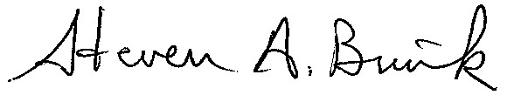
STEVEN A. BRINK
Vice President – Public Resources
916-208-2425
steveb@calforests.org

