Pinal Energy is requesting CARB to consider how carbon dioxide (CO₂) from ethanol fermentation can displace fossil CO₂ in commercial applications and lower the carbon intensity (CI) score for an ethanol fuel pathway. CO₂ captured from industrial processes is used in many industries and should be considered as a co-product for fuel pathways where it can be showed to displace the use of fossil carbon dioxide. Adding CO2 as a co-product will allow the merchant CO2 market to effectively compete with that of the captive CO2 market.
Pinal Energy is a corn ethanol facility located in Maricopa, AZ. Pinal Energy captures the CO₂ from the fermentation process and sells it to Reliant, a primary CO₂ provider, in both liquid and solid forms, for use in the food and drink industry in the Arizona area.

Summary

There is already a provision in the LCFS regulation for CO₂ from ethanol fermentation to be stored by EOR or in permanent geological storage under CARB’s Carbon Capture and Sequestration (“CCS”) protocol. Ethanol plants that implement such a storage protocol can reduce their pathway Carbon Intensity (“CI”). The current CCS protocol unfairly favors ethanol plants that are close to geological storage. The protocol rewards the storage of biogenic CO2 from ethanol fermentation, but it does not have any impact on the quantity of fossil CO ₂ extracted and used in industrial applications. In absolute terms, the total fossil CO2 extraction and use remain the same.
Pinal Energy believes that the LCFS regulation should be modified to allow producers to capture and use biogenic CO₂ in commercial and industrial applications such as the food and drink industry, which will displace fossil CO2 use and result in an actual reduction of fossil CO₂ extraction. The resulting reduction in lifecycle greenhouse gas emissions should be awarded to the fuel pathway. This will allow more equitable treatment of ethanol plants and allow biogenic CO ₂ use to offset fossil CO ₂ in both the merchant and captive CO₂ markets and prevent market distortion.

LCFS Regulatory Context

The LCFS core philosophy is based on the life cycle analysis of greenhouse gas emissions from fuels. One boundary condition is that the regulation only applies to transportation fuels. A more subtle boundary was introduced in 2019 with the addition of carbon capture and sequestration into the regulation. The boundary condition is that carbon dioxide must be sequestered into storage permanently (for 100 years) either by storage into a brine reservoir or by capturing part of the CO₂ during CO₂ Enhanced Oil Recovery. The capture of the carbon dioxide can be used to reduce the Carbon Intensity of a fuel pathway or as a project-based credit generator through the innovative crude or the efficient refinery credit program. The addition of the CCS protocol has closed a potential methodology for reducing pathways CI scores by utilizing captured biogenic CO₂ to displace the use of fossil CO₂. Prior to the update, CARB had allowed Pinal Energy to reduce its pathway CI score by selling biogenic CO₂ capture at their ethanol plant to displace the use of fossil CO₂ in the Arizona market.

The Rationale for Change to LCFS Regulation

Background to Fossil CO2 Extraction EOR and Food and Drink Use.
There are numerous fossil CO₂ production sites in the US, such as Sheep Mountain and McElmo Dome sites in Colorado and Bravo Dome in northeastern New Mexico (Figure 1). These reservoirs produce fossil CO₂ for use in various industries broadly categorized as ‘capital’ and merchant’; the primary method of CO2 use is in the capital market, for EOR. One of the first CO₂ EOR projects was initiated in 1972 in the Kelly-Snider oil field in Texas. After the first CO₂ EOR process was successfully demonstrated, the investment necessary to develop and transport large volumes of fossil CO₂ to the oil fields was put in place. Kinder Morgan built a pipeline across New Mexico that takes fossil CO₂ from Colorado and New Mexico into the Permian Basin oil field in West Texas.
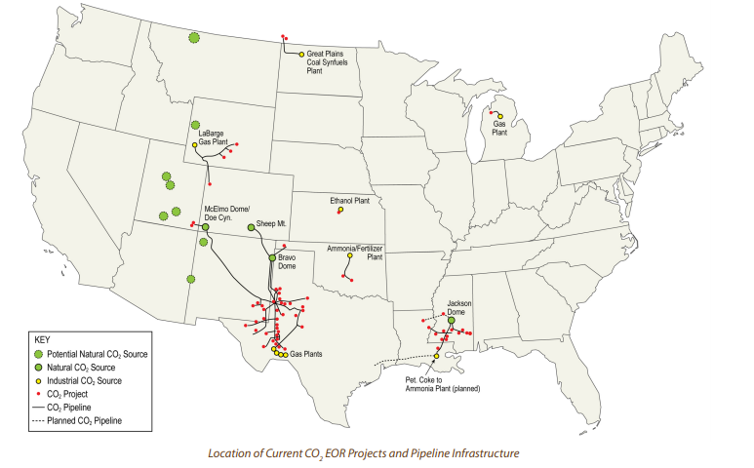
Figure 1
Today CO2 EOR is an essential component of US oil production, accounting for nearly 6% of US onshore oil production, or 350,000 barrels a day. This technique uses CO₂ to increase the production of oil from existing oil fields. In 2010 the West Texas oil field used approximately 1.6 billion cubic feet (90,000 Metric Tons) per day of naturally sourced fossil CO2 for EOR. Around 90% of the CO₂ used in EOR ends up being permanently stored. Therefore, fossil CO2 used in EOR creates a loop of extraction and injection, with a small amount being lost through fugitive emissions into the atmosphere. The use of CO2 in EOR falls into the ‘captive’ CO₂ market, and makes up 89% of demand, with urea synthesis consuming 11%.

CO₂ is also used extensively in the food industry in the ‘merchant’ market, for cooling, freezing (individual quick-frozen foods, “IQF”), extraction, preservation, fertilization, and carbonation. The domestic market for commodity CO₂ has been steadily increasing annually. As the Hemp and Cannabis industry continue to grow, CO₂ demand is expected to keep increasing because it is used for growth and extraction in this industry. CO₂ price has been steadily increasing year over year. In 2015 the merchant market was 11 MMT, 75% of which was used by food processing and in carbonated beverages. Fossil CO2 extracted for the merchant market is ultimately disposed into the atmosphere and contributes to global warming.

CO2 produced from fermentation at an ethanol plant is biogenic CO2; the CO2 disposed into the atmosphere from merchant market activity is absorbed by corn plants from the atmosphere and released again during the ethanol fermentation process. When this CO2 is captured and repurposed for use in the merchant market, it creates a loop: the CO2 disposed of by merchant market activity is absorbed by corn plants, then it is released during fermentation, captured and repurposed for merchant activity to repeat the cycle. This cycle prevents the extraction, use, and disposal of an equivalent volume of new fossil CO2.

The Rationale for Allowing Displacement of Fossil CO2 in Fuel Pathways

Kinder Morgan estimates that the McElmo Dome is approximately 203,000 acres and is one of the world’s most massive known accumulations of nearly pure CO₂ with about 5 trillion cubic feet of recoverable CO₂ remaining to be produced. Production of the CO₂ from the McAlmo dome would take 281 million metric tons of high purity CO₂ out of fossil storage. Some Carbon dioxide is used for EOR, of which a significant percentage is stored permanently in oil production reservoirs, and some go to the food and drink industry.

48 ethanol plants in the US already capture and produce 4.5 million tons of CO_{2; i}n the cases where Carbon dioxide is sourced from corn-ethanol plants, it is not a waste-recovery product but a co-product that, in many regions, can only be replaced by higher-emitting, less-economical resources. Fossil CO₂ extracted from CO₂ domes is significantly less expensive than that from ethanol plants (around $95 per ton delivered). Of the 48 plants producing ethanol, eleven are proximal to geological carbon dioxide sources; allowing the CO₂ from those plants to displace fossil CO2 would reduce the CI of approximately 1 billion gallons of ethanol and generate 3.3 Million Metric tons of carbon credits. Natural geological sources can be the cheapest of all types. When source quality and well-head pressure are ideal, the feedstock is extremely clean, requiring only minor carbon filtration, and the elimination of a feed compressor can save half the power demand⁶.

Displacing the use of the fossil CO₂ with biogenic CO₂ has been shown to reduce the mass of fossil CO₂ being extracted. Here Pinal is a good example; Reliant only draws CO₂ from geological sources for the Phoenix market when Pinal energy is not creating any. Using biogenic CO₂ in the food industry displaces the use of fossil CO₂. Allowing LCFS participants to lower their fuel pathway CI by providing biogenic CO₂ from fuel production aligns with CARBs goals of reducing the CI of fuels in California, and financially rewards fuel producers for capturing and selling their CO₂. In this instance, reducing the use of fossil CO₂ can be achieved without utilizing expensive and complicated engineering and financial instruments that are significant barriers to CCS projects.

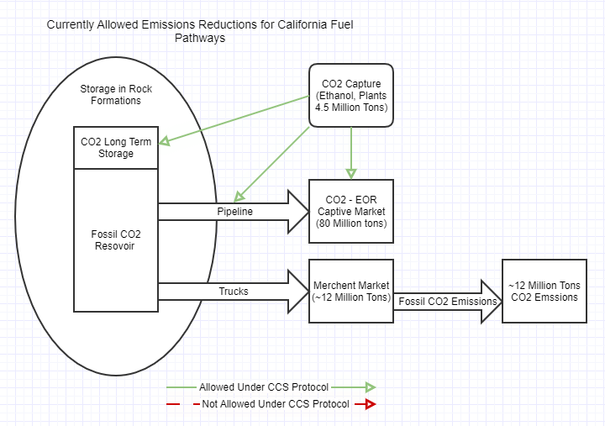

In the above diagram, the CCS protocol allows the injection of biogenic CO₂ into storage, EOR, and a pipeline feeding EOR under the assumption that this CO₂ will remain in the ground. CO₂ from the captive market is able to out-compete the merchant market with the addition of carbon credits.

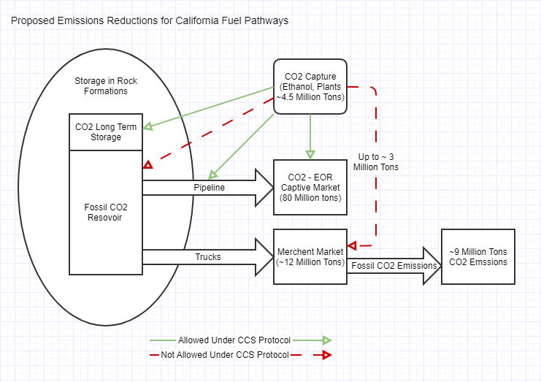

In the proposed change, CO₂ is allowed to be used as a co-product, thus permitting the injection of biogenic CO₂ into the merchant CO₂ supply chain. Capturing this CO2 is equivalent to leaving an equivalent amount of fossil CO₂ in the ground by not extracting that amount from the fossil reservoir. This concept of displacement has always been at the core of LCFS’s compliance strategy. CARB allows the concept of displacement and book and claims accounting to demonstrate the use of RNG and renewable electricity used as the transportation fuel in California. The renewable attributes are decoupled from the original fuel molecules and used to represent the ownership and transfer of transportation fuel without regard to physical traceability. Similarly, biogenic CO2 injected into the merchant CO2 supply chain can be traced through its use and disposal to demonstrate the displacement of an equivalent amount of fossil CO2. Pinal is committed to working with CARB staff to develop the appropriate accounting methodologies, monitoring systems, and end-user affidavits to demonstrate compliance.

4.0 The Example of Pinal Energy LLC
Pinal Energy is in a unique situation, and perhaps clearly illustrates the issue. Reliant, Pinal’s business partner, could buy CO₂ captured from fermentation during the production of ethanol. The CO₂’s end-use is dry ice in the food industry. CO₂ needed to fulfill Arizona’s needs is obtained from geological CO₂ reservoirs- Bravo Dome and McElmo Dome. The biogenic CO₂ from fermentation is displacing the CO₂ that would have previously been extracted from geological reservoirs – thus ensuring that the fossil CO2 remains in permanent natural storage. Allowing Pinal to reduce the CI of its ethanol pathway by displacing fossil CO₂ would encourage Reliant to utilize the now more cost-effective biogenic CO₂ from Pinal rather than the fossil CO₂.

Pinal Energy previously submitted a Method 2A application in 2014 under previous LCFS regulation. During the communication on that pathway application, CARB staff acknowledged the facts and reasons which suggested that Pinal Energy’s unique situation could/should be granted avoided CO₂ emission credits (see attached letter). This reduction in CI for Pinal’s pathway is no longer possible under 2019 regulatory changes to the LCFS with the addition of the CCS protocol.

5.0 Summary of Arguments
The use of biogenic CO2 in merchant activity is equivalent to injecting an equivalent volume underground. CARB currently allows and promotes this through its CCS protocol. By granting the avoided CO₂ emission for the displacement of fossil CO2 in the food industry, CARB will be taking the right action in encouraging CO₂ suppliers not to extract and release the geologically sealed CO₂ from underground geological reservoirs. This is also in line with the position and values of CARB, which is well known for being progressive in addressing climate change issues. Furthermore, the lower CI ethanol produced from this pathway will help CARB in achieving the GHG reduction goals set by the LCFS regulation.
There are several reasons to include a change into the regulation to allow utilization of biogenic CO₂ in the merchant market:
- No other national or state policy has the potential to reduce the 12,000,000 MT of geological CO₂ extracted from fossil sources and used in the merchant market
- CO₂ is a co-product of ethanol production and should be treated as such when it can be shown to displace geological CO₂. The output of up to 3.3 million metric tons of geological CO₂ may be reduced.
- Without a balance to the credits generated from CO₂-EOR, it is likely that the food industry will utilize more fossil CO₂ as EOR-CO₂ pathways are approved for ethanol plants, and biogenic CO₂ prices rise as the supply of biogenic CO₂ to the merchant market falls.
- It adds a powerful and simple method for many fuel plants to reduce their pathway CI and generate more credits.
- It will add high volumes of credits to the credit bank.

We hope to discuss a pathway to regulatory changes that would allow ethanol producers to capture CO₂ and not only use it for EOR. Specifically, Pinal would encourage CARB to consider CO2 as a co-product from ethanol plants where the direct offset of CO2 from geological sources can be shown.

https://www.globalenergyinstitute.org/sites/default/files/020174_EI21_EnhancedOilRecovery_final.pdf
https://www.netl.doe.gov/sites/default/files/netl-file/CO2_EOR_Primer.pdf
Supekar, Sarang. (2015). Environmental and Economic Assessment of Carbon Dioxide Recovery and Mitigation in the Industrial and Energy Sectors. 10.13140/RG.2.2.21135.48804.
https://www.kindermorgan.com/
http://www.ethanolproducer.com/articles/14122/

