September 3, 2021

Ms. Rajinder Sahota, Deputy Director
California Air Resources Board
1001 I Street
Sacrament, CA 95814

Re: Comments on 2022 Climate Change Scoping Plan Scenarios
Dear Chair Randolph,
Sierra Business Council (SBC) thanks you for the opportunity to comment on the 2022 Scoping Plan Scenarios following the public workshops held on August 17, 2021. As a non-profit organization focused on strengthening the environmental, economic, and community resilience of the Sierra Nevada region, SBC strongly supports the state’s climate actions, and in particular, the prioritization of achieving carbon neutrality by 2045 at the latest, and if possible setting a more ambitious goal of neutrality by 2035. We believe it is important to base this discussion on what that ambitious goal means, reducing greenhouse gas emissions from our current 431 MTCO2e per year (2020) to zero emissions in 25 years (2020-2045), or a net additional reduction 17.5 MTCO2e per year for 25 years.
In our previous letter dated July 9, 2021 addressed to Chair Randolph we highlighted one important strategy to achieving carbon neutrality, using the natural ecosystem function of natural and working lands (NWL) to remove CO2 from the atmosphere and recommended: 1) adopting a carbon accounting approach where greenhouse gas (GHG) emissions, carbon stocks, and fluxes in those stocks, including in natural and working lands (NWL), could be measured against goals set in a carbon budget, and 2) including anthropogenic wildfire emissions in both the 2022 Scoping Plan and the California Greenhouse Gas Emission Inventory program in order to measure progress against a true emissions baseline.
The presentation on August 17th implied that the California Air Resources Board is still not considering including natural and working (NWL) lands in the AB 32 GHG Inventory sources (see slide 3 in the presentation). We believe carbon neutrality cannot be achieved unless natural and working lands are included as both a source and a carbon sink.
SBC’s specific comments on the August 17 presentations are below.

- Carbon Neutrality by 2045 Cannot Be Achieved Without Addressing Biomass Utilization and Carbon Capture and Sequestration (CCS)
The results from our current suite of climate investments shows California making real progress, which should be applauded, however we are not making progress quickly enough for California to achieve its 2045 carbon neutrality goal without the deployment of a strategy that includes both biomass utilization and carbon capture and sequestration, in addition to a natural and working lands (NWL) strategy.

The California state legislature created the Greenhouse Gas Reduction Fund, which funds the California Climate Investments program in 2012 and first appropriated in 2014. In 2020 California Climate Investments programs invested over $3.1 billion in over 51,000 projects, which will result in a reduction of almost 18 million metric tons of carbon dioxide equivalent (MTCO2 e) over project lifetimes. Cumulatively, $8.3 billion in investments reported as implemented since the inception of California Climate Investments are expected to reduce 66 million metric tons of carbon dioxide equivalent over project lifetimes. Over the 6 year life of California Climate Investments the program has reduced on average 11 MTCO2e per year.
California wildfire emissions between 2000-2019 are estimated to have equaled 14 MMT per year. 2020 California wildfire emissions are estimated to have been 112 MMT. 2021 California wildfire emissions are already on pace to meet or exceed 2020 levels, likely increasing our rolling 20 year average to substantially more than 14 MMT, perhaps as high as 40-50 MMT per year.

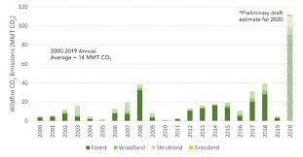

Annual wildfire CO2 emissions (million metric tons, MMT) by general vegetation category

The California 4th Climate Assessment estimates that wildfire acreage area burned will increase by 77% by 2100, which, even if 2020 & 2021 wildfire related emission are an anomaly, would still equate to wildfire related emissions of at least 25 MMT per year by 2100. At this pace wildfire emissions will consistently exceed the emissions reductions achieved though all the entire California Climate Investment programs.

Although we realize that significant reduction in emissions are being achieved by other state programs and mandates, including mandated reductions in electricity sector through the Renewable Portfolio Standard and the fuels sector through the Low Carbon Fuel Standard, when all of the reductions are taken into account, California emission reductions remain in deficit by 2045.

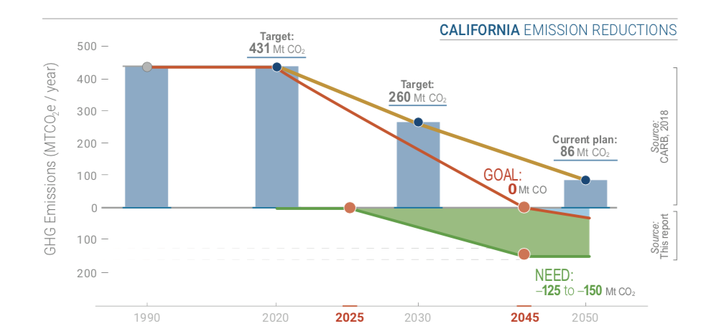

Goals of California’s emissions plan extrapolated to 2045 (CARB, 2017) with negative emissions estimates from the Getting to Neutral report.

For this reason we believe that the California Air Resources Board should explore and potentially adopt either Option B, C or D as presented in the workshop on August 17th 2021, and explicitly reject any non CCS scenario, due to the fact that in the absence of CCS, and based on our current investment results we cannot achieve carbon neutrality.

- The Scenarios Should Identify Bioenergy Opportunities for Carbon Negative Emissions

The scenarios presentation mentions carbon neutrality in several places, however it does not pose any questions in the sector specific presentations about opportunities to achieve carbon negative emissions. We believe that sector specific emissions reductions, especially in the electricity, transportation, and industrial sectors which can achieve negative emissions by combining bioenergy with carbon capture and storage or use (BECCS), and in some cases, with bioenergy alone.
According to Lawrence Livermore National Lab and other experts who’ve considered how to achieve carbon neutrality, achieving carbon neutrality will require a significant investment in negative carbon emissions. LLNL also found that the biggest opportunity for negative carbon emissions in California is from BECCS, which can provide more than two-thirds of all the carbon negative emissions needed to reach carbon neutrality.
- The Scenarios Should Focus Much More on SLCP Reductions and Near-Term Opportunities to Benefit the Climate

Governor Newsom in recent media comments and a growing cohort of climate experts from across the state have been stating that based on the evidence of climate acceleration contained in the most recent IPCC report, we must be accelerating our efforts to adopt de-carbonization measures, but that those measures will likely take two to three decades to have a significant impact on warming.
Climate scientists agree that the only measures that reduce warming immediately and can do so at large scale are the measures to reduce Short Lived Climate Pollutant emissions. Those measures also have enormous co-benefits for public health and safety by reducing methane, black carbon, smoke, wildfire, toxic air contaminants, water pollution, and other impacts of organic waste disposal and fires, both wild and controlled.
This makes it even more important to increase our focus on SLCP, including the elimination of the use of diesel and reductions in methane and black carbon from organic waste.
During the presentation the slides on vehicle electrification and petroleum reduction make no distinction between diesel and other fuels, despite the fact that diesel is a significant source of black carbon emissions. The single biggest opportunity to reduce SLCP emissions in the transportation sector is to replace diesel with carbon negative bio-methane from organic waste. Increasing use of bio-methane to reduce SLCP emissions should be another explicit goal of the transportation sector scenario planning. This would not only reduce SLCP emissions from organic waste, but also reduces black carbon from diesel combustion. This should be the highest focus in the transportation sector and yet is not mentioned at all.
Finally, eliminating diesel from the electricity sector should be an explicit goal of the Scenarios and the Scoping Plan since diesel is a major source of black carbon emissions, as well as toxic air contaminants and smog. Increasing incidents of Public Safety Power Shutoffs and electricity grid disruption from wildfire is driving the public, residential and commercial sectors to deploy diesel generators, a significant new source of SCLP, and source that threatens to offset gains made in reducing SCLP in other sectors.

- The Electricity Sector Scenario Must Address Lifecycle Emissions of SB 100 Eligible Resources

The electricity sector scenarios presented fail to focus on the lifecycle carbon intensity of different resources or opportunities for carbon negative emissions. To achieve a zero carbon electricity sector, it is critical to adopt a lifecycle carbon intensity focus, rather than focusing on specific technologies – i.e., combustion – that are not related to carbon intensity.
In order to achieve a zero carbon electricity sector, it will be critical to have significant carbon negative emissions in the sector since most resources are not, in fact, truly carbon neutral. This includes solar and wind power, which have lifecycle carbon intensities between 4 and 40 grams of CO2e per kilowatt-hour. Batteries also have some carbon emissions on a lifecycle basis. These are due to sourcing the raw materials, manufacturing, installation, land use changes, and disposal or recycling of used batteries and other equipment (turbines, panels, etc.).
Bioenergy, by contrast, can be carbon negative – in some cases, extremely carbon negative – because it reduces SLCP and GHG emissions from organic waste as well as displacing fossil fuels. When carbon capture and storage or use is added, then all forms of bioenergy can be carbon negative.
Given the wide range of carbon intensities for RPS eligible resources, it is critical to include lifecycle carbon intensities of different RPS resources to plan accurately for a zero carbon electricity grid. The scenarios planning, therefore, should consider where there are opportunities for carbon negative emissions, how to drive down emissions from RPS resources that are not carbon neutral or carbon negative, and how to achieve a truly zero carbon electricity grid. Ignoring the lifecycle emissions of different resources will not lead to an accurate assessment of electricity sector emissions.

Thank you for your attention to these important issues as ARB works to achieve the State’s 2045 carbon neutrality goal. We look forward to discussing these recommendations and continuing to engage with you throughout the Scoping Plan update process.
Sincerely,
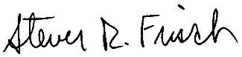
Steven Frisch
President, Sierra Business Council

California Air Resources Board, Annual Report to the Legislature on California Climate Investments Using Cap-and-Trade Auction Proceeds, at page ii.
California Air Resources Board, Greenhouse Gas Emissions of Contemporary Wildfire, Prescribed Fire and Forest Management Activities, December 2020, at page i.
https://www.climateassessment.ca.gov/state/overview/
Lawrence Livermore National Lab, Getting to Neutral – Options for Negative Carbon Emissions,” January 2020, at page 1
Lawrence Livermore National Lab, Getting to Neutral – Options for Negative Carbon Emissions,” January 2020, at page 2.
Id.
Presentation of Dr. V. Ramanathan, UC San Diego and Scripps Institute, Presentation June 24, 2021 at MoveLA Symposium on Short-Lived Climate Pollutant Reductions.
Lawrence Livermore National Lab, Getting to Neutral – Options for Negative Carbon Emissions,” January 2020, at page 2.
Id. at page 4.
See, https://www.nrel.gov/analysis/life-cycle-assessment.html

