October 24, 2022

Ms. Rajinder Sahota
California Air Resources Board
1001 I Street
Sacramento, CA. 95814

Re: CARB Scoping Plan Environmental Analysis – Electric and Hydrogen Aircraft
Dear Ms. Sahota:
This letter is in response to the California Air Resources Board Revised Environmental Assessment for the 2022 Scoping Plan.
In his July 22, 2022 letter to CARB, Governor Gavin Newsom called for the incorporation of specific goals and actions into the draft 2022 Scoping Plan. This included the goal to move away from fossil fuels in part by reaching 20% clean fuels for the aviation sector. Industry experts interpreted this goal to mean 20% of aviation fuels should be Sustainable Aviation Fuel (SAF) by 2030, to put the state on a trajectory of net-zero greenhouse gas emissions by 2045. However, CARB’s interpretation of the 20% “clean fuels” target that Governor Newsom has proposed has moved to 20% of fuels should be replaced by hydrogen and electricity by 2045, and the remainder should come from SAF. Breaking this down – the Governor’s 20% target, as interpreted by industry experts – would mean 800 million gallons of SAF by 2030, with the possibility of contributions toward this 20% from hydrogen and electricity. World Energy currently produces the majority of SAF consumed in California. If World Energy’s commercial plant conversion project is successful, by 2026 the company will be capable of producing up to 350 million gallons of SAF. This would leave another 450 million gallons to come from other sources. Given the timeline to permit, construct, and begin plant operations, this is still an aggressive target.
However, CARB’s interpretation of the Governor’s target siloes this into two targets and quadruples the necessary SAF production to 3.2 billion gallons of SAF by 2045 and another 800 million gallons equivalent of hydrogen and electricity by 2045. Regardless of the stringency of the target for replacing conventional aviation fuels, bifurcating the technology types between SAF on the one hand and hydrogen and electrification on the other seems unnecessary and prone to fall short of achieving objectives. A more technology-neutral approach would alleviate this risk. Specifically, the proposed target for hydrogen and electric propulsion technologies seems impossibly ambitious, given the current trajectory of research and development into those technologies for commercial size airplanes. Even a 10% goal for these technologies by 2045 may still not be achievable, but it would be more realistic and reflective of the status and expected development of hydrogen and fuel cell technologies. We present the following industry investment information on electric and hydrogen aircraft to demonstrate the current development of these technologies, and how electric and hydrogen aircraft are unlikely to completely address CARB’s contemplated technology-specific target.

Industry Research
Aviation manufacturers have continually made improvements to commercial aircraft sustainability, efficiency, and emission output. Thorough and rigorous testing and certification have been completed with each new model and improvement by the Federal Aviation Administration (FAA). These improvements have resulted in a consistent decrease in overall emissions, 80% of which occur at takeoff and landing. The global commercial aviation fleet has seen fuel efficiency emissions (proxy for carbon emission reductions) improvements of 1.5-2 % every year.
Commercial airlines continue to invest in and deploy technology, operations, and sustainable aviation fuel (“SAF”) advances. Airlines have dramatically improved their fuel efficiency and reduced their CO₂ and other emissions by investing billions in fuel-saving aircraft and engines, innovative technologies like winglets (which improve aerodynamics), and cutting-edge route-optimization software.
Aviation and aerospace manufacturers are fully committed to emission and technology advancement as demonstrated by work on hydrogen technologies since the 1960’s, and investments into electric aircraft. Boeing has invested in that technology through Wisk, which has developed an electric vertical take-off and landing vehicle. Additional electric technologies include: auxiliary power units, which assist with on ground and in flight power; fuel cell power development, which converts hydrogen into electric power; and electrification of manual and hydraulic systems like the 787 that produces over 1 megawatt of power in flight.
Electric aircraft in current development will accommodate a small number of passengers per flight and will be limited to short-range trips as indicated in the graphic below.

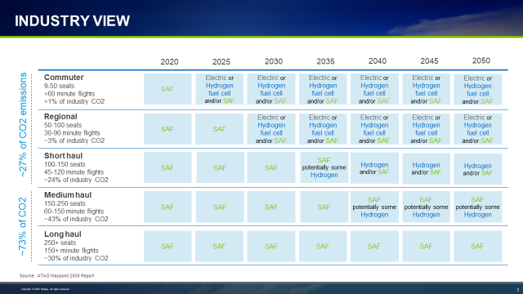
It is estimated that electric and hydrogen technologies will not be a viable solution to decarbonize long-haul flights with over 100 passengers well past 2050. Airbus is working to develop hybrid-hydrogen aircraft intended to be powered by hydrogen combustion through modified gas turbine engines, and the potential use of hydrogen fuel cells. However, industry research shows we are several decades away from having any viable technology available for use in long-haul commercial aircraft, other than SAF, as safety testing hydrogen and electrification alone takes many years.
In addition, the certification process for new aircraft can take years. The concept to certification process for any new aircraft takes anywhere from five to 15 years before final approval from the FAA or the aviation authorities in other countries.
Additionally, electric and hydrogen propulsion technology will take significant infrastructure development and monetary investment for the production, storage, distribution, and use. This will have an impact well beyond airports and their surrounding communities.
Based on the industry’s research and investments into new technology, and consistent with the findings of academic research, the most efficient, practical, and near-term capability to decarbonize the aviation industry, and improve local air quality in airport communities, is the use of sustainable aviation fuel (SAF). With the continued improvements in engine technology, SAF will provide the safest, and largest decrease in GHG emissions and other criteria pollutant from the aviation sector, for decades to come.

Feasible targets
To keep California moving aggressively to combat emissions from aviation CARB policy should align with the reality of technology advancements. For the foreseeable future through minimally 2050, SAF is the proven propulsion fuel that will be available to airlines and will serve as a bridge to zero emission technologies of the future.

Working together
We also suggest that CARB establish a standing technical advisory panel with representatives from airports, airlines, and aerospace manufacturers to understand and remove roadblocks for the implementation of SAFs and development of hydrogen and electrification.
We also encourage CARB to work closely with the Environmental Protection Agency (EPA) and the FAA on strategies for reducing aviation-related emissions, as CARB appears to recognize airline operations and emissions from aircraft are within the exclusive jurisdiction of these federal agencies. Under the Clean Air Act and the FAA Act, these agencies work to protect the environment without compromising aviation safety. They effectively balance several considerations when aiming to reduce pollutants (recognizing that there may be interdependencies, such as trade-offs between emissions of NOx and CO2), and other impacts such as noise (recognizing that there may be trade-off between fuel efficiency and noise). We stand ready to support discussions with these agencies in their continuing efforts to further reduce aviation’s environmental footprint.
Sincerely,
Papia Gambelin
Papia Gambelin
Managing Director, Wester Region Government Affairs
United Airlines
Leeor Alpern
Director of Government and Community Relations
World Energy
Mark Taylor
CA Director of State & Local Government Relations
The Boeing Company
Erin Cook, Sustainability & Environmental Policy Director
San Francisco International Airport

Based on pre-COVID jet fuel consumption estimate of 4 billion gallons of fuel.

