RAY HAYNES  411.  40.  GOVERNMENT RELATIONS & CONSULTING | 9060 Grove St  Elk Grove, Ca. 95624  (916) 709-9781  ray-haynes@hotmail.com

December 15, 2022
California Air Resources Board

To the Board

I was asked to comment about the subject of your public hearing on December 15 and 16, 2022, specifically Agenda Item 22-26-1, Public Meeting to Consider the 2022 Climate Change Scoping Plan for Achieving Carbon Neutrality. From my time in the Legislature, I have worked on real efforts to reduce the waste from oil-based fuel combustion in various countries around the world, and in California.
Based on my work, I have noticed that CARB’s approach to reducing “greenhouse gases” has only shifted waste from poisonous gas to another, or from one waste product to another. All human effort produces waste. The key to reducing waste is to increase the efficiency of the waste production devices.
As an example, CARB’s efforts to reduce carbon-based waste created from mobile sources in the 1990’s was mandated MTBE in gasoline for vehicles and low aromatic diesel fuels for diesel engines. Both efforts were, quite frankly, failures. MTBE simply made the carbon-based waste heavier than air, which did reduce CO emissions in the air, but causing that waste, plus the MTBE to fall on the ground, then washed into water when it rained. That polluted lakes, rivers, and ground water, and ultimately caused the state to abandon MTBE as an additive. Low aromatic fuel mandates increased the cost of diesel fuel and destroyed numerous diesel engines because it reduced the lubricity of the diesel fuel. Since those fuels did not sufficiently reduce carbon-based waste, even though it significantly increased the cost of using the fuel, CARB ultimately moved toward eliminating “old diesel” engines, once again significantly increasing the cost to the users of the diesel engine and to the consumers of the products produced by these engines.
The current effort to move to electric vehicles is fraught with uncertainty. The fact that the mobile source emissions may be reduced doesn’t mean that overall greenhouse gases will be reduced. In fact, there is substantial evidence that moving the emissions from mobile to stationery sources may make CARB look like it is accomplishing its goal of reducing emissions from mobile sources, but doesn’t decrease overall emissions, thus, quite frankly, doesn’t deliver cleaner air to the citizens for California. In addition, there is no plan to study the waste generated by the use of batteries. Again, disposal of solid waste may not be the mandate of the board, but it should consider not only how its mandates adversely affect consumers and job creators, but it should also consider how its mandates affect other efforts at dealing with waste, whether it is water or solid pollution. Based on its past actions, those factors seem not to have been sufficiently considered by this board
What if there was a way to increase the efficiency of the mobile source producers of waste, and reduce the carbon-based emissions?
There actually is, and CARB has been aware of the process since the early 1990s. The staff studied it and rejected it in the 1990s in favor of MTBE. D-1280X has been proven in studies around the world to reduce actual greenhouse gases by increasing the efficiency of the fuel used in the engines. That reduces the price to the user, reduces production costs, decreases consumer costs, and cleans the air. CARB studies, studies I spent 10 years in the Legislature attempting to get released (ultimately released in 2004, during the Schwarzenegger administration), proved this point, and yet CARB has taken no action to consider its use. Admittedly, the producer of D-1280X have never had extensive political connections or the “juice” to move the prejudice of CARB’s staff to fuel additives (unlike the political connections that resulted in the approval of the additive MTBE), but that does not make the product any less effective than test after test has proven.
I know that the producers of D-1280X will appear at the hearing on December 15 and 16 to present these facts to the Board. I would appear and comment as well, but my schedule does not permit that appearance, which is why I am writing this letter.
Please take the time to listen and consider the comments of the producers of D-1280X about the product. It does do what they say it will do, and it increases the efficiency of the fuels used in mobile sources. That decreases producer and consumer costs, while at the same time reducing efficiency. That is a win/win for California, and even though it comes through unusual channels, that is, not through the typical, politically connected, sources, it is better for California and its citizens than the previous actions of the Board.

Thanks for reading and considering these comments.

Sincerely yours,
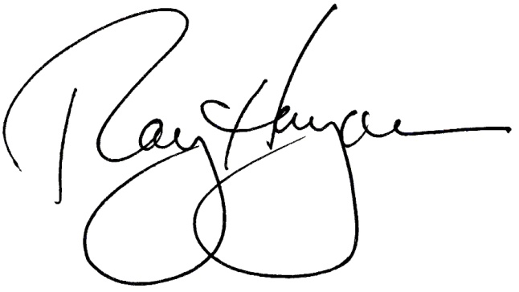
Raymond N. Haynes
Attorney at Law
California State Senate, 1994-2002
California State Assembly, 1992-94, 2002-06
ALEC National Chair, 2000

