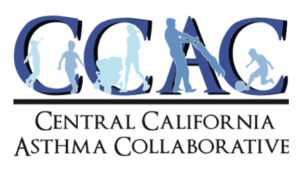

Recommendation: The Scoping Plan has very actual health data and what’s there should be elaborated on. Even though there is a note that this information is in the appendix, there should be more data used to support those conclusions so the public can better understand the results of studies and research and data used to support those conclusions so the public can better understand data used to support those conclusions so the public can better understand the results of studies and research and data used to support those conclusions so the public can better understand re detailed summary in the body of the scoping plan. For example, describing reduced heat impacts clearly and not just having an arrow going up or down. Estimated percentages of how much it would increase or decrease in different scenarios is critical and provide something data used to support those conclusions so the public can better understand the results of studies and research and data used to support those conclusions so the public can better understand substantial to measure progress-or the lack of-against. CARB should analyze and data used to support those conclusions so the public can better understand the results of studies and research done and data used to support those conclusions so the public can get a better understanding of their analysis on health benefits.

Recommendation: CARB discusses wildfire and wildfire smoke, however there is little or no substantive mention of public health impacts. For example, it mentions the potential negative impacts on ecosystems and the environment but no specific examples of the health impacts on vulnerable populations such as pregnant women, the elderly, children, etc. There should be a table of specific data on how wildfires can impact human health. This section would then be moved to the environmental analysis section of the scoping plan. It would be beneficial if CARB describe in each of the scenario sections what would happen if no or minimal actions were taken to reduce or mitigate wildfire smoke.

Recommendation: CARB has addressed the racial equity impact, but has not mentioned a health impact report including a full life cycle assessment of various carbon reducing strategies. There is no mention of data or other information sharing with the health care system including facilities and providers, providing a health indicator informed tracking tool to tied progress on the scoping plan implementation, and benchmarks or metrics that can be used for other EJ groups and others working on climate resilience and adaptation plans in local communities.. CARB must work closely with EJAC and providing reports of progress within the scoping plan and to develop Participatory Action Research projects in the development and evaluation of Scoping plan measures.

Respectfully,
Kimberly McCoy
Climate & Environmental Policy Advocate
Central California Asthma Collaborative

