730 17th Street
Suite 340???
Denver, Colorado 80202

Office: 303-534-0488
Fax: 303-534-0487
tvessels@vesselscoalgas.com

November 4, 2016
Comments on: Cap and Trade Regulations Amendment Workshop.

Greetings ARB Board and Staff,

If the only goal of the California Cap and Trade system was to slow climate change so humanity had more time to adapt then it would be reasonable to take the following steps:

- Join or become affiliated with the Climate and Clean Air Coalition.
- Adopt methane emission reductions as the primary strategy to slow climate change.
- Disregard the distinction of anthropogenic or fossil sourced methane in favor of reducing any methane emission regardless of its source.
- Adopt the IPCC 2013 5th Assessment Report’s 20 year Global Warming Potential value for Methane.
- Increase the % of Offsets that can be utilized in lieu of Allowances.
- Eliminate invalidation risk from any factors outside of the GHG reduction projects.
- Persuade California and Western Climate Initiative Utility Commissions to accept electricity generated from projects that are deemed eligible for ARB Cap and Trade as renewable energy (this would encourage electricity generation rather than flaring of waste methane).

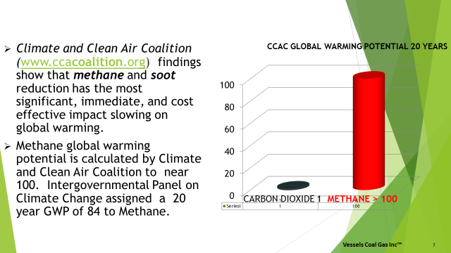

Scientific findings are ahead of policy and economic activity. The EPA and state of California still use the conventional time period of a hundred years for comparing the Global Warming Potential of greenhouse gases. That convention was adopted around 1990 when scientists believed it would be a hundred years before serious climate change would occur. Climate research discovered the atmosphere was warming faster than the early climate models had predicted. In 2012 a scientific finding was published in the magazine Science stating that methane and black carbon were the two most important emissions to reduce to slow climate change or global warming. Methane and black carbon, Short Lived Climate Pollutants (SLCPS), were found to have a much more powerful near term impact on global warming then the longer term impact of CO2. Attention is now focused on a 20 year time period as the critical time frame in which to take action. In 2014 a number of countries, scientists, and the United Nations Environment Program formed the Climate and Clean Air Coalition (CCAC) to concentrate on research and programs to reduce SLCPS. In March of this year the Global Methane Forum, jointly conducted by the Global Methane Initiative (GMI) and the CCAC at Georgetown University methane was announced as the number one greenhouse gas to control. The presentation was made by Johan Kuylenstierna, Deputy Director, Stockholm Environment Institute, University of York, CCAC Science Advisory Panel (UK) and Drew Shindell, Duke University, CCAC Science Advisory Panel (USA). The title of their presentation was, “What Science Tells us: why methane is important.” The scientists have calculated that the more accurate Global Warming Potential Factors for methane are 100 for a twenty year time period and 40 for a hundred year time period. The following chart illustrates the differences between the current GWP calculated by scientists and the earlier GWPS still used by government agencies.

This year the CCAC reported their GWP of 100 for a 20 year time period and a GWP of 40 for a 100 year time period. The most recent Assessment Report (AR) by the International Panel on Climate Change was in 2013. The EPA on their web site refer to the IPCC factors in the 5th AR. However the EPA’s convention used for domestic greenhouse gas reporting still follows an earlier 2007 IPCC Assessment Report and still follows the 100 year time span with a GWP of methane at 25. For the Cap and Trade System in California CARB uses the even earlier 1995 Assessment Report from the EPA that referred to the IPCC AR of 1995 and uses a GWP for methane of 21 which was based on a 100 year time frame. The most current CCAC 20 year time GWP is 5 times that used by the state of California.

The United States EPA prepares the USA inventory of greenhouse gas and submits this data to the United Nations Framework Convention on Climate Change (UNFCCC). The regulatory agencies are using outdated GWPs and the accounting protocols are not being updated to reflect the latest science (which would require the use of the GWPs found in the 5th AR).

The choice of the timeframe is an accounting function. If the goal is to align the urgency of climate change mitigation and reality of SLCPS, the agencies should be using a 20 year GWP for methane based on the 5th AR while we await the eventual 6th AR. The EPA and ARB do not set these GWP values. The IPCC sets the values and the agencies cite various versions of the IPCC assessments.

VCG has adopted the CCAC 20 year GWP of 100 as it is the most current factor from the world’s foremost scientific community on atmospheric science. VCG uses the GWP of 100 to emphasize the significance of reducing methane emissions. Being current on the science can allow us to anticipate imminent policy and economic trends that will provide opportunities. The following chart shows the evolution of the awareness of the SLCP methane and how far behind are the GWP factors used by the EPA and CARB. VCG believes policy makers and regulators will eventually take actions based on a 20 year time frame by concentrating on reducing methane emissions. The EPA on its web site discusses the 2013 IPCC AR. ARB uses the 20 year GWP of 84 for methane in its enforcement actions of methane emissions outside the Cap and Trade System.

Currently in the California Cap and Trade system greenhouse gas reductions are priced at around $11.60 to $13.00 a metric ton (Tonne) of CO2 (tCO2e). An allowance to emit 1 tCO2e is about $12.90. An offset to 1 tCO2e emission is about $11.60. ARB assigns a GWP to methane based on the 1995 100 year time frame. The most recent scientific research recommends greenhouse gases be assessed their global warming potentials over 20 year time periods. The following chart compares the current value of tCO2e of methane under the ARB Cap and Trade system vs what the value would be if the global warming factors of the Climate and Clean Air Coalition were used. If methane were more accurately valued more resources would be directed at capturing and destroying methane.

This chart shows what the price of methane would be per offset given the same volume of methane but on a 20 year time scale if its current price was related to its GWP.
This value is derived from the IPCC AR5 from 2013.

Vessels Coal Gas, Inc. mine methane emissions captured as of January 30, 2016 solely due to California Cap and Trade.

Methane (CH4) emissions destroyed- 1.556 billion cubic feet (BCF)

Carbon Dioxide metric tons equivalent emission reduction- 2.578 million tCO2e

Destruction of 1.556 BCF of methane emissions has the effect of reducing greenhouse gas emissions by…
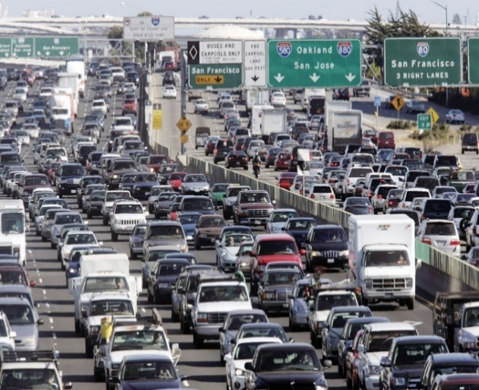
Taking more than 500,000 passenger vehicles off the road for one year. (average passenger emits 4.7 tCO2e per year “EPA”.)

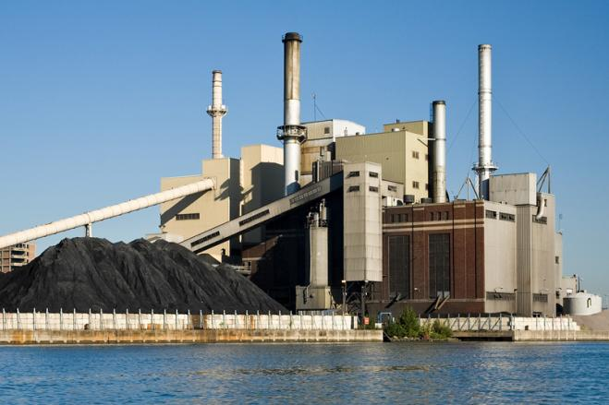
Cutting back 2,500,000 Mega Watts of electricity generation from coal powered electricity generation. (1 Mega Watt of electricity generation from coal emits about 1 tCO2e “Energy Information Agency”.

http://www.ccacoalition.org/en/content/about-ushttp://www.unep.org/climatechange/

Thomas J. Vessels, President of Vessels Coal Gas, Inc.

Uses current Climate and Clean Air Coalition findings for 20 year Global Warming Potential (GWP) of 100 for methane.

