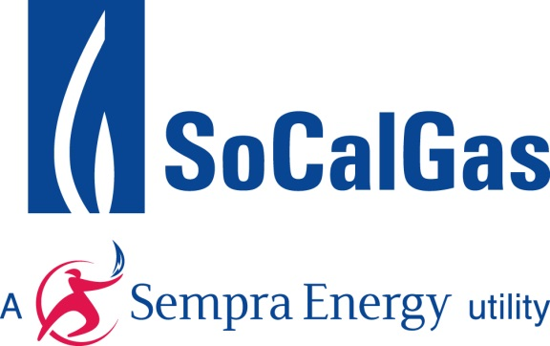
Allison Smith
Manager
Energy and Environmental Affairs
555 W. Fifth Street, GCT 17E5
Los Angeles, CA 90013
tel: 213.244.5369
email: afsmith@semprautilities.com

July 13, 2015
Mr. Matthew Botill
Manager, Climate Investments Branch, Policy Section
California Air Resources Board
1001 I Street
P.O. Box 2815
Sacramento, CA 95812

RE: Southern California Gas Company Comments to the “Funding Guidelines for Agencies that Administer California Climate Investments”
Dear Mr. Botill:
Southern California Gas Company (SoCalGas) would like to thank the Air Resources Board (ARB) for the opportunity to offer comments on the proposed revisions to the draft Funding Guidelines for Agencies that Administer California Climate Investments dated June 16, 2015 (Funding Guidelines) and the Supplement to the Funding Guidelines dated July 13, 2015.
SoCalGas supports the revisions to the Funding Guidelines to the extent they further the objectives of AB 32 by 1) cost-effectively reducing the emissions of greenhouse gases (GHGs) through fuel and technology neutrality and effective coordination. 2) ensuring open, transparent and unbiased program delivery, and 3) maximizing the economic, health, and environmental co-benefits to disadvantaged communities and to the state as a whole. As such, SoCalGas offers the following comments and recommendations to ARB as it considers revisions to the Funding Guidelines.
Cost Effectiveness

ARB should include cost-effectiveness as a criterion in the “Project Selection Requirements” section of the Funding Guidelines. In alignment with the goals and intentions of AB 32, we feel it prudent for projects and programs to be evaluated on the basis of the quantity of greenhouse gas emissions abated or sequestered per dollar spent, in addition to the other selection requirements. By including this metric in the Funding Guidelines for administering agencies, we will ensure that our state has the best chance to transition to a low-carbon economy in the least-disruptive way possible, while maintaining the competitiveness of our businesses and reducing the impact to our most vulnerable residents.
Fuel and Technology Neutrality

The Funding Guidelines do not address that agencies should remain fuel and technology neutral in selecting program and projects to support. To achieve the greatest GHG reduction and co-benefits per dollar spent, it is critical for agencies to solicit programs and projects that take an “all-of-the-above” approach to GHG reduction solutions. We encourage ARB to include language in the Funding Guidelines that will address the issue of fuel and technology neutrality.
Coordination with Investor Owned Utilities and Other Program Administrators

While we have observed that some administering agencies are taking initiative to coordinate with Investor Owned Utility (IOU) programs and other program administrators, we encourage ARB to explicitly provide guidance in the Funding Guidelines regarding inter-program coordination. Under the auspices of the California Public Utilities Commission (CPUC), the state’s IOUs administer a wide variety of energy efficiency, distributed generation, and low-income programs that result in GHG reductions. To optimize the use of the auction proceeds, it is imperative that administering agencies be required to leverage existing programs and avoid duplicative efforts. This can be addressed with an expansion of the “Coordinating Investments and Leveraging Funds” section of the Funding Guidelines, where it already states that administering agencies should seek opportunities to work together.
Transparency of Program Design Process and Project Proposals

We request ARB develop a more transparent framework for administering agencies to follow when developing program proposals. We feel public input would be beneficial to the effectiveness and success of the programs. Currently, the process by which individual California Climate Investment programs are designed and developed is not clear and does not appear standardized in any way. While we recognize that the Triennial Investment Plans allow for public comment for the prioritization of investments, the individual program proposals seem to be developed with little transparency. We recommend that program proposals being considered before the legislature for funds appropriation be made publicly available in a manner that is consistent with one of the stated purposes of the Funding Guidelines, to “provide accountability and transparency.”
In addition, while we support the disclosure of application information proposed by the Supplement to the Funding Guidelines, we recommend that ARB require individual project proposals to the administering agencies be made publicly available. This will also provide the necessary transparency to inform future applications and increase the overall quality of applications as the program cycles progress.
GHG and Co-Benefit Quantification Methodology Development Process
We strongly urge ARB to include greater stakeholder participation in the upfront quantification development process for California Climate Investment programs. Based on the proposed Quantification Methodology Process on page 18, ARB will only begin consultation with administering agencies during step four of the methodology development, and will then only work with external experts “as needed on the science, tools, and potential approaches.”
While we are heartened to see that ARB is developing two contracts to leverage academic and external expertise for the quantification assessment, we would also suggest seeking input from external stakeholder groups, IOUs, industry groups, and non-governmental organizations who have access to critical data, insight, and models to share that can provide immense value in developing the state’s tools for emissions quantification in these emerging fields and project areas. During the information gathering stage, and throughout the model development process, a stakeholder participation process can help ARB and each administering agency develop the most accurate tools based on the best available information. This could create a more streamlined opportunity to review best available approaches via ongoing input, rather than waiting for public review during the comment period.
SoCalGas hopes that the comments and recommendations provided will inform ARB and help to improve the revisions to the Funding Guidelines currently under consideration.
Sincerely,
Allison Smith
Allison Smith
Manager
Energy and Environmental Affairs

Cc: Edie Chang, Deputy Executive Officer, California Air Resources Board
Cynthia Marvin, Division Chief, California Air Resources Board
Shelby Livingston, Branch Chief, California Air Resources Board

