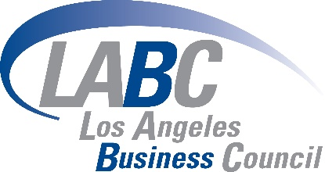

May 26,2022

Chair Randolph and Members of the Board
California Air Resources Board
1001 I Street
Sacramento, CA 95814

RE: The Proposed Advanced Clean Cars II Rule

Chair Randolph and Members of the Board,

On behalf of the Los Angeles Business Council (LABC), we would like to encourage The Air Resources Board (CARB) to further develop the Advanced Clean Cars II program to include stronger pollution-free car sales before the end of the decade. The proposed update to the Advanced Clean Cars program has targets for pollution-free car sales that are far below what the Air Resources Board stated was needed to reach our state’s air quality and climate goals. The LABC strongly supports strengthening interim sales targets for electric cars to at least 75% in 2030 to ensure that overall ZEV sales requirements meet the emission reduction targets CARB established.

Threatened with the climate crisis, California continues to deal with unprecedented drought, wildfires, high heat days and increasing air pollution. Gavin Newsom’s executive order N-79-20, directing the state to require sales of all new passenger vehicles to be zero-emission by 2035, puts California on the right path towards dramatically reducing pollution across its communities while making the state more resilient when faced with a changing climate. Setting an interim target of 75% of all new passenger vehicles to be zero-emission by 2030, will not only help California reach its 2035 zero-emission car sale goals but will also reinforce California as the nation’s leader in reducing our carbon output and advancing policies that lay the groundwork for a more vibrant, inclusive green economy.

In partnership with the GOBiz ZEV Team and the UCLA Luskin Center for Innovation, the LABC Institute conducted a study called “An Agenda for Equity-Centered Clean Transportation” which found that California cannot achieve its goal of transitioning every vehicle to zero-emissions technologies without proactively creating policies that make clean transportation options truly accessible and practical for priority communities. For this reason, the LABC would also like to encourage that the Advanced Clean Cars II program also include equity provisions that will prioritize California’s pollution-burdened communities. LABC strongly supports ACC II standards that are equity centered and that maximize access, affordability, and direct benefits to Disadvantaged Communities. Currently, the proposed rule has voluntary equity provisions for carmakers, which in turn do not guarantee emissions reductions in communities historically overburdened with transportation pollution. The most effective way to ensure ZEV deliveries to overburdened communities within the rule is to make these provisions mandatory.

According to the American Lung Association, California has 6 out of the 10 most polluted cities in the country, with Los Angeles being dead last. It is crucial to implement an equitable statewide electric vehicle infrastructure plan that will help California dramatically improve its air quality. With the average ownership/lease for a new car being about 6 years, California has the opportunity of eliminating millions of fossil fuel burning cars by increasing the sales of pollution-free vehicles while also increasing accessibility to these pollution-free vehicles throughout all communities.

We strongly encourage the Air Resources Board to set stronger air pollution standards throughout California. With stronger zero-emission sale targets that prioritize Disadvantaged Communities, California will be able to reach its air quality and climate goals while transitioning to a clean transportation future.

Sincerely,

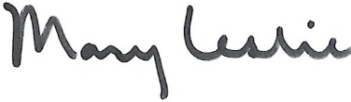
Mary Leslie
President
LABC

