
March 6th, 2017

Executive Officers
Nadine Watt, Chair
Watt Companies

Jacob Lipa, Immediate Past Chairman
Micropolitan/Psomas

Antonio Manning, Vice Chairman
J.P. Morgan Chase & Co.

Alan Rothenberg, Vice Chairman
1st Century Bank

Thomas Flintoft, Vice Chairman
Kindel Gagan

Richard Ziman, Founding Chairman,
Rexford Industrial Realty

Mary Leslie, President
Los Angeles Business Council

David Sears, Treasurer
Pacific Reach Partners

Linda Bernhardt, Secretary
AMBOO Corporation

Chairman’s Circle

Celeste Altimari, Haworth

Javier Angulo, Walmart

Shad Balch, General Motors

Rick Bartlett, Unisource Solutions

David Borger, STV Group, Inc

Chris Bullinger, Hecate Energy, LLC

John Choi, Airbnb

Marcia Choo, Wells Fargo Bank

David Cobb, HDR

Andy Cohen, FAIA, Gensler

Brad Cox, Trammell Crow Co.

Joaquin de Monet, Palisades Capital Realty Advisors, LLC

Mark DiNapoli, Suffolk Construction Co.

Marcie Edwards, LA Dept. of Water & Power

John Ek, Ek & Sunkin

Donna Estacio, American Airlines

Amy Freilich, Armbruster Goldsmith & Delvac LLP

Virginia Grebbien, Parsons

Ron Griffith, Century Housing Corporation

David Hart, Steinberg

Clyde Holland, Holland Partner Group

Sonnet Hui, Hazens Group

John Huskey, Meta Housing Corporation

Adrian Jayasinha, The Walter J. Company

Deborah Kallick, Cedars-Sinai Health System

Sharon Keyser, Paramount Pictures

Janet Lamkin, Bank of America

Shane Martin, Loyola Marymount University

John Marshall, Westfield, LLC

Mike Massey, MTMASSEY Consulting

Greg McWilliams, FivePoint, LLC

George Mihlsten, Latham & Watkins

Jerry Porter, CresaPartners

Kevin Ratner, Forest City

Dennis Rodriguez, Siemens

Kirk Rose, HMC Architects

Michael Rosenfeld, Next Century Associates, LLC

Sarah Shaw, JMB Realty Corporation

Patti Shwayder, Aimco

Lori Tierney, IIDA, Tierney Management, LLC

C.Y. Wang, Ernst & Young, LLP

Christian Wentzel, Ontario Solar Provider Inc.

Phil Williams, Delos

Gillian Wright, Sempra Energy Utilities

Mary Nichols, Chair
California Air Resources Board
1001 “I” Street
Sacramento, CA 95814

Dear Chairwoman Nichols,

On behalf of the Los Angeles Business Council (LABC), we would like to thank the California Air Resources Board for allowing us to provide feedback on the 2017 Climate Change Scoping Plan Update. The Scoping Plan is of upmost importance to our membership as the key driver of how we will achieve our ambitious and necessary climate change targets in a manner that will best address environment, economy and equity.

The Los Angeles Business Council is a vital advocacy and educational organization, representing over 150 members that support economic competitiveness and sustainability in the areas of energy, transportation, and housing. The LABC was an early business supporter of AB 32, which targeted a drop of GHG emission in California to 1990 levels, and shortly thereafter, SB 32, that set the target even lower to reduce GHG emissions by 40 percent below 1990 levels. Our membership believes that these crucial policies help us achieve a cleaner environment, while making California economically competitive by driving innovation and creating a new clean-tech economy.

We believe the Scoping Plan Update lays out an ambitious win-win scenario of fostering substantial economic development while reducing dependency on fossil fuels. Specifically, we support the Proposed Scoping Plan Scenario including the extension of the Cap-and-Trade Program post-2020 and strategies to for emissions reductions at refineries.

Cap-and-Trade
As a business organization, the market-driven mechanism of cap-and-trade has made the program attractive for our members as a tool to reduce GHG emissions. Cap-and-Trade has also allowed for investments to be made in areas of upmost concern to Los Angeles, including affordable housing, transportation and equity. Several of our members have been direct recipients of cap-and-trade funding under the Affordable Housing and Sustainable Communities program. This includes the LA County Metropolitan Transportation Authority who has received hundreds of millions of dollars to complete projects crucial to the expansion of Los Angeles’ public transit system that will reduce the number of cars on the road and help connect Angelenos from their homes to their jobs. As California and Los Angeles’ aim to address our affordability and homelessness crises, the funding from the AHSC program has gone directly to help building affordable and mixed-income housing to help alleviate rent-burden facing so many Californians. We encourage including more of a discussion on how cap-and-trade in California will set an example for the rest of the nation to follow. As the program continues to reduce emissions, while creating good-paying, clean-tech jobs it will attract the attention of other state’s and nations who will look to follow in California’s footsteps.

Transportation
We applaud the Update’s inclusion of transportation as a key driver of reducing GHG emission. We believe the development of the High Speed Rail is a major development in California’s transportation infrastructure that would supplant many privately used automobiles and thereby decrease emissions, while creating jobs and economic growth. We would recommend the addition of mentioning the growing electronic rail system in Southern California and its impact on the region.
A Shift at the Federal Level
One other notion not addressed in the Scoping Plan Update has been recent events occurring at the federal level. Although California has made efforts to work in concert with the global community to reduce GHG emissions, the new administration in Washington D.C. may challenge our State’s efforts to be a leader in fighting climate change. In the face of this face, we request that there is more discussion in the Update on how California will maintain its leadership role in preserving the natural environment, increasing renewable energy/energy efficiency and potential avenues of partnership and commitment to international treaties in the chance that the federal government pulls its support.

We hope that our feedback informs the California Air Resource Board’s Scoping Plan Update in a meaningful way. We believe that significant strides have been made to lay out a substantive blueprint to reaching SB 32 benchmarks. If you have any questions regarding the remark made here, please contact us at your earliest convenience.

Best,

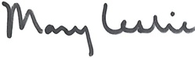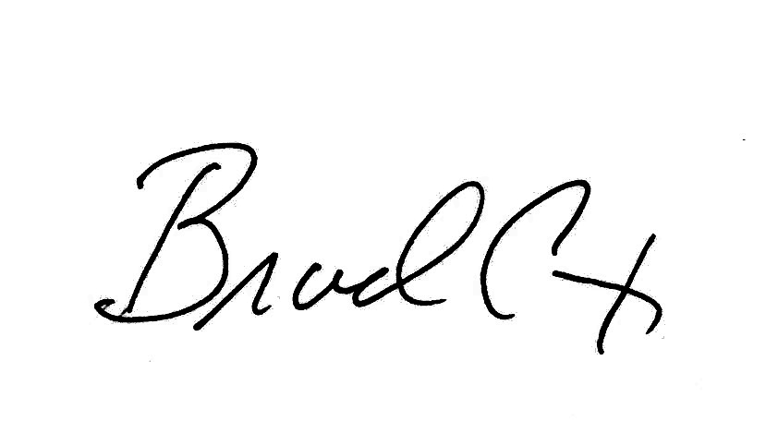
Mary Leslie Nadine Watt Brad Cox, LEED AP
LABC President LABC Chair LABC Institute Chairman

