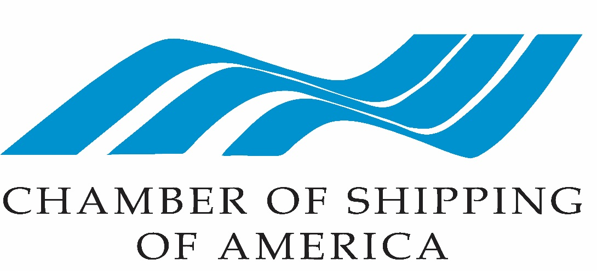
1730 Rhode Island Avenue, NW
Suite 702
Washington, DC 20036

December 9, 2019
Clerk of the Board
California Air Resources Board
1001 I Street
Sacramento, California 95812

Transmitted via email to: cotb@arb.ca.gov
bsoriano@arb.ca.gov
acsondes@arb.ca.gov

Subject: PROPOSED CONTROL MEASURE FOR OCEAN-GOING VESSELS AT BERTH

Thank you for the opportunity to provide comments on the proposed At-Berth Draft Regulation. We appreciate the many meetings held and outreach efforts CARB has taken to discuss these complex issues with the regulated community.

The Chamber of Shipping of America (CSA) represents 30 U.S. based companies that own, operate or charter oceangoing tankers, container ships, and other merchant vessels engaged in both the domestic and international trades. The Chamber also represents other entities that maintain a commercial interest in the operation of such oceangoing vessels. Our members operate internationally and off all coasts of the United States and regulations which have a direct operational and economic impact on these vessels are of continuing concern. The proposed CARB regulations will have a significant impact on the many CSA members that operate containerships, tankers, bulk carriers and roll-on roll-off vessels in California.

- While we agree that a deliberate and reasoned approach to the implementation of shore power is warranted, we do not believe this proposal meets those criteria both in the timelines established and across all regulated entities

- We are fully in agreement with the industry coalition vessel operators that this proposed regulation should not go forward without amendment. We believe that the industry alternatives currently being discussed, along with corrections to the existing rule for currently regulated fleets, should be substituted and CARB should allow the next step in the existing rule to be fully implemented for these existing regulated fleets. Equally as important is our concerns that this rule, provides no CARB approved alternative compliance options for many vessels especially those making infrequent calls to California and eliminates the fleet average compliance option used by the currently regulated vessels, leaving no margin for error and sets vessels up for failure despite all reasonable efforts to comply.

- We are aware that an industry coalition comprised of the Pacific Merchant Shipping Association (PMSA), the California Association of Port Authorities (CAPA), the Cruise Lines International Association (CLIA), the Western States Petroleum Association (WSPA) and the World Shipping Council (WSC) submitted extensive comments regarding the proposed measure SRIA and economic considerations regarding the development of the Proposed At Berth Control Measures in a letter dated August 26, 2019. Furthermore, the industry coalition proposed alternatives to the proposal in a letter dated February 15, 2019. To the best of our knowledge and as of this date, CARB staff has not responded to the submitters of these two documents, failed to include any reference to these documents and most certainly did not include the industry coalition proposed alternative in the SRIA. Therefore, we request that each of the issues identified in the Industry Coalition Proposed Alternative be addressed and responded to formally.

- The routes and berths of vessels regulated under the existing requirements are generally more predictable and regular than the operational characteristics of those vessels proposed to be added to the program. For example, many chartered vessels or vessels engaged in the tramp trade e.g. single voyage charters, may be directed very late in its voyage, to call at ports/berths based on the charterer’s needs at the time and thus 7 days advance notice to the terminal operator and operator of the CARB approved emission control strategy is not possible. The different commercial and operational scenarios across ship types must be incorporated into these discussions to enable a workable program for all entities.

- Critical to success in a program of this kind is that both sides of the ship/shore interface are fully integrated in a timely and safe manner, a point with which we are sure CARB agrees. However, in the proposed regulation, specifically under section 93130.14, there are deadlines for submitting a schedule for implementing equipment (terminals) or a schedule for installing equipment and/or any necessary construction projects (ports), there is absolutely no deadline for when that equipment must actually be installed. Vessels however must actually be prepared to plug in or use an alternative compliance method by the set dates contained in the proposed regulations. We believe this represents a complete disconnect between the hard timeline for vessels to comply and the timeline for terminals and ports to actually provide the necessary infrastructure to assure compliance. In this respect, we believe a set implementation date should be established for terminals and ports to provide the necessary shore based infrastructure which should be in line with the compliance timeline for vessels.

- While we applaud California’s leadership in addressing vessel emissions and the movement toward shore power or other alternative compliance mechanisms, it must be appreciated that the rest of the world is also struggling with how best to implement similar requirements. Given that shipping is global in nature and the diverse commercial and operating arrangements across multiple ship types and within ports, it is important to note that the International Maritime Organization’s (IMO) Maritime Safety Committee (MSC 98) proposed to develop mandatory and non-mandatory safety provisions for the cold ironing of ships and guidance on safe operation of on-shore power supply service in port, with work being led by the Ship’s System and Equipment Subcommittee (SSE). The acceptance of this issue as a work plan item recognizes the importance of global consistency across all ship types and port configurations. A Correspondence Group was established to further develop the guidelines taking into account technical standards established by the International Organization for Standardization (ISO), the International Electrotechnical Commission (IEC) and the Institute of Electrical and Electronic Engineers (IEEE) Standards Association. The SSE subcommittee focused initially on the operational safety aspects with further developments to incorporate a much needed uniform set of equipment standards as well as consideration of the need for amendments to SOLAS Chapter II-1 and II-2. The Guidelines are in draft form and further work will continue on this issue at SSE 7 to be held in March 2020. We urge CARB to recognize the complexity of this issue as it relates to multiple ship types and port/berth configurations and allow the IMO process to fully develop these guidelines before implementing CARB regulations for vessels not currently covered under the existing regulations.

- We would also like to support the very detailed comments submitted by the Pacific Merchant Shipping Association on this regulatory proposal on the way forward to enable the future program to be successful, achievable, practical and truly beneficial to the environment.

We thank you for the opportunity to submit these comments and would be pleased to answer any questions you may have with regard to issues identified.

Respectfully submitted,

Kathy J. Metcalf
President
Chamber of Shipping of America
202.775.4399
kmetcalf@knowships.org

