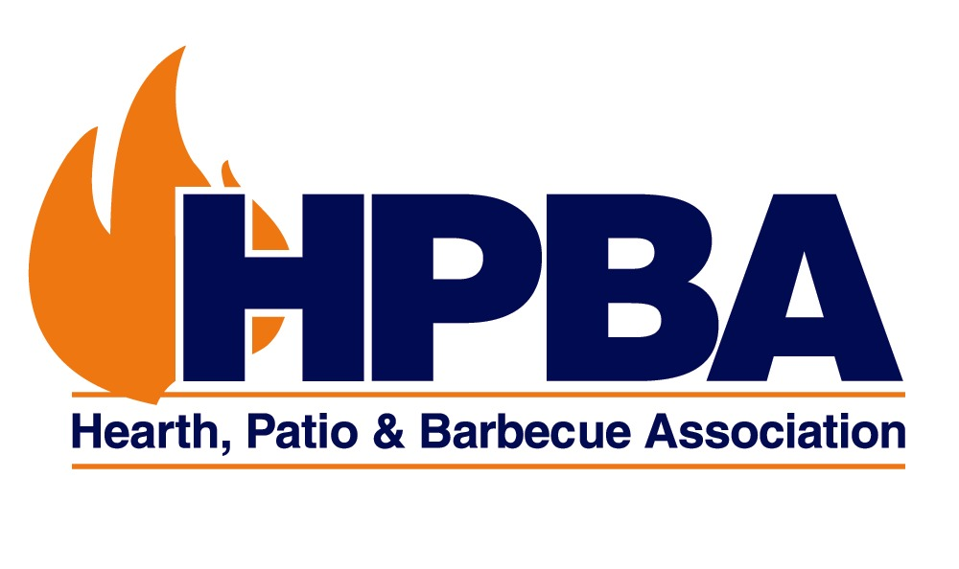
Suite 600, 1901 North Moore Street
Arlington, VA 22209 USA
Phone: (703) 522-0086 • Fax: (703) 522-0548
Email: hpbamail@hpba.org
Web Site: www.hpba.org

January 17, 2017

Richard Corey, Executive Officer
California Air Resources Board
Sacramento, California

RE: Proposed Short-Lived Climate Reduction Strategy

Dear Mr. Corey:

The Hearth, Patio & Barbecue Association is the North American trade association that represents residential wood-burning products, including woodstoves, and pellet stoves. Our comments on the Air Resources Board’s (ARB) Short-Lived Climate Pollutants (SLCP) strategy are informed by an understanding that many households in rural communities (particularly low income households) will continue to heat with wood. The changeouts contemplated in the SLCP are the most direct way to reduce black carbon and methane from these households, while providing the benefits of lower PM emissions, less wood use, and fewer structural fires related to historically poor installations.

Other commentators have decried the lack of solid data on the degree to which EPA-certified woodstoves reduce black carbon and methane emissions. In the long term, the program will benefit from more research on this issue – both in reviewing the technical support documents for in situ studies that form the basis of the EPA’s AP-42 emission database and studies on the newest EPA stoves. There is, however, no reason to believe that reductions in black carbon and methane emissions would be significantly different from the reductions in PM that are achieved when old stoves are replaced with new stoves. HPBA supports additional research on the issue by EPA or ARB.

Having closely followed and participated in more than 50 woodstove changeout programs, it is our experience that there is frequently a conflict between the desire to change out a large number of units (which can be accomplished with incentive vouchers) and the need to address the poorest families in the communities (who may be using the most wood per capita out of economic need). Low income families often live in marginal housing and utilize old, poorly-installed stoves, which can be difficult and expensive to replace. We strongly encourage the ARB to follow the model that EPA uses in the Targeted Airshed Grant Program, and many states have used in their own woodstove changeouts, which is to focus the program primarily on very low income households.

As with all changeouts, we are ready to work collaboratively with ARB or local districts on these types of programs. If you have any questions, or would like to discuss our comments further, please contact me at 916.536.2390 or crouch@hpba.org

John Crouch
Director of Public Affairs
HPBA Sacramento Office

