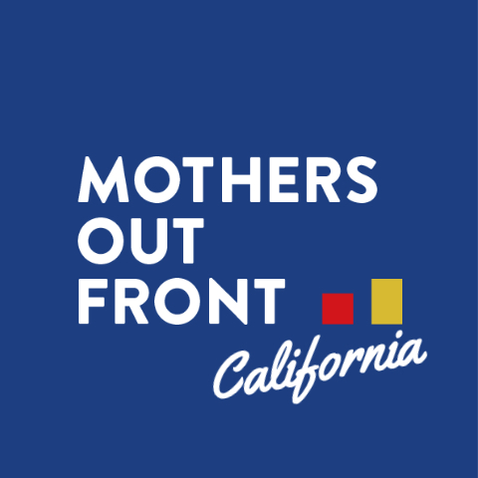

MOTHERS OUT FRONT’S PUBLIC COMMENT
AT THE CALIFORNIA AIR RESOURCE BOARD MEETING
November 19, 2020

Hello,

On behalf of Mothers Out Front, a growing grassroots movement of 35,000 mothers and others mobilizing for a livable climate for all children, I thank you for hosting this very important meeting.

My name is Hoai-An Truong. I serve on the leadership team of Mothers Out Front Silicon Valley, and I also work with Turnout4Transit led by the youth climate activists at Silicon Valley Youth Climate Action. I live in San Jose and while I’m not a mother, I am an aunt several times over and very concerned about the climate.

There is a 30-year lag between the time that greenhouse gases are emitted and when the effects are felt. The devastating wildfires we are experiencing today are largely due to emissions from 30 years ago.

Let me repeat this: There is a 30-year lag between the time that greenhouse gases are emitted and when the effects are felt. The devastating wildfires we are experiencing today are due to emissions from 30 years ago.

In 2018, California wildfires burned almost 2 million acres; in 2020, a record-shattering 4.2 million acres have burned. We cannot afford to continue exacerbating the conditions that cause such destructive fires and other climate impacts. The orange skies foretell increasing disaster, a warning which we must heed. We must limit, minimize and eventually eliminate the use of fracked gas within residences, businesses and office buildings to protect our climate as well as our health.

The science on the health harms of emissions from indoor and outdoor combustion appliances is clear. As mothers, we are especially alarmed by the fact that children growing up in homes with gas stoves are 42% more likely to experience symptoms of asthma.

We commend you for elevating the importance of indoor air quality and taking bold action to improve it. What we need now is leadership to act on the clear science on the health harms of emissions from indoor and outdoor combustion appliances. CARB has the power and ability to do something about this issue, and we are supportive of CARB taking more action on indoor air quality. As other states look to California for leadership on clean air issues, we hope that CARB can step up to the plate.

We have four specific asks of you today:

First, we urge CARB to meaningfully include the environmental justice community from day one in determining the strategy and process to improve indoor air quality.
There is an outsized health and environmental burden on communities of color. Solutions that address indoor air quality should align with other work to address the air pollution burden outdoors and ensure that these communities benefit from policies in a manner that is consistent with environmental justice principles. Solutions must prioritize BIPOC, low-income, disadvantaged and other vulnerable populations.

Second, we support you in setting more protective indoor air quality guidelines and to establish model rules for appliance regulation.
We urge CARB to update indoor air quality guidelines based on the latest science for common indoor pollutants like nitrogen dioxide and carbon monoxide. In addition, CARB should establish model rules for appliance regulation that can be reviewed and adopted by local air districts to limit emission from indoor appliances that vent outdoors.

Third, we urge you to develop regulation specifically targeting the emissions from gas appliances.
CARB should assess the total annual air pollution, greenhouse gas emissions and healthcare costs from gas appliances in residential and commercial facilities and develop a plan and regulations to reduce them and phase out gas appliance sales over time.

Fourth, we support you to continue pressing for rapid building decarbonization through Title 24 and Title 22 standards.
California cities and counties have passed reach codes that already exceed state standards, in direct response to their communities’ concerns about climate, health and safety. CARB needs to continue pressing for new building electrification in the 2022 update to Title 24, and to support the electrification of appliances by 2030.

Thank you for listening to this comment and for taking action to provide a healthy environment today and a livable climate tomorrow for our children and all Californians.

Contact Info:
info.ca.norcal@mothersoutfront.org

