March 18, 2021

Clerks’ Office
California Air Resources Board
1001 I Street
Sacramento, California 95814
https://www.arb.ca.gov/lispub/comm/bclist.php

Subject: Comments on Proposed Amendments to the California Consumer Products Regulation; Board Agenda Item # 21-2-1

Dear Board Members:

Diversified CPC International (Diversified) appreciates the opportunity to provide comments on the Initial Statement of Reason (ISOR) for the Consumer Products VOC Regulation.
Diversified CPC International is a supplier to the Consumer Products Industry. Diversified is a propellant supplier of liquefied propellants as well as HFC-152a and HFO-1234ze to the Aerosol Industry. Our company has a facility in the South Coast Air Quality Management District. Diversified CPC manufactures high purity natural gas liquid aerosol propellants at its processing facility in Anaheim, CA.
Diversified has worked closely with CARB on the Consumer Products VOC Regulation since the early 1990’s. These regulations not only effect California but our spread throughout the United States. Our comments are the following.
Adding Compounds to MIR Table
Diversified supports the proposal to add diethyl carbonate, 1-chloro-3,3,3-trifluoropropane, HFO-1233zd and alkane mixed-minimally 90% C13 and higher to the MIR table of Values. Diversified has supported the Reactivity Concept since it began.
CARB IPE Compressed Gas provision
Nearly two and a half years into the rule development, CARB staff proposed an IPE provision for the use of compressed gas as a way to reduce or offset the use of Global Warming Potential compounds used in Hairspray, Dry Shampoo’s and Personal Fragrances. Initially we applaud the staff’s creative thinking in using the IPE Provision. However, after closer review we cannot support this provision as proposed. This provision was released with less than 90 days to comment. Why would staff wait so long into the rule development process to release such a new concept?
As stated, after significant review and comment to the staff the provision is unclear and confusing. In addition, compressed gases have physical limitations which make formulating with these compounds difficult. Diversified requests that CARB staff add language to clarify the IPE such as calculations for volume and ozone formation potential in the criteria section of the IPE.
Diversified also supports the National Aerosol Association (NAA) provision to the IPE on Reactivity. CARB has used Reactivity in the past and Reactivity is sound science. The use of Reactivity allows for manufacturers to have more flexibility in reformulating.
Conclusion
Diversified thanks the staff for their hard work and ingenuity. Diversifies supports the addition of compounds to the MIR table. Unfortunately, at this time we cannot support the Compressed Gas IPE. However, we do request that the board direct staff to add the NAA proposal on Reactivity, or an alternate Reactivity provision for the IPE. This addition can be done during a 15-day notice period.
Thank you in advance for considering our comments. Any questions or comments feel free to contact our consultant Doug Raymond at 440-339-4539 or at djraymond@me.com.

Sincerely,
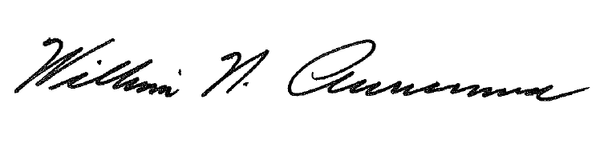
William N. Auriemma
President & CEO

Cc: Ravi.Ramalingam@arb.ca.gov
joe.calavita@arb.ca.gov
josh.berghouse@arb.ca.gov
david.edwards@arb.ca.gov
jose.gomez@arb.ca.gov

