The Center for Methane Emissions Solutions

Washington, DC

July 18, 2016

**BY EMAIL via** http://www.arb.ca.gov/lispub/comm/bclist.php

Clerk of the Board

California Air Resources Board

RE: The Proposed Regulation for Greenhouse Gas Emission Standards for Crude Oil and Natural Gas Facilities.

# The Center for Methane Emissions Solutions (CMES) is a coalition within a non-profit organization that represents the views of companies in the methane mitigation industry in the United States, including the leak detection and repair (LDAR) space.

# The methane mitigation industry is a robust and growing American industry. 72 companies have headquarters in the U.S., and there are approximately 570 methane mitigation facilities located across the country. These facilities are manufacturing plants, assembly facilities, service centers, service provider offices, and administrative offices.

In response to publication of the proposed Regulation for Greenhouse Gas Emission Standards for Crude Oil and Natural Gas Facilities, CMES offers these thoughts to help the ARB produce a final rule that provides the most practical, economic, and effective structure to capture methane emissions that would otherwise be released into the atmosphere. Capturing these emissions both enhances the revenue lines of oil and gas producers because they can monetize natural gas that would otherwise be wasted and also slows the detrimental environmental damage done by a greenhouse gas 84 times more potent than carbon dioxide.

**Colorado’s Regulation 7**

By way of background, we should note that we have watched carefully the implementation of Colorado’s Regulation 7, currently the most comprehensive set of methane waste regulations at the state level. No lawsuits have been filed to stop the implementation of the rule, and we are unaware of any significant effort to role back the rule legislatively or at the regulatory level. In an effort to understand why implementation of such a rigorous regime has gone so smoothly, CMES recently published a study of the oil and gas industry’s perceptions of the implementation of Colorado’s Regulation 7. The study is attached to these comments as Exhibit A.

Of the ten oil and gas operators who sat for in-depth interviews, Keating Research found that these companies had themselves conducted more than 1,100 site inspections at facilities over the past year. On average, oil and gas companies found methane leaks on 9 out 10 sites inspected. More importantly, oil and gas companies reported that implementing Colorado’s rule was very cost effective. When they took into account the natural gas they saved and sold because of their LDAR programs, 8 out of 10 said they had either profited, broken even, or paid just a little more under Colorado’s regulation. And 7 of 10 said that the benefits of the regulation outweighed the costs.

# Specific Available Technologies and an On-Ramp for Innovative Technologies to Come

# We understand that individual companies and other trade associations focused on particular technologies will likely submit comments as to specific provisions in the proposed rule that could be improved, with the perspective that as the oil and gas industry finds more leaks, technology is readily available to repair those leaks extremely economically. We certainly believe such comments should be given careful consideration.

# But we are very concerned that the proposed regulations do not contemplate the commercialization of new technologies which promise to dramatically reduce the cost of detection of methane leaks and promise to enhance the ability of the industry to measure leaks many fold. For example, the U.S. Department of Energy has funded research and development in 11 such companies under the ARPA-e Methane Monitor Program, and the successful companies in this program will be ready to go to market with their technologies within two to three years. We strongly believe that the new regulations should provide some process whereby these new commercial technologies are validated and are certified as useful to comply with the regulations. The U.S. EPA has provided for such an on-ramp in their final rule on new and modified sources of methane emissions in the oil and gas industry, and the Bureau of Land Management at the U.S. Department of the Interior has included such a process in their draft rule for new and existing sources on federal public lands.

# Method 21

One of the major flaws in the proposed regulations is the requirement that Method 21 be used to measure all leaks, in order to set the repair timetable for those leaks. That requirement will disincentivize the use of any other detection technology -- especially Optical Gas Imaging (OGI) technologies -- even though those detection technologies find leaks 15 times faster than Method 21 devices, find more leaks, find leaks in hard-to-reach areas for Method 21 devices, and are safer for oil and gas production workers to use. See the following case study of Jonah Energy’s experience with OGI technology: <http://www.ogj.com/whitepapers/2016/05/optical-gas-imaging-at-jonah-energy-saving-gas-and-saving-money-through-regular-ogi-surveys.html>. Put simply, oil and gas producers will not likely pay for a second detection technology if they know they need to use Method 21 in all events any way.

Forgoing these substantial benefits of OGI and alternative technologies in favor of Method 21 so that a repair timetable can be set seems particularly counter-productive, because the larger the leak, the more incentive an oil and gas producer will have to repair that leak faster, regardless of the regulations. The larger the leak, the more natural gas is wasted, and the greater the loss of revenue for the producer. Revenue to the bottom line will move the producer the repair the leak as fast, or maybe faster, than the regulations’ timetable.

It is true that Method 21 does measure the leaks, whereas as some OGI technologies do not. But it is important to remember that some currently available technologies do in fact measure leaks (and the chemical components of the leaks) and that research and development of technologies currently funded by the U.S. Department of Energy’s ARPA-e Monitor Program will produce commercially available methane measurement technologies that promise to be vastly more precise and cost-effective than Method 21 within two to three years. Thus, there is a strong probability that the proposed regulations will be outdated soon, requiring compliance with a much less precise technology.

So we would argue that on balance, the regulations should not forgo the benefits of OGI and other alternative technologies that are available now: the ability to find more leaks faster and technologies much safer for workers to use. Following Colorado’s example of not measuring the size of leaks but requiring all leaks – no matter what their size – to be repaired in 14 days will likely result in finding more leaks faster, and as study after study has found, roughly 9 out of 10 will be easily repaired in that period. We believe that removing the requirement that Method 21 always be employed will incentivize producers to use these alternative technologies and the result will be less methane released into the atmosphere than with the Method 21 requirement for the near term. As more cost-effective technologies with more precise measurement capabilities come to market, the regulations can be modified accordingly.

# Leak Detection and Repair

Our comments about the leak detection and repair sections of the proposed regulations are underwritten by several factual premises.

First, leaks are caused both by equipment failure and by operator error. In an exhaustive study of super-emitting leaks in the Barnett Shale region, the authors concluded that “equipment malfunctions and error-inducing workforce conditions are the most common causes of excess emissions related to avoidable operating conditions.” **(**Daniel Zavala-Araiza et al.,“Toward a Functional Definition of Methane Super-Emitters: Application to Natural Gas Production Sites,” *Environmental Science & Technology*, page 8172.) Thus, leaks cannot be predicted based on the age or quality of the equipment, as operator error can render such equipment ineffective.

# Second, while most of the leaks that occur are small, a minority of leaks are “super-emitters,” accounting for a disproportionate amount of methane emissions that could be avoided. A few leaks can account for 20% of the methane emissions in a particular region. (See David R. Lyon et al.. “Constructing a Spatially Resolved a Methane Emission Inventory for the Barnett Shale Region,” *Environmental Science & Technology*, pages 8147-8155.) Because methane leaks cannot be seen or smelled by oil and gas workers, even these large super-emitting leaks can go completely undetected.

# Third, once detected, it is almost always economic for the producer to repair these leaks. Such was the conclusion of a Carbon Limits study of data from 4,293 surveys of oil and gas facilities in the U.S. and Canada published in 2014:

# “The vast majority of leaks are economic to repair once identified: even assuming a low value of gas (3 USD per McF), leaks amounting to more than 97% of total leak emissions are worth repairing. In addition, over 90% are from leaks that can be repaired with a payback period of less than one year. This means that once the survey has been performed, it is economic to repair almost every leak, even at low gas prices.” (*Quantifying Cost-Effectiveness of Systematic Leak Detection and Repair Programs Using Infrared Cameras*, Carbon Limits Report CL-13-27, March of 2014, page 5.)

# These factual premises lead to the following conclusions regarding the proposed rule.

# We heartily endorse the proposed regulations’ requiring quarterly inspections, because:

# super-emitters contribute disproportionally to methane emissions in any particular region;

# without inspection an oil and gas producer cannot determine whether there exists a small or super-emitting leak;

# such super-emitting leaks can be just as easily be produced by operator error as by an equipment failure;

# the amount of methane released into the atmosphere by a super-emitting leaks can be enormous if such a leak goes undetected for up to six months;

# quarterly inspections result in methane emissions reductions 50% higher than the reductions produced by annual inspections (See *Economic Analysis of Methane Emission Reduction Opportunities in the U.S. Onshore Oil and Natural Gas Industries,* ICF International, page 3-10);

# the net present value of quarterly inspections (taking into account the natural gas not wasted if repaired quickly) is either neutral or, at worst case, only slightly negative (see Carbon Limits study, page 7); and

# early results from Colorado’s experience with requiring quarterly inspections suggests that quarterly inspections are either not a significant burden on oil and gas producers or a net positive, with early paybacks from recovering the otherwise waste natural gas.

# The ARB should not predicate frequency of inspections on the number of leaks found in the immediate past; rather, the Colorado regime for inspection frequency is more appropriate. There are two reasons for this:

# First, given that one of the causes of leaks is operator error, worker maintenance and operating mistakes can occur randomly and trigger leaks from otherwise the most effective components. And those errors may also cause large, super-emitting leaks. Past performance in this case is not a good predictor of future outcomes.

# Second, the incentives such a rule creates can be perverse. They may motivate producers not to find leaks and fix them, but rather to manage the detection and reporting of leaks to come within certain component percentage thresholds. Such a rule would divert producers from the main goals of the rule itself.

# The ARB should reconsider the provisions in paragraph 95699(o) that prohibit leaks at any facility over a certain number or should clarify what will be the enforcement protocol for violations of this subparagraph. Remember that leaks, and large ones in particular, cannot always be predicted and have a random dimension, often due to operator error. It would seem that the goal should be to reduce the frequency of leaks and the fast repair of those leaks when they are found. The regulations’ requirements of regular quarterly inspections of facilities and components advances the goal, and perhaps some certification by producers that they have in place rigorous worker training programs would be similarly helpful. But to unduly penalize producers for exceeding a certain number of leaks within a time period when the offending leak is caused by a single worker’s failure to adequately close a hatch, seems counter-productive. It may incentivize operators to hide the excessive leak and avoid repair of the leak for some period of time, which is precisely not the result the regulations are trying to achieve.

# Centrifugal Compressors

We generally support the language in the proposed regulations regarding centrifugal compressors and their focus on wet seals that fail. In particular, we agree with the provisions of subparagraph 95668(e)(7), highlighting the value of retrofitting from a wet oil seal to a dry seal. It is true that the switch to dry gas seal is not technically feasible in all circumstances, but in many instances, the use of dry gas seal technology for centrifugal compressors is technically, environmentally and economically the most viable option. Dry gas compressor seals are installed with a control system that monitors the performance, health and emissions of the shaft seal. These control systems are integrated with the facilities digital monitoring systems allowing access to the data required to meet the reporting requirements of state and federal regulations.

We should note that the Fluid Seals Association (FSA) has developed a *life cycle cost calculator* tool for centrifugal compressors to analyze the relative merits of the various options and will make the toolavailable to help determine what might be the Best System of Emission Reduction. It takes into consideration the annual operating costs including maintenance costs, the value of leaked gas, consumables, the cost of all the energy consumed and the cost of lost production resulting from seal failure which is quite considerable in wet seal systems. This comprehensive tool calculates, amongst other factors, the energy consumed from the seal and the support system, the compressed gas energy released, and the pipe friction from oil contamination. Taking into account one-time costs such as total retrofit costs, it calculates payback period, the present value of the annual operating costs over the lifespan remaining, and the total life cycle cost.

The *life cycle cost calculator*, developed by FSA Mechanical Seal Division members can be tailored to local conditions for individual cases and thus can help our oil and gas customers confirm the economic and environmental value propositions between re-routing the gas, flaring, or retrofitting the centrifugal compressors with dry gas seal technology.

# Submitted on behalf of the Center for Methane Emissions Solutions by:

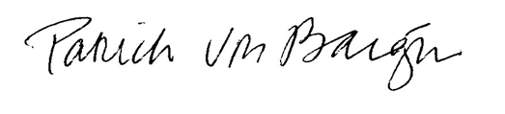

# Patrick Von Bargen

# Executive Director

# [patrick@methanesolutions.org](mailto:patrick@methanesolutions.org)

**EXHIBIT A**

**From: Chris Keating, Keating Research, Inc.**

**Date: April 10, 2016**

**Re: *The Colorado Case Study On Methane Emissions: Conversations With The Oil And Gas Industry***

**Key Findings From Interviews With Representatives Of Companies That Are Conducting Site Inspections To Detect Methane Leaks At Oil and Gas Operations In Colorado**

*These key findings are based on 30 minute telephone interviews among 10 representatives of oil and gas companies and 3rd party suppliers that are conducting site inspections to detect methane gas leaks at oil and gas operations in Colorado as required under Colorado’s Regulation 7. Interviews were conducted with representatives from larger oil and gas producers, smaller producers and leading companies in the third party service provider industry. These interviews were conducted on behalf of the Center For Methane Emissions Solutions by Keating Research from December 7, 2015 to January 31, 2016.*

*To complete these 10 interviews, Keating Research contacted 35 oil and gas companies in Colorado and invited each of them to be interviewed about their experience with Colorado’s Regulation 7. Interviews were completed with representatives of all of the oil and gas companies that expressed a willingness to participate in this research.*

***Colorado oil and gas companies have conducted thousands of site inspections over the past year as required under Colorado’s Regulation 7.***

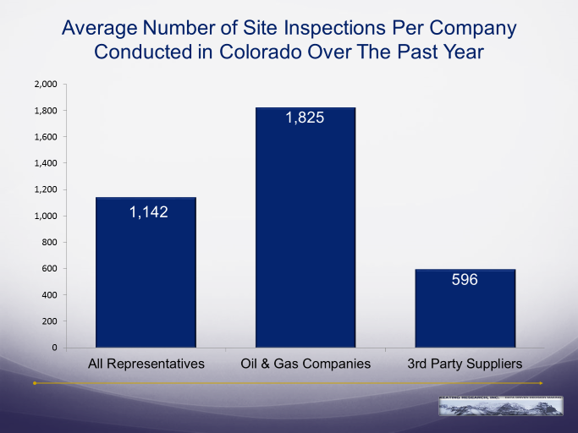In fact, the companies interviewed here conducted more than 1,100 site inspections on average at their oil and gas operations in Colorado over the past year.[1]

**The inspections are working to help find methane leaks.** When we ask representatives to tell us how many methane leaks they are finding during a *typical* site inspection, **they report finding 2 to 3 methane gas leaks on average, and they find at least one methane gas leak in 9-out-of-10 typical site inspections.**

As a result of these site inspections over the past year, these representatives tell us, on average, that their company found more than 800 methane leaks in Colorado.

The equipment most predominately used to detect these methane leaks during a site inspection is an *infrared gas imaging and detection camera*. Eight-of-ten representatives say they commonly use an infrared gas imaging and detection camera to detect leaks, while the remaining say they most often use a portable methane detector unit.

The infrared gas imaging camera does not allow the user to determine how much methane was leaking by volume, so representatives were unable to give us specifics on exactly how much methane was escaping from the leaks that they found.

***Most of the methane leaks are described as small and easily fixed within a few days.***

The vast majority (88%) of methane leaks that were found during site inspections over the past year are described as a small leaks, while about 1-in-10 are described as large, significant leaks.

**In 9-of-10 cases the representatives agree that the cause of the leak is typically something simple such as an open valve or a loose connection or seal**, while only 1-in-10 of the leaks are considered more problematic than that.

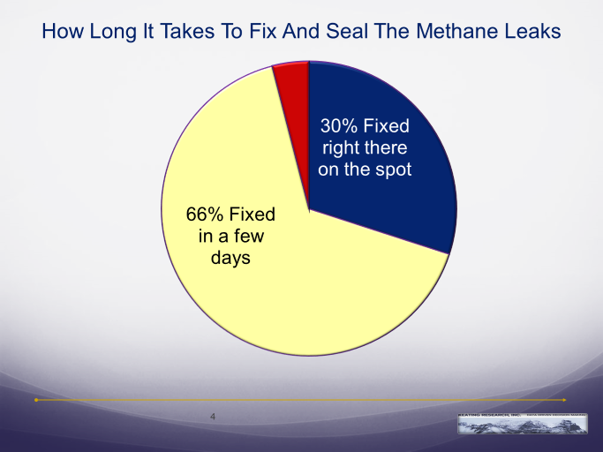When it comes to fixing the leaks, if the repair is simple enough an attempt is made to make the repair right then on the spot, and **nearly all of the leaks are either *fixed right there on the spot* (30%) or *fixed within a few days* (66%)**.

In fact, representatives indicate that a repair technician typically moves around with the team finding and repairing the methane leaks. Only a very small proportion of the leaks take longer than a few days to fix.

Representatives tell us that the small methane leaks are primarily found in *regulators / controllers*, *separators*, *valves and tank hatches*.

The cause of the leak is typically *debris*, a *loose connection* or *wear and tear* on the equipment. Specific examples given in the survey of equipment that was found to be leaking and the cause of the leak include the following:

*T-12 thermostat regulator. The cause was dirt or debris in the component.*

*Packing on a valve. It was caused by a loose bolt.*

*High low controllers. The controller was faulty.*

*Loose fittings on separators. Most common is tanks.*

*Valve and flow line. It was caused by the age of the equipment.*

*Seal on a tank hatch. Debris caused the seal to leak*

*Hatch. The cause would be wear and tear.*

*Numeric devices. Loose packing.*

*The hatches on the storage tanks and the cause is over pressure of the storage tanks.*

*Well head the casing tubing is leaking because of its age.*

*Threading connections, high low controllers the thief patch seal, T-12 and liquid levels.*

*Flange, where to parts fit together and the seal of the flange will leak.*

*Pipe connection leak and the clamp was loose.*

*Leaks on a vapor line. Because of bad fittings.*

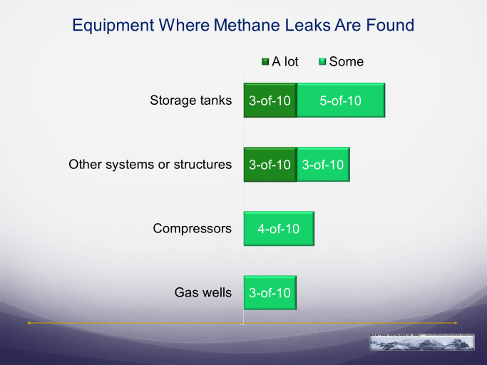**Colorado’s oil and gas companies are finding leaks across all types of equipment at the site, with the most leaks in the storage tanks**, 8-of-10 representatives say that they are finding *a lot* or *some* leaks in the storage tanks.

Methane leaks are also typically found in systems other than gas wells and compressors, 6-of-10 representatives say that they are finding *a lot* or *some* leaks in the other systems or structures.

The methane leaks in the other systems or structures are primarily found in the *piping*, *threaded connections* or the *regulators*. Representatives describe the following types of methane leaks they are finding on other systems or structures:

*Pumps or valves or connectors.*

*Small connections like fittings, thermostat regulators, and pressure regulators.*

*Threaded connection.*

*Separators.*

*Piping and plumbing. Fitting valves and valve packing.*

*Pipe connections that have small leaks and they are fixed on the spot or at least a few days.*

*Emission control devices. Two and three phrase separators and vapor recovery towers.*

*Storage facilities, piping, controllers.*

*Emission controls or vapor line piping.*

***Oil and gas company representatives agree that Regulation 7 significantly reduces methane emissions in Colorado.***

What is most encouraging is that oil and gas company representatives are taking notice that finding and fixing the thousands of methane leaks under Regulation 7 is reducing methane emissions in Colorado. Six-of-ten representatives *agree* with the statement – **Regulation 7 significantly reduces methane emissions in Colorado**, compared to 3-of-10 who *disagree*.

Four-of-ten representatives feel that Regulation 7 is improving air quality and reducing methane emissions *a great deal* or *quite a bit*, while the remaining say that these aspects are improving *somewhat*.

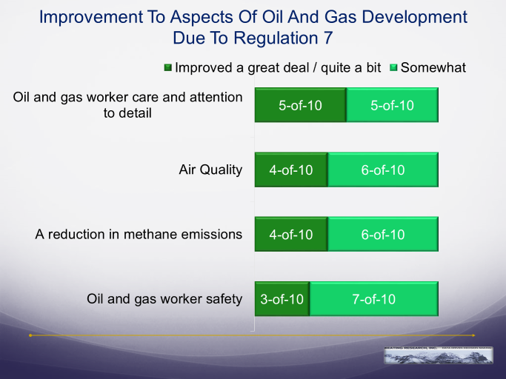**In addition to reducing emissions and improving air quality, oil and gas company representatives also believe that Colorado Regulation 7 improves their companies’ efficiency – it improves oil and gas worker care, attention to detail, and safety.**

At the top of the list is oil and gas worker care and attention to detail, 5-of-10 representatives say worker care and attention to detail is improving *a great deal* or *quite a bit*, while the remaining say worker care and attention to detail is improving *somewhat*.

***Eight-of-ten of oil and gas company representatives say that in the long run they are profiting, coming out even, or paying out just a little more than they are collecting in new revenue because of Colorado’s Regulation 7.***

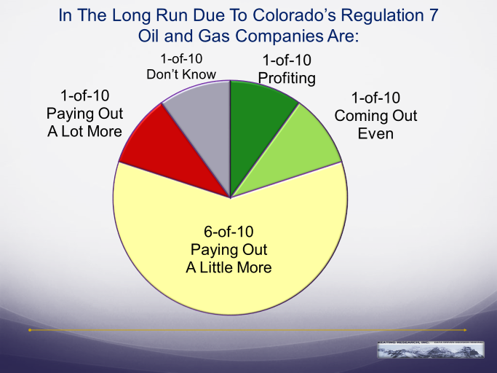Oil and gas company representatives understand that when they balance out the money they are spending to find and fix the methane leaks against the additional revenues they are receiving from the gas they are recapturing, 8-of-10 say that they are profiting, coming out even or paying out *a little* more money than they are collecting in new revenue.

Only 1-in-10 say that they are paying out *a lot* more money to find a fix the leaks than they are collecting in new revenue.

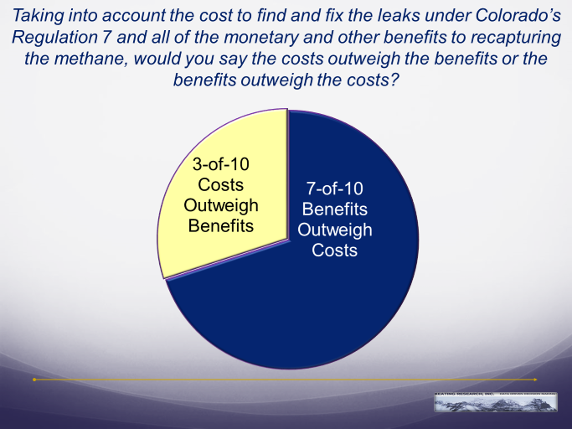***Oil and gas company representatives believe the benefits to finding and fixing the leaks under Colorado’s Regulation 7 outweigh the costs.***

In fact, when all of the monetary and other benefits from Regulation 7 are taken into consideration, representatives are more than twice as likely to say that the benefits outweigh the costs. A full 7-of-10 believe all of the benefits of Regulation 7 outweigh all of its costs.

*Chris Keating, Ph.D., President and founder of Keating Research, has worked as a public opinion pollster in Colorado for the past 21 years. Keating Research has established itself as the leading survey research firm in Colorado, having conducted hundreds of survey research projects in Colorado and Denver alone.*

1. A site inspection is defined as when they go out to an area or property with oil and gas operations to do an inspection for methane gas leaks.