October 30, 2015
Coalition on Agricultural Greenhouse Gases  1201 Connecticut Avenue, NW, Suite 300  Washington, DC 20036  (O)571-312-6139  (M)202-701-4298  www.c-agg.org  dreed@drdassociates.org | 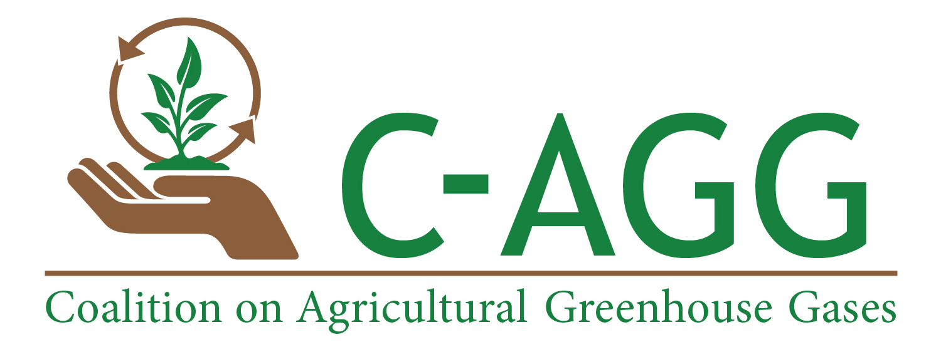

California Air Resources Board
1001 I Street, Sacramento, CA 95814
Submitted to: (add portal link here)
C-AGG Background:
The Coalition on Agricultural Greenhouse Gases (C-AGG) is a multi-stakeholder coalition of agricultural producers, scientists, environmental ngo’s, methodology experts and developers, carbon investors, and project developers that promotes the development and adoption of science-based policies, programs, methodologies, protocols and tools for greenhouse gas (GHG) emissions reductions and carbon sequestration from the agricultural sector. C-AGG supports capacity-building and concrete approaches to incentivize voluntary GHG emissions reduction opportunities for agricultural producers that enhance productivity and income generation opportunities while benefiting society.
C-AGG Comments on ARB Short-Lived Climate Pollutants (SLCP) Draft Strategy
C-AGG commends the state of California for continuing to take a leadership role in cutting emissions of CO₂, and in developing a strategy to cut emissions of SLCP, which can immediately slow global climate change and the impacts of climate change. Among the options identified in the draft strategy to combat SLCP emissions, voluntary incentive-based reductions are included, as are market-supporting activities and regulatory action.
SLCP and Dairies. The Draft Strategy notes that California already has offset protocols under the Cap-and-Trade program to limit methane emissions; this includes the Compliance Offset Protocol Livestock Projects, first adopted in 2011 and revised in 2014. The Compliance Offset Protocol Livestock Projects provides methods to quantify and report greenhouse gas (GHG) emission reductions associated with the installation of a biogas control system (BCS) for manure management on dairy cattle and swine farms. The protocol focuses on quantifying the change in methane emissions, but also accounts for effects on carbon dioxide emissions.
As noted on Page ES8 and again on Page 45 of the Draft Strategy, CARB intends to develop a regulation by 2018 to require avoiding or capturing methane from manure management at new and expanded dairies (emphasis added). To ensure that market signals remain strong and consistent for potential investors and investments to install methane digesters on existing dairies, C-AGG recommends that ARB’s SLCP Strategy explicitly state that methane digesters installed on existing dairies after the 2018 regulations will still qualify to generate compliance offset credits under the Compliance Offset Protocol Livestock Projects, as long as they do not accompany an expansion of the dairy. In particular, since the footnote on Page 45 refers to “new projects” as opposed to “new dairies”, this statement is necessary to ensure that the intended regulation does not apply to existing dairies.
Additionally, ARB should clearly define what constitutes an expansion of a dairy so that it is unambiguous both to dairy owners and operators, to ARB, and to other stakeholders. Both of these clarifying additions should help to avoid any confusion interpreting the regulation.
A number of factors have contributed to a low installation rate of methane digesters in CA since the Compliance Offset Protocol Livestock Projects took effect in 2011. Among these reasons are the following:
- High equipment and installation costs for digesters
- Conflicting permitting and other regulatory requirements in the state, including air quality standards for Best Available Control Technologies (BACT) requirements for NOx that have prevented some existing methane digesters from upgrading engines or expanding digesters
- Lack of or difficulty accessing net metering in some areas of the state and with some energy providers
- Variable technological and operational successes associated with methane digesters
To remove the offset signal now – a critical financial and investment signal - will erode investor confidence in agricultural offsets in general (given that the agricultural sector is an uncapped sector in the cap-and-trade program), and will impact the financial viability of these projects. Currently, compliance offset credits in the CA market represent a significant potential portion of revenue from dairy digesters; to remove this revenue stream before digesters are installed on as many dairies as possible will undermine CA’s SLCP plan and make installations more costly to dairy owners and to the State.
C-AGG applauds the acknowledgment in the SLCP Draft Strategy that financial incentives will be required to help increase methane digester installation rates across the state. The Draft Strategy includes a stated focus on alignment of financial incentives with improved manure management practices (on pages 45 and 46). The following statements underscore the need for funding and incentives to install methane digesters on dairies in the state:
“Continued and likely increased State funding or incentives is important to support initial infrastructure, to prove technologies and market opportunities that are necessary to scale potential solutions. CDFA estimates that at least $100 million per year for five years will be needed to support the development of necessary manure management infrastructure, in the form of grants or loans or other incentive payments.”
Continued availability of compliance offset generation represents both an investment by the state and an incentive for others to invest in methane digester installations, and is aligned with the stated goal of fostering markets (page 46), including for other environmental and ecosystem benefits associate with methane digester co-products, such as soil amendments and environmental credits.
The SCLP Draft Strategy states that it adopts the national dairy industry goal of reducing enteric emissions 25% by 2030, compared to current levels. The national dairy industry goal is actually a 25% reduction in enteric emissions and on-farm emissions by 2020; it is not limited to nor does it solely apply to enteric methane emissions. We urge CARB to invest in the necessary research, together with the national dairy industry, to help foster innovative ways to reduce enteric methane emissions without altering productivity or animal comfort.
We again urge ARB to revisit CA’s inventory on methane, since some researchers in CA have indicated that the inventory does not appear to show the appropriate proportions of methane emissions from enteric and manure sources from livestock.
One tactic identified in the Draft Strategy to help incentivize reduced SLCP from dairies is …”labeling programs to recognize leading companies in the market place, including those producing milk with low levels of dairy methane emissions…” C-AGG applauds the desire to differentiate good actors and innovators who are able to reduce their methane footprints, but cautions against unfairly penalizing dairies without the same level of resources or the same ability to reduce emissions in the same timeframe as others. To the extent that the state develops and makes available financing and other incentives to dairies in the state, it must ensure that these opportunities are equally available to dairies across the state, of all sizes, and for differing existing management practices to avoid choosing winners and losers. Otherwise, an unintended consequence of this approach may be to unnecessarily harm small dairies without the same level of resources and the same ability to take advantage of resources as larger dairies. The dairy industry at the national level and the agricultural sector in general is currently working to achieve sustainability in a pre-competitive fashion in order to engage as many participants as possible and to avoid potential negative, unintended consequences from differentiation.
SLCP and GWPs. C-AGG agrees with ARB (as indicated on pages 21 and 22) that utilization of Global Warming Potentials (GWP) with a time horizon of 20 years better capture the importance of SLCP. Particularly since CARB is recommending policies based on the SLCP Strategy, C-AGG believes it is essential to utilize the best available science with regards to GWP and the impacts of climate pollutants in a 20-year , versus a 100-year timeframe. Emissions estimates presented in the report are calculated using 20-year GWP; given that the IPCC and scientists globally are raising alarms that the impacts of climate change are being felt earlier than many predictions, mitigation actions are needed now, and a focus on mitigation actions with the highest impact in the shortest timeframe is wise. ARB should consider utilizing the 20-year GWP for methane as part of the Compliance Offset Protocol Livestock Projects in order to enhance the incentives, and thus the uptake, of projects to abate methane emissions in a more timely fashion.
Compost and Soil Amendments. C-AGG agrees with ARB that enhanced market development for the use of compost and soil amendments, including biochar, is a constructive SLCP strategy. Enhanced waste utilization and value-added use of waste will continue to build a more sustainable society, and to the extent this includes agricultural wastes and applications, a more sustainable agricultural sector. The acknowledgment and inclusion of soil health initiatives is critical to not only mitigate climate change through increased soil carbon sequestration and reduced soil carbon losses, but is also critical to build agricultural sector resilience and adaptation to climate change. Increased soil carbon and organic matter content increases soil moisture retention, reduces erosion from wind and water, and improves soil fertility and productivity while drawing down atmospheric carbon.
Biochar is a particular technology in this area deserving of further research and demonstration. We note that a Biochar Offset Methodology was recently adopted by the CAPCOA GHG Exchange; utilization of that methodology across the state will help to demonstrate the beneficial impacts of biochar as a soil amendment, and further elucidate cost-effective approaches to biochar production and utilization systems.
Achieving Success. C-AGG congratulates CARB on its focus on integrated and coordinated planning to help achieve the aggressive SLCP strategy, and its acknowledgment of and identification of financial investment pathways to help achieve success. Leveraging limited public resources through private sector engagement will require a continued focus on investment strategies and signals that bring and keep investors and private sector partners to the table. Continued investments in agricultural sector offsets, and in the enacted Compliance Offset Protocol Livestock Projects, will be critical to retain and continue to attract the many private sector entities seeking to participate in carbon markets as a means to mitigate climate change, including a host of new ecosystem service market investors seeking to deliver multiple ecosystem service benefits common to agricultural and land use offsets.
Finally, coordination with Subnational, Federal, and International Partners will be essential to replicate the successes achieved in CA. CA’s leadership in climate change policies and programs is globally recognized, and the state’s ability to help other jurisdictions achieve the same successes will help to ensure a needed global response to the climate change issue in a more timely fashion.
We look forward to next steps in this process, and thank ARB for the ability to comment on the SLCP Draft Strategy. We would be happy to provide any additional input or clarification of these comments if desired.
Sincerely,
Debbie Reed
Executive Director
Coalition on Agricultural Greenhouse Gases (C-AGG)
1201 Connecticut Avenue, NW, Suite 300
Washington, DC 20036
(O)571-312-6139
(M)202-701-4298
www.c-agg.org
dreed@drdassociates.org

