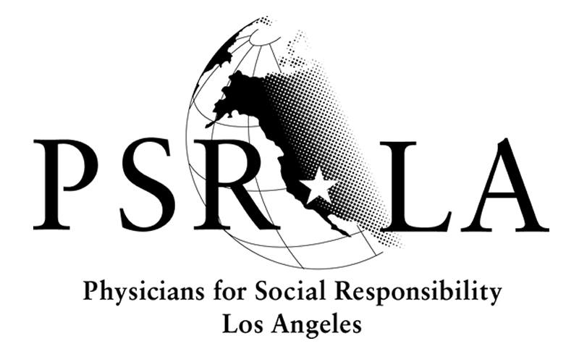
The physician and health advocate voice for a world free from nuclear threats and a safe, healthy environment for all communities.

July 8, 2016

Mr. Richard Corey, Executive Officer
California Air Resources Board
1001 I Street
Sacramento, CA 95814

Re: Physicians for Social Responsibility Los Angeles Comments to 2030 Target Scoping Plan Update Concept Paper

Dear Mr. Corey:

On behalf of the Physicians for Social Responsibility Los Angeles (PSR-LA) we respectfully submit these comments on the 2030 Target Scoping Plan Update Concept Paper. PSR- LA brings the physician and health professional voice outside of the clinic and to important topics such as climate change. Our members understand that their patients live in communities that have a legacy of being overlooked by regulators and overburdened by polluters. They recognize that any strategy to meet climate targets must put the needs of environmental justice communities at the center. Our comments below reflect the health protective principles that guide us as an organization. We believe strategies like the 2030 Scoping Plan update must place a similar emphasis of health and equity.

The health costs associated with air pollution and climate change are staggering. Asthma alone costs families and the state over $208 million every year. A RAND Corporation study found that air pollution costs federal, state, and private health insurers $193 million in hospital costs alone.

The most recent State of the Air Report by the American Lung Association proved that there remains a lot of work to do. 32 million Californians (84%) are negatively affected by air pollution.

By aggressively addressing climate change with a focus on direct emission reductions, we have the opportunity to do right by the planet and the communities impacted by poor air quality. Strong action and consideration of cumulative impacts will bring health benefits to the communities that need it most.

Recommendations:
Overall we are pleased to see that this concept paper recognizes the importance of the Environmental Justice Advisory Committee (EJAC) and the concerns of environmental justice communities. PSR-LA is very excited by the series of community workshops to be held throughout the state to allow community members to provide insight into the EJAC’s recommendations. It is important that these recommendations are considered carefully as the Draft 2030 Scoping Plan is developed. In its prior iterations, the recommendations by EJAC did not receive the incorporation or attention we believe they deserved. We hope that after this robust community ground-truthing process, the work of EJAC is used as a base layer that CARB can build upon. We would like to echo our support of the EJAC’s long-standing position on international forest offsets. Programs like this fail our communities by allowing polluters to continue business as usual and continue to harm health in the places where folks live, work, and play.

PSR-LA would also like to recommend that the timeline for the Scoping Plan update be extended. An extension will allow for more meaningful community participation and take into account the analysis by the Office of Environmental Health and Hazard Assessment on impacts of AB 32 implementation on disadvantaged communities. Findings from this report should be considered in the Scoping Plan update and a delay in the timeline would make this feasible.

Climate investments present an incredible opportunity for our communities to build resiliency and transition into the new clean energy economy. However, the reality of gentrification weighs heavily on our ally social change organizations and their community members. Greater communication among CARB, organizations like the Strategic Growth Council, and local grassroots organizations is crucial to creating solutions that allow investment without displacement.
The AB 32 Adaptive Management Plan should provide for proactive, science-based, and community-driven solutions when unintended environmental justice impacts and inequities are discovered. CARB must be able to act quickly to mitigate or fix the harm, and respect the intent of this tool – to act on early warnings like the findings from the first iteration of the adaptive management tool. The program should also be strengthened by measuring co-pollutants in addition to greenhouse gases.
The state should regularly produce a public health impact assessment that studies the health impacts of the state’s climate programs, particularly in disadvantaged communities, on a regularly basis (at a minimum every two years). The upcoming OEHHA Analysis on AB 32 and Environmental Justice is a good start but regular analysis will provide the comprehensive feedback and enrich our programs.
We are excited by the many ideas existing in the concept paper and look forward to further analysis of the Concepts 2,3,and 4. We strongly support looking to alternatives to Cap and Trade as it fails to provide the emissions reductions needed and are worried about evidence showing increases in emissions and potential hotspots.

As a member of EJAC we stand in support of all the EJAC recommendations.

PSR-LA appreciates your consideration of our comments and if you have any questions please contact me at (213)-689-9170 or marguello@psr-la.org.

Sincerely,

Martha Dina Argüello

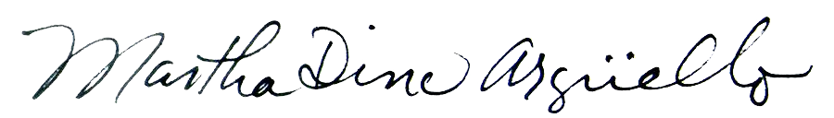
PSR-LA | 617 S. Olive St, Ste. 200, Los Angeles, CA 90014 | phone 213-689-9170 | fax 213-689-9199 | email info@psr-la.org | www.psr-la.org
PSR-LA | 617 S. Olive St, Ste. 200, Los Angeles, CA 90014 | phone 213-689-9170 | fax 213-689-9199 | email info@psr-la.org | www.psr-la.org
PSR-LA | 617 S. Olive St, Ste. 200, Los Angeles, CA 90014 | phone 213-689-9170 | fax 213-689-9199 | email info@psr-la.org | www.psr-la.org
PSR-LA | 617 S. Olive St, Ste. 200, Los Angeles, CA 90014 | phone 213-689-9170 | fax 213-689-9199 | email info@psr-la.org | www.psr-la.org

PHI Costs of Environmental Health Conditions in California Children
2010, RAND Corporation, Cost and Health Consequences of Air Pollution in California
2016 State of the Air Report, American Lung Association

