February 26, 2017

California Air Resources Board
1001 I Street
Sacramento, CA 95814

RE: 2030 Target Draft Scoping Plan

Dear CARB and stakeholders,

We appreciate your work to reduce GHG emissions and are thank you for the opportunity to comment on the CARB 2030 Target Scoping Plan.

For context, the Unitarian Universalist Fellowship of San Dieguito is a non-profit religious organization that seeks to affirm seven principles of faith: 1) The inherent worth and dignity of every person; 2) Justice, equity and compassion in human relations; 3) Acceptance of one another and encouragement to spiritual growth in our congregations; 4) A free and responsible search for truth and meaning; 5) The right of conscience and the use of the democratic process within our congregations and in society at large; 6) The goal of world community with peace, liberty, and justice for all; 7) Respect for the interdependent web of all existence of which we are a part. Based on these collective values, our vision for our fellowship and world includes sustainable living. It is with these principles and vision foremost in our minds that we write to express our comments regarding the CARB 2030 Target Scoping Plan.

We are concerned about climate change and the economic drain on our local economy from importing fossil fuels into our state. We have analyzed the economic effects of importing over $100 billion in fossil fuels from outside California, and we believe that replacing imported fossil fuels with locally produced renewable energy will stimulate our local economy. Our research regarding Cap and Trade (C&T), which has been tried since 2012, shows it to be ineffective in reducing GHGs. Our analysis of the British Columbia carbon tax and of the relevant articles cited in your Scoping Plan, led us to conclude that the tax, while too low, has had moderate success. We believe that California can reduce GHG emissions while stimulating the local renewable energy sector of our state economy in an efficient and equitable manner through a carbon fee/tax and dividend. In this letter, we present government data supporting our findings.

As mentioned, we advocate a carbon tax and dividend. If the tax is downstream near the consumer, an additional tax on leaks, particularly wellhead leaks such as Aliso Canyon, would be an important component. If the tax is upstream, it must be structured to include all GHG emissions from fossil fuels, including those that escape through leakage. In order to avoid hardship and further efficiency and equity, it would be necessary to return most of the revenue to California residents in the form of a dividend, divided equally among all residents, with half shares for children. A portion of the revenue could be used to fund other state-sponsored programs.

We understand your concern “If we set the price too high, we have made the program unnecessarily expensive, and if we set the price too low, we will not achieve enough GHG reductions.” We believe that there is little risk to setting the carbon tax too high, as this will only serve to decrease fossil fuel consumption and stimulate the economy, provided that the tax is accompanied by a corresponding tax credit (dividend) paid to each resident. We also believe that it is possible to ascertain the correct level of the tax by an examination of our own state’s history with fluctuating gas prices.

California’s history with high gas prices evinces the effects of $4.00/gallon pricing on consumption and on the renewable energy sector of our state’s economy. Your own 2014 report, “Impacts of Gas Price on Passenger Vehicle Use and Greenhouse Gas Emissions” states:

Overall, changes in gas price can lead to significant effects on travel behavior, with some (usually limited) effects visible in the short run and (most) others measurable only after several years (long-run effects).

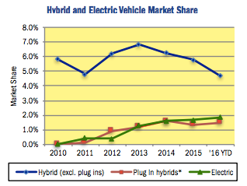
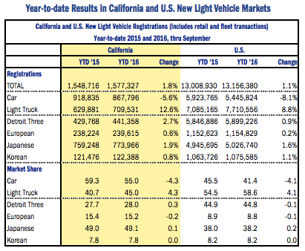
In 2014, when gas prices exceeded $4.00/gallon, purchases of hybrid vehicles increased and carpools became more common. (See charts below.) Now that gas prices have been under $3.00 for nearly a year, light trucks sales have begun to increase, while car sales have decreased.
The consumer response to price fluctuation supports a carbon tax in the range of $100-150/metric ton ($0.88 - $1.32/gallon) as an ideal first step, phased in slowly and possibly followed by additional increases, to motivate Californians to reduce their consumption of gasoline.

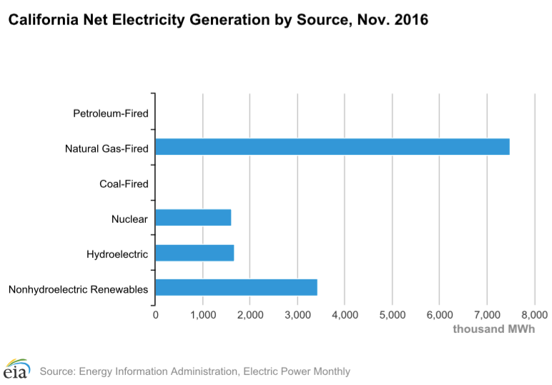
Although there is little recent data regarding the price elasticity of demand for fossil fuels other than gasoline, the increased production of renewable energy in California over the last couple of years indicates that Californians are ready and eager to substitute local renewable energy for imported fossil fuels. According to the EIA, from December 2015 to December 2016, the net generation of electricity from small-scale solar generation increased 28%. During the same period, utilities increased electric generation from 786,000MW to 988,000MW. Our state is now producing over 5% of our electricity from solar energy, and nearly half from renewable sources. (See California Net Electricity Generation by Source chart below.) This recent surge indicates that we are at a tipping point where a tax on carbon would lead to a significant increase in investment of renewable energy. Yet Sempra and other electric providers are still advocating for constructing additional gas-fired power plants. A carbon tax would provide strong motivation to abandon such plans and construct additional solar farms, wind farms, and hydroelectric plants. A carbon tax would speed the shift, which has already begun, but is happening too slowly, from fossil fuels to renewable sources such as solar, wind, and hydroelectric.

We believe that some of the assessments in the Scoping Plan were based on a misunderstanding of the BC report “Trends in Greenhouse Gas Emissions in B.C. (1990-2014)”. The Scoping Plan states “BC’s emissions have increased by 2.7 percent from 2011 through 2014,” citing this report. This is a misrepresentation in various ways. The BC tax was implemented in 2008, and amended in 2010 to phase out the exclusion of forestry related emissions for biofuels such as biodiesel, ethanol, and hydrogenated vegetable oil (HVO). Emissions from 2011 to 2014 are more closely related to the 2010 amendment than to the 2008 implementation of the tax itself. Furthermore, the same report states that emissions dropped from 66.3 Mt CO2e in 2007 to 62.7 Mt CO2e in 2014, a decrease of 5.5%. To fully understand the effect on the tax, it is important to look at additional data, such as GHG data from 2007, GDP data, and population data.

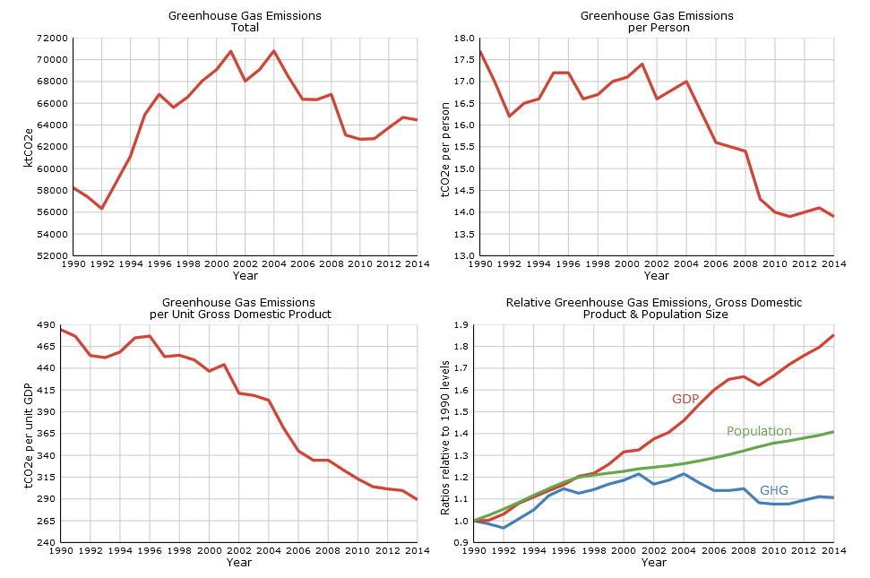
As you can see from the Greenhouse Gas Emissions charts below, GHG emissions seem to have decreased after the tax, but not substantially. In relation to population and GDP, GHG emissions seem to have decreased substantially. This trend began just before the tax was implemented, which could indicate a weak correlation between the tax and emissions. However, that could be due to fossil fuel price variations. Fossil fuel prices spiked in 2008, then dropped precipitously; in late 2009, fossil fuel prices began to rise again, and continued until 2012, when they plateaued for two years and then fell. It is likely that the BC tax, at only CAD$30/ton, approximately US$22.50/ton, implemented slowly over years when fuel prices were fluctuating, was too low to have a particularly substantial impact on emissions.
BC Greenhouse Gas Emissions

CARB, in the Scoping Plan, expresses a concern regarding an “unnecessarily expensive” carbon tax, but does not specify exactly what that concern is. Based on our assumption that your concern is economic, we will address the effects on the economy here. We do ask, however, that you specify your concern if it is not an economic one.

If revenues from the carbon tax are used primarily to pay a dividend to residents, there is no concern that the economy will be stifled. Rather, it will be stimulated by the shift from fossil fuels imported from outside the state to local renewable energy.

The costs to California of these imported fuels is substantial. According to the EIA, California spent a total of $137,720 million on energy in 2014, including $102,265 million for fossil fuels (oil, gas and coal), and $35,455 million for “other” forms of energy. Of the $102,265 million spent on fossil fuels, $86,002 million was for 629.5 million barrels of oil, $16,128 million was for 2,351 billion cubic feet of natural gas, and $135 million was for 1.7 million short tons of coal. From a fiscal perspective, this would be fine if that money stayed in our state. But it doesn’t. In contrast with renewable energy which is produced locally, very little of the fossil fuels we consume are produced within our state. California only produced 204,699 barrels of oil, 218,590 million cubic feet of gas, and no coal. Thus, California imports 68% of its oil at a cost of approx. $58,481 million; 91% of its natural gas at a cost of $14,676 million and 100% of its coal at a cost of $135 million, equating to a total cost of $73,292 million for imported fossil fuel.

And this is not all. A significant portion of the $35,455 million for “other” was spent to import electricity. $562 million was paid to Canada and Mexico to import 12,369,304 million MW of electricity from Canada and Mexico. An additional 79,719,494 million MW of electricity was also imported from other states, at varying prices, which likely cost over $30,000 million. When this is added to the $73,292 million paid for imported fossil fuels, we find that over $100 billion is being sent from California to outside our state for fossil fuels. An aggressive carbon tax will incentivize us to buy local renewable energy, thus enabling us to keep much of that $100+ billion in our state. This would be a tremendous boon to our economy.

Another important effect of a carbon tax is psychological. Our state could make a tremendous statement regarding the environmental cost of GHGs by being the first to implement a carbon tax. Even if the tax is too small to have a measurable impact on emissions and needs to be accompanied by a cap and trade system, a tax on carbon would make a statement about our state and about our understanding of the impact of fossil fuels. This, in and of itself, is important.

With regard to Cap and Trade (C&T), there are a number of issues that were not addressed by your Scoping Plan. First, the major beneficiaries of C&T are the Wall Street firms, such as Goldman Sachs and J.P. Morgan, which create the market for carbon offset. Other beneficiaries include developers of renewable energy projects outside California. This is a cost to our state and a drain on our economy.

Second, the economists, Chichilniski, Heal and Starett, who developed the concept of C&T back in the 1990’s and pushed it through Kyoto, have basically abandoned it as unworkable.

Finally, the assertion that C&T provides emissions certainty is unfounded. Emissions have increased since the implementation of C&T in 2012. The downward emissions trend that began in 2007, ended in 2011, at 352.4 mill metric tons CO2, and then went up. In 2014 it was 358.0 mill metric tons (See California Carbon Dioxide Emissions, below).
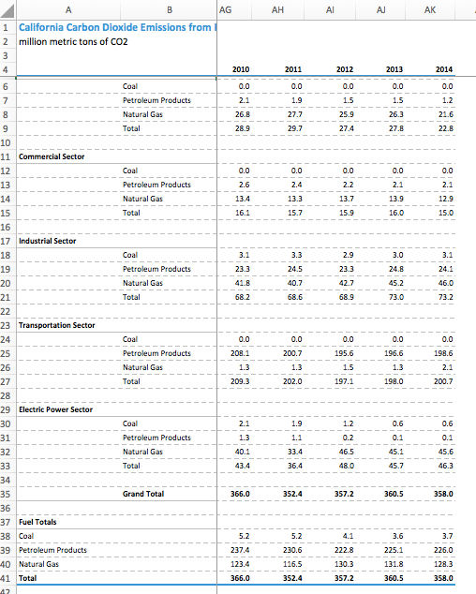

In conclusion, we believe that a carbon tax/fee and dividend can provide an effective, efficient and equitable means of enabling our state to meet or exceed our emissions reductions targets while also stimulating our state’s economy.

We appreciate your work to promote the health and well-being of our state and the planet, and we are thankful for the opportunity to comment on your Scoping Plan. Please do not hesitate to contact Laura Colban (858-692-2528 lauracolban@gmail.com) if you have any questions.

Sincerely,

by unanimous vote of the Board of Directors of the Unitarian Universalist Fellowship of San Dieguito
Alisa Guralnick, President
Mark Tuller, Vice President
Heather Stroud, Secretary
Rich Franswa
Bob Quick
Clint Stoddard
Alison Schlick
Rev. Meghan Cefalu

https://www.arb.ca.gov/cc/sb375/policies/gasprice/gasprice_bkgd.pdf
http://large.stanford.edu/courses/2016/ph240/wang1/docs/cncda-nov16.pdf
http://www.eia.gov/electricity/monthly/epm_table_grapher.cfm?t=epmt_1_17_a
http://www.env.gov.bc.ca/soe/indicators/sustainability/ghg-emissions.html
http://www.eia.gov/dnav/pet/hist/LeafHandler.ashx?n=PET&s=EMM_EPM0_PTE_NUS_DPG&f=A
https://www.eia.gov/state/data.cfm?sid=CA#ConsumptionExpenditures
https://www.eia.gov/dnav/pet/pet_crd_crpdn_adc_mbbl_a.htm
http://www.eia.gov/electricity/state/california/ See table 10 of Excel file.
https://www.eia.gov/environment/emissions/state/

