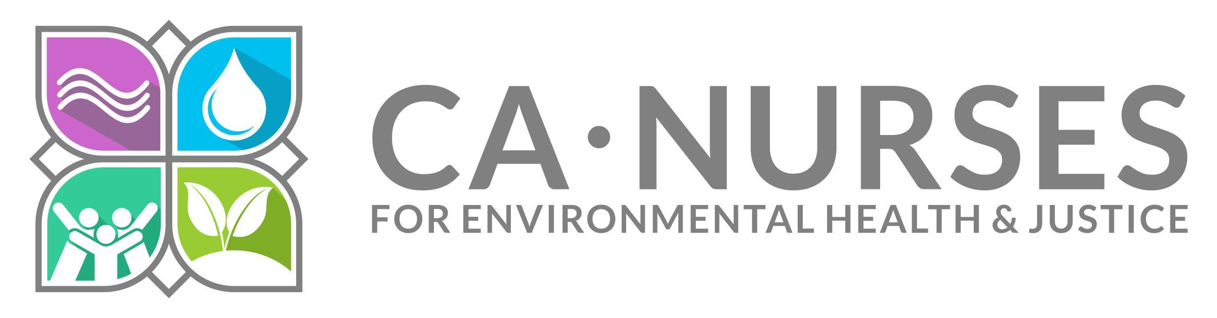
June 12, 2023

Clerk of the Board
California Air Resources Board
Submitted electronically

Comments on the Proposed Amendments to the Greenhouse Gas Emission
Standards for Crude Oil and Natural Gas Facilities
As nurses who live and work in communities impacted by the oil and gas industry, we strongly support the California Air Resources Board’s amendments to the state oil and methane regulations to better comply with the U.S. Environmental Protection Agency’s requirements for California’s State Implementation Plan. We also have suggestions to strengthen the amendments.

We care for patients as registered nurses, nurse practitioners, nurse clinical specialists, occupational health nurses, public health nurses and school nurses. Methane emissions are linked to emission of co-pollutant volatile organic compounds (VOCs) involved in ozone formation. Methane is also linked to climate change as a potent greenhouse gas. Poor air quality, including ozone non-attainment, leads to multiple poor health outcomes, such as increased hospital and urgent care visits for asthma and COPD exacerbations, increased cardiac events, increased rates of chronic illnesses and cancer, and decreased longevity. In the recent past, leakage of VOCs into soil, which then percolated into houses, resulted in months-long evacuations and long-term health risks for residents. Recent methane leaks discovered in Kern County have worried the residents, especially the high percentage of tested wells that have active methane leaks. We look forward to satellite detection in the future and applaud those efforts.

In addition, climate change promotes more severe wildfires, and longer exposure to wildfire smoke leads to increasingly severe health and public health emergencies as our patients are exposed to particulate matter, particularly for those who must continue to work outside such as in agricultural work or construction. Toxic wildfire smoke exposure results in increased respiratory and cardiac emergencies and includes cognitive impacts such as increased rates of dementia and learning impairments in the long-term. The communities impacted by wildfires are also impacted by extreme winter storms and flooding; due to the double impact of climate change exacerbated emergencies, they experience loss of housing, employment, health facilities, and infrastructure, besides reduced community cohesiveness and the tragic loss of lives.

We would like to emphasize that stronger regulation of methane emissions and the co-pollutant VOCs will protect the most vulnerable among us. Pregnant individuals, infants, children, adolescents and the elderly are all less able for physiological and social/behavioral reasons to protect themselves from environmental contaminants. Exposure is increased through higher resting respiratory rates in the young and the body systems that would protect our patients are ineffective through immaturity or the effects of aging. They cannot always wear masks or transport themselves to safety in case of emergencies. By protecting the most vulnerable, our entire community will be safer. It is not enough to protect only working adults.

We support the 350 Sacramento/Climate Action California letter and the proposed changes to the amendments which would move us closer to protecting the most vulnerable. In particular, we support their proposed amendment to subarticle 95675 that “each metric ton of methane emitted in violation of this subarticle constitute a separate violation” to raise methane violations to the level of CO2 violations contained in other regulations.

In regard to subarticle 95688(b)(2)-(4), we question the assumption that well stimulation treatment (WST) is declining, and that circulation tank regulations do not need to be strengthened. Due to the delay in implementation of the set-back ruling, permits for WST have increased and those of us who live in communities with oil extraction can view on a daily basis WST equipment at oil wells near housing, schools, and medical facilities. This was not seen at this level in 2022. We would like to believe that fracking and WST will end in 2024, but the fossil fuel industry has delayed any reduction in their operations, even to the extent of suing the governor and the state with the goal of being permitted to continue fracking more and more wells. In light of this industry’s resistance to regulation, please consider addressing the lack of adequate technology and inadequate regulation of WST operations, including cessation of those operations, for now at least within 3200 feet of vulnerable populations. In addition, carbon capture and sequestration are planned for many of these same locations in the very near future, which will impact methane, CO2 and VOC emissions.

We also urge testing for volatile organic compounds when methane leaks are discovered, which is not a current practice. We expect CARB and CalGEM to coordinate efforts to put this testing into policy and into practice soon because the impacted communities have requested this on multiple occasions.

Sincerely,

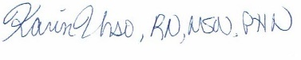
Karin Urso, RN, MSN, PHN
karinurso@att.net
California Nurses for Environmental Health and Justice
Acting Fossil Fuel, Air Quality, and Transportation Committee Chair
www.calnursesforehj.org

