Michael Shaw
Vice President, Government Relations

November 4, 2016

Mary Jane Coombs
California Air Resources Board
1001 I Street, 2nd Floor
Sacramento, California 95814

RE: CMTA Comments on ARB Informal Staff Proposal on Cap-and-Trade Regulation Industry Assistance Factor Calculation

Ms. Coombs,

The California Manufacturers & Technology Association (CMTA) respectfully submits the following comments on the Cap-and-Trade Regulation Industry Assistance Factor Calculation Informal Staff Proposal. We appreciate the opportunity to comment on this important proceeding and support ARB’s effort to reduce GHG emissions while protecting California industry.

CMTA works to improve and enhance a strong business climate for California's 30,000 manufacturing, processing and technology based companies. Since 1918, CMTA has worked with state government to develop balanced laws, effective regulations and sound public policies to stimulate economic growth and create new jobs while safeguarding the state's environmental resources. CMTA represents 400 businesses from the entire manufacturing community -- an economic sector that generates more than $230 billion every year and employs more than 1.2 million Californians.

A WELL-DESIGNED CAP-AND-TRADE PROGRAM REMAINS MOST COST EFFECTIVE STRATEGY
CMTA continues to support the development of a well-designed cap-and-trade program that supports cost effective opportunities for covered entities to meet their compliance obligations to reduce GHG emissions. With varying abilities of manufacturers to reduce GHG emissions at a particular facility, it makes sense to create a number of options for companies to comply. The cap-and-trade program along with offset credits help control compliance costs while meeting obligations to reduce emissions.

LEAKAGE RISK RESEARCH DOES NOT FULLY ACCOUNT FOR IMPACT ON MANUFACTURERS
As CMTA pointed out in June 10th comments, the leakage risk studies mandated by Board Resolutions 11-32 and 12-33 fail to appropriately assess leakage risk created by the significant cost increases. The NERA Economic Consulting firm that accompanied our comments focused on the adequacy of the data, robustness of the results, and applicability of the approach to determine leakage risk for policy application based on the information provided in the study papers. Continuing to rely on this information creates an unreliable basis for efforts to reduce GHG emissions as the understated leakage risk means that emissions-related activities are more likely to leave California and increase outside of jurisdictions that fully account for the cost in the way California does.

Given the significant potential financial impact of these changes, CMTA believes that ARB should address post-2020 industry assistance factors in a separate 45-day comment period as the impact of the proposed changes represents significant cost increases to those covered entities.

INCREASED COMPLIANCE COSTS RESULT IN ECONOMIC,GHG LEAKAGE
The proposed changes to assistance factors for the post-2020 period directly affect more than 30 CMTA members resulting in significantly higher compliance costs that make the state less attractive to manufacturing facility investments and job growth. California already lags the nation in manufacturing investments drawing in less than a quarter of the investments in new and expanded facilities than the rest of the nation and consequently the state also sees growth well below the national trend.

The proposed assistance factor adjustments threaten the continued prosperity of some highly mobile industries, including our landmark aerospace sector by 94 percent, breweries by 49 percent and paper products by 54 percent or more. Other California industries also face major assistance factor reductions that will increase the likelihood of emissions leakage. Some of these industries have been characterized as energy-intensive and trade-exposed, but these proposed assistance factor adjustments seem to ignore the impact of increased compliance costs and place these sensitive industries at greater risk.

Manufacturers are highly sensitive to increased costs and react negatively to imbalances created when costs are imposed in one region versus another where they are not. The increased cost raises the possibility of the emissions activity leaving California and picking up elsewhere as the company faces stiff domestic and international competition.

The loss of existing manufacturing is not the only form of leakage risk facing California. As manufacturing returns to the U.S. from overseas, much of that growth is occurring in other states resulting in emissions and jobs that do not fall under California's reduction program.

INCREASED EMISSIONS FROM TRANSPORTATION
The loss of manufacturing in California means that more inputs and finished products will need to be shipped into and through California in order to meet consumer demand. It is unreasonable to expect consumer demand for basic products, such as cereal, toilet paper, alcohol or gasoline, to change significantly. However, it is to be expected that where those products are manufactured will change as these manufacturers face increased costs in the millions and tens of millions of dollars annually.

This is true particularly in the case of unique California facilities that only face out-of-state or international competition.

CONCLUSION
It is critical that ARB err heavily on the side of reducing the risk of leakage both in terms of GHG emissions and jobs. ARB should retract the proposed assistance factor adjustments and maximize the industry assistance in order to minimize impacts to California. It is highly recommended that ARB also look to maintain the current level of industry assistance through the third compliance period rather than follow through with projected cuts. California can remain a national and international leader without placing its middle-class job creating manufacturing sector at greater risk.

I look forward to working with you on this and future climate change policy issues. Please do not hesitate to contact me regarding this matter to answer any questions or concerns you may have.

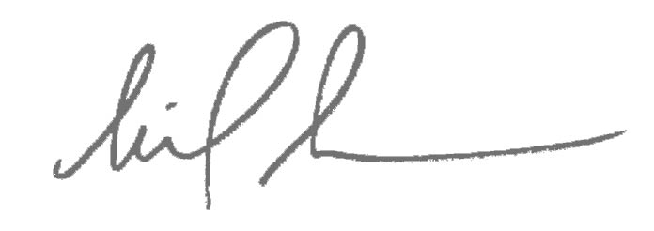
Sincerely,

Michael Shaw

