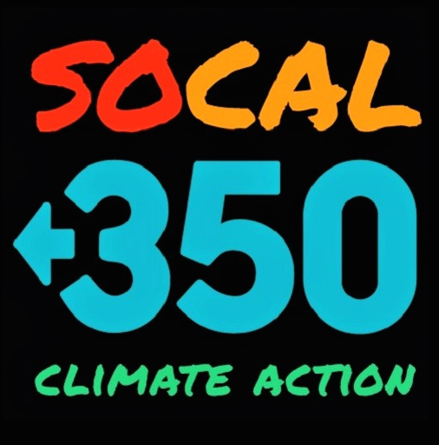

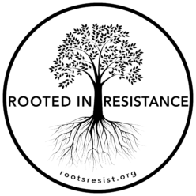

December 8, 2019

Mary Nichols, Chair
California Air Resources Board
1001 I Street
Sacramento, CA 95814

RE: Support for a stronger Advanced Clean Trucks standard

Dear Chair Nichols and Members of the Board,
Our organizations are writing to ask the California Air Resources Board (CARB) to set a more stringent Advanced Clean Trucks rule.
Residents of our communities of the Greater Los Angeles Area live in neighborhoods of major California cities. They also live adjacent to the San Pedro Bay ports and freight passageways, and in the shadows of vast warehouse complexes which increasingly crowd residential sectors of the Inland Empire.

Too many of our neighborhoods, especially communities of color and those whose residents are predominantly low-income, are exposed to the serious health challenges caused by toxic diesel particulate matter from heavy-duty trucks hauling goods to remote distribution centers.

Throughout the Southland our members are also greatly concerned about diesel trucks’ smog-forming greenhouse gas emissions as well as their disproportionate contribution to the alarming increase in global warming.

We encourage you to significantly strengthen the proposed targets by specifying a minimum of 15% zero-emission trucks on the road in the next ten years. You will effectively stimulate manufacturers to develop both the existing and promising electric truck technology at the more rapid rate that our health, a family-supporting clean-tech workforce, and our climate emergency all require.
Sincerely,

350 Riverside, Claudia Y. Custodio, Steering Committee Member
350 South Bay Los Angeles, Sherry Anne Lear, Co-organizer
SoCal 350 Climate Action, Jack Eidt, Co-founder
Sunrise Inland Empire, Courtney Smith, Hub Coordinator
Indivisible Alta-Pasadena, John Jackson, Organizer
Indivisible group, Rooted in Resistance, Ruth Richardson, Co-leader
Indivisible Suffragists, Virginia Robbins, Secretary
Ban SUP (Single Use Plastics), Anita Ghazarian, Vice-lead

