January 7, 2022

Public Comment for CARB’s LCFS Program
Promoting Biochar to Advance California’s Climate Goals

Biochar is well known for its many contributions to soil health, including a variety of ecosystem services such water retention, supporting biodiversity, and increasing productivity of the state's essential agricultural sector. Less recognized is its potential to contribute to long-term carbon sequestration, particularly through stabilization of waste biomass that would otherwise be burnt or decompose into methane and other greenhouse gas emissions. It is essential for leading state agencies like CARB to recognize biochar’s mitigation potential for several reasons:

- Biochar as a soil amendment has a long history, but conventional biochar production and recycling pathways are relatively inefficient and emission-intensive.
- Many varieties of biochar can sequester carbon for centuries. Thus, biochar can make essential contributions to California's short- and medium-term mitigation objectives, reducing the state's contribution to global warming risk until more permanent mitigation and sequestration strategies are developed and deployed.
- California currently produces more than 54MT of waste biomass per year, representing an "emissions overhang" of organic material that threatens more immediate release methane and other greenhouse gases through burning and/or decomposition. Today, the volume of this waste is accelerating because of more determined public and private wildfire risk management strategies, while burning restrictions are increasing the biomass loads of state landfills.

Biochar needs to be officially recognized and incentivized for its mitigation potential. This will increase incentives to reduce emissions from burning and biomass decomposition, advance biofuel production and carbon sequestration, and promote innovation to develop more stable and carbon-retentive biochar.

We recommend that CARB explicitly recognize biochar’s mitigation potential with LCFS accreditation, working with the state’s research community to develop a pathway certification program that grades and credits biochar for sequestration potential, rewarding innovation for its important contributions to climate, food, and economic security.

CARB should also consider the work of the International Biochar Initiative (IBI), which has extensive data to support the scientific basis for the use of biochar to sequester carbon. The IBI has developed a scientifically based classification tool that could be used by CARB. See example below.

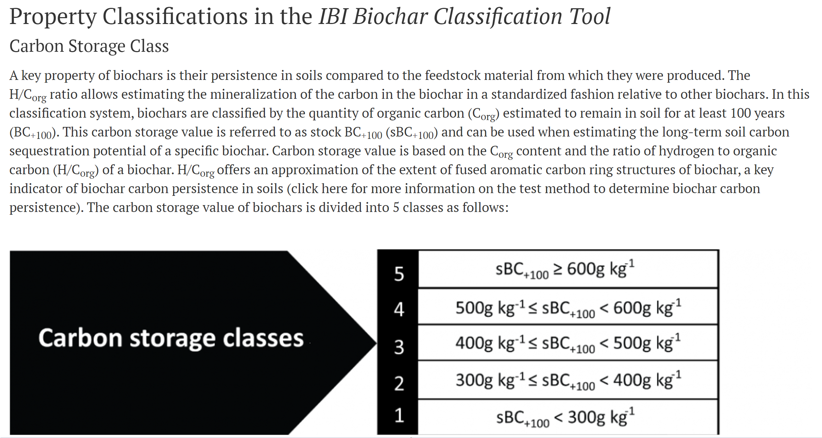
https://biochar-international.org/biochar-classification-tool/

Thank you for your consideration.

Respectfully,
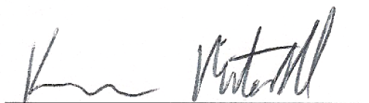
Kieran Mitchell
CEO, Caribou Biofuels
kieran@cariboubiofuels.com
510-421-0365

The latent CO2 in this waste material equals about ¼ of California’s current emission cap.

