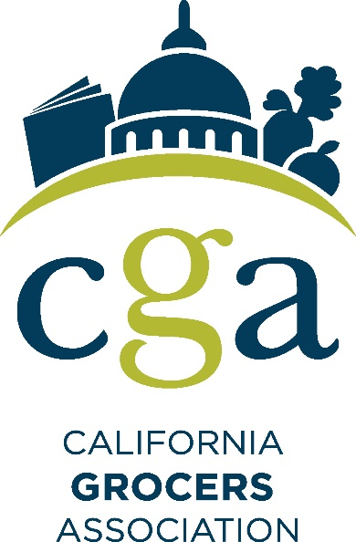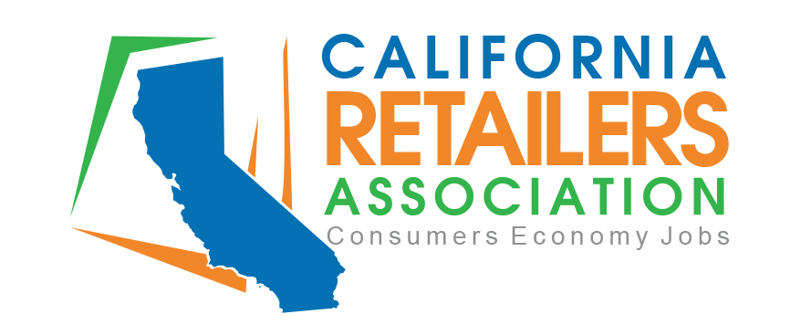

Risk Reduction Branch
Transportation and Toxics Division
California Air Resources Board
1001 I Street, P.O. Box 2815

To whom it may concern,

We appreciate the ability to comment on the proposed Transportation refrigeration unit (TRU) regulations. Representing the foremost retail and food industries in California, the California Grocers Association and the California Retailers Association request that the Board pursue the most cost-effective options for emissions reductions while maintaining availability and access for consumers to fresh and healthy food options which often require refrigeration.

In this vein, we request the Board strongly consider research by the California Trucking Association which suggests that the bulk of emissions reductions being sought under this proposal can be achieved by a single control measure that would require all diesel engines in trailer TRUs, domestic shipping container TRUs, railcar TRUs, and TRU generator sets that operate in California to meet U.S. EPA Tier 4 emission standards for 25-50 hp engines. Focusing on measures that maximize reductions before other, more marginal measures may be the best way to achieve emissions goals while minimizing the impact to consumers and other public health matters.

Pursuing cost-effective options for emissions reductions is important for grocery consumers. It is important to note that any significant economic impacts of the TRU Regulation to grocery refrigeration and operations would effectively counteract other state and federal efforts to expand food access. A report by the Department of Food and Agriculture (CDFA) pursuant to the California Healthy Foods Financing Initiative of 2011 found that low-income communities have 20 percent fewer sources of healthy food when compared with higher-income communities, and nationally, those communities have 25 percent fewer chain supermarkets than their middle-income neighborhoods. State initiatives to address “food deserts” include the Healthy Stores Refrigeration Grant Program, enacted by the 2018 Budget Act, which provides grants for small retail and corner stores to purchase energy efficient refrigeration equipment in low-income or low-access areas throughout the state to stock California-grown fresh produce, nuts, and minimally processed foods.

While “food deserts” and lower income areas may be more negatively affected by these regulations, rural and fire-prone areas to suburban neighborhoods will likely be impacted by them as well. When looking at the recent PG&E, SoCal Edison, and SDG&E Public Safety Power Shutdowns (PSPS), hundreds of thousands of Californians have been left without power for days at a time. Residents’ food spoils quickly and they need replenishments more frequently than normal. Grocery and distribution centers affected by these PSPS events need to keep food at safe temperatures and stay open to help their neighbors. This requires the utilization of varying methods of refrigeration, including TRUs that may need to be running for unknown amounts of time. We ask that the Board look at how emergencies and PSPS events will impact the utilization of these and to include reasonable measures into regulation to allow for the heightened operation of these units when appropriate.

Another critical need to be considered for the health of all Californians is preserving easy access to school meal programs for students. The dairy agricultural community takes sustainability and improving food and nutrition security seriously and are committed to continually improving the sustainable production of essential nutrient-rich dairy foods in California. According to the Dairy Council of California, scientific research confirms that milk, yogurt and cheese offer a unique package of nutrients – including calcium, Vitamin D, potassium and more – that work together to provide multiple health benefits including optimal growth and development in children and reduced risk in chronic diseases such as Type 2 diabetes and heart disease. However, by age 6 most children are not meeting the recommended daily servings from the dairy food group. There is compelling evidence linking food insecurity to poor health outcomes. With children and families living with food insecurity, providing access to nutritious and wholesome foods is essential to helping children reach their full potential as adults. One example of this critical safety net is the school meal programs. Research tells us that eating school breakfast every day is associated with improved academic and health outcomes among children and adolescents. It is important to ensure reasonable approaches to regulations are considering the need to maintain accessibility of these vital programs for California’s youth.

The California Grocers Association is a non-profit, statewide trade association representing the food industry since 1898. CGA represents approximately 500 retail members operating over 6,000 food stores in California, Nevada, and Oregon, and approximately 300 grocery supplier companies. Traditional supermarkets in California employ more than 300,000 residents in virtually every community in the State. CGA members supply Californians with their basic needs of food, drink, and other supplies on a daily basis.

The California Retailers Association is the only statewide trade association representing all segments of the retail industry including general merchandise, department stores, mass merchandisers, fast food restaurants, convenience stores, supermarkets and grocery stores, chain drug, and specialty retail such as auto, vision, jewelry, hardware, and home stores. CRA works on behalf of California’s retail industry, which currently operates over 164,200 stores with sales in excess of $571 billion annually and employing over three million Californians – nearly one-fifth of California’s total employment.

Thank you for your consideration of these critical issues as you move forward with developing these regulations with health, emissions, and fiscal responsibility for all Californians in mind.

Thank you,
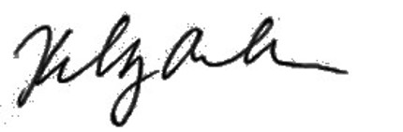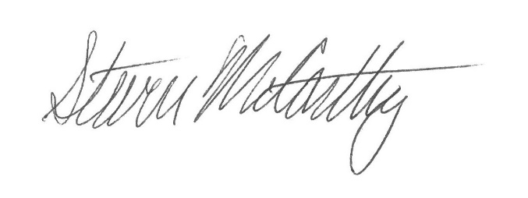

Kelly Ash
Vice President, Government Relations
California Grocers Association

Steve McCarthy
Vice President, Government & Regulatory Affairs
California Retailers Association

