Air Volatics
3664 Genista Place
Fallbrook, CA 92028
8/30/2020
Mr. Tom Steyer
California Economic Task Force

Dear Sir,
My name is Frank Micone. After retiring from the DuPont Co after 30 years in technical sales and distribution , I started a new company called Air Voltaics and was granted effective June 1st, distribution rights for the State of California for Two SWCC Certified lines of High Tech Small Wind Turbines similar in size to the Windmills that helped to build California and the West. Our goal at Air Voltaics is to offer affordable Small Wind and Hybrid Wind/Solar systems to the rural areas of California that have sufficient wind.
Fortunately, California is blessed with an abundant supply of this renewable energy. Unlike the rest of the world, the US is woefully behind in adopting this technology in generating electricity in rural areas and farm country. Small Wind turbines such as the Kestrel 3.5kw and SD Wind Energy 6kw generate power day and night and are excellent additions to any solar system as well as a stand-alone system. These systems complement each other. These certified Turbines qualify for all Federal ITC Tax credits like solar as well as the USDA REAP program for rural areas of the US.
California currently offers a .90 cents per Watt rebate to the citizens of California under the SGIP, Self-Generation Incentive Program. Unfortunately, a decade old policy in the SGIP program only allows the rebate to be paid if the turbine is mounted to an 85 ft tower which is cost prohibitive. As a result, only a handful of rebates have been paid out over the last 5 years and has defeated the purpose of offering the incentive in the first place. A typical 3kw turbine on a 30 to 45 ft pole runs about 25 thousand with installation and a Hybrid wind/solar system about 40 to 45 thousand with 4 kw of solar. With rebates the ROI can be reduced to around 5 years.
The purpose of this letter is request that the policy be changed to allow California SGIP rebates to be paid out for small wind turbines 6kw and lower, installed on towers starting at 9 meters or roughly 29 feet and above. These new turbines are able to make excellent power at these lower hub heights unlike the turbines in the past. We are also requesting that the current policy of paying .90 cents per watt be restored to $ 2.00 per watt as in the past. This can be done for a period of 5 years with a decrease of 10% per year after that for an additional 5 years. These new turbines are fully tested and certified by the SWCC, Small Wind Certification Council, unlike the turbines in the past which resulted in problems. All proposed sites can be required to be tested a minimum of 60 days with a computerized wind anemometer to insure there is a minimum of 5 to 10 miles per hour of average wind speed.
Unlike the monster turbines in places like Palm Springs, these turbines are for the people of California in rural areas. They do not kill birds or harm the environment. This has been proven out over hundreds of years of data. I have one installed at my home in Fallbrook, Ca which runs great and compliments my solar system producing power when the sun is no longer available and during peak hours of 4-9pm when power is the most expensive. These small wind turbines can help California achieve its goals regarding renewable energy. This can be an easy win for the California Economic Task Force that you chair. The funding already exists. All that is needed is a policy change. The program is currently run by the Center for Sustainable Energy out of San Diego. We are currently setting up dealers throughout the state which will result in additional jobs and income for California. I am currently installing a 6kw Turbine along with a ground mount solar array at the Sierra Roble Winery in Warner Springs, Ca. which should be up and running around the end of September which you and your team are welcomed to stop by when we have the opening ceremony.

Yours truly,

Frank J. Micone
Air Voltaics
airvoltaics.com
760-518-1203

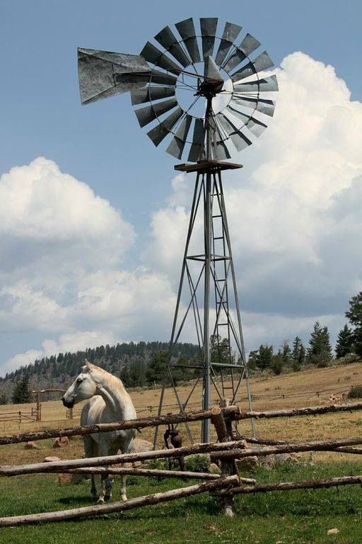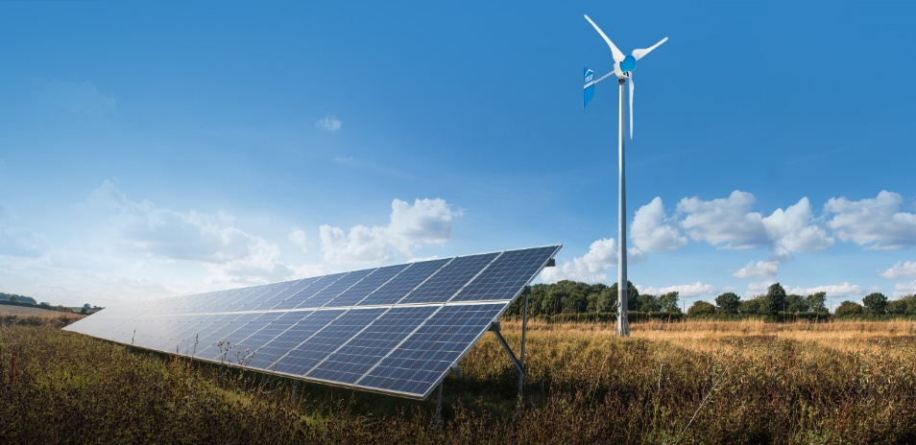

Past Present

