September 19, 2016



Board of Directors

Olof Johansson
Chair
Sveaskog
Sweden

Sergey Tsyplenkov
Vice Chair
Greenpeace
Russia

Matthew Arnold
JPMorgan Chase
USA

Mark Bierbower
Hunton & Williams LLP
USA

John Begley
Harbor Paper
USA

David Brand
New Forests Pty Limited
Australia

Richard Burrett
Earth Capital Partners
United Kingdom

Sally Collins
Sally Collins LLC
USA

Linda Coady
Liu Institute for Global Issues
University of British Columbia
Canada

Martha Isabel Ruiz Corzo
Sierra Gorda Biosphere Reserve
Mexico

Colin le Duc
Generation
Investment Management LLP
United Kingdom

John Earhart
Global Environment Fund
Argentina

Randy Hayes
Rainforest Action Network
USA

Hans Hoogeveen JD MP
Ministry of Agriculture,
Nature and Food Quality
Netherlands

Miguel Milano
Instituto Life
Brazil

Daniel Nepstad
Instituto Pesquisa Ambiental
de Amazônia
Brazil

Ole Yusuf Petenya
Shompole Community Trust
Kenya

Bettina von Hagen
Ecotrust
USA

Michael Jenkins
President
Forest Trends
USA

Dear Sir/Madam,

I am writing in regards to the notice of public hearing to consider amendments to the California Cap on Greenhouse Gas Emissions and Market-Based Compliance Mechanisms Regulation.

Forest Trends supports the ARB staff recommendation to revise the cap and trade program to achieve the new mandated GHG reduction levels of 40% below 1990 levels by 2030, the new level of reductions that is now required by state law and was signed last week by the Governor.

We strongly support the staff recommendation to maintain the existing role for offsets, strongly support the staff recommendation to continue discussing the role for sector based credits, including especially, those from tropical forests, and to adopt regulations that would these types of offsets in the 3rd compliance period.

We urge you to act quickly to complete this addition to the program, and we want to point out that ARB has explored this issue extensively and has built a strong record supporting this action. The ARB staff has recommended this action many times, adding tropical forest offsets is specifically referenced and contemplated in the existing AB 32 regulations, and adding tropical forest offsets will bring many benefits to California, including:

- Helping to fulfill the directive in AB 32 to act globally;
- Contributing to fulfill the requirement in AB 32 to adopt the most cost effective mechanism to meet the reduction level;
- Providing assistance to help tropical forest states that have signed Governor Brown’s Under-2-MOU meet their emission reduction pledges;
- Mitigating global climate change that is generating impacts affecting disadvantaged communities disproportionately, and adversely impacting natural resources upon which all life depends.

Please inform Forest Trends if we can provide any further information related to this matter.

Sincerely,
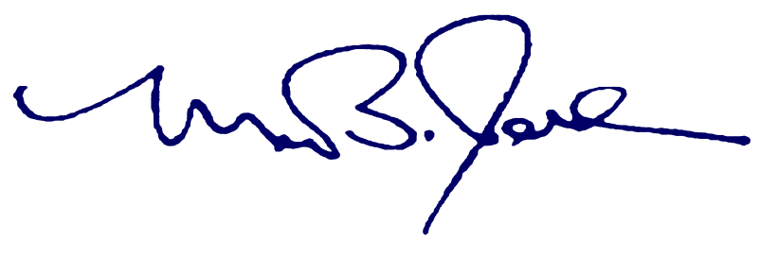

Michael Jenkins
President & CEO

