**From CARB**

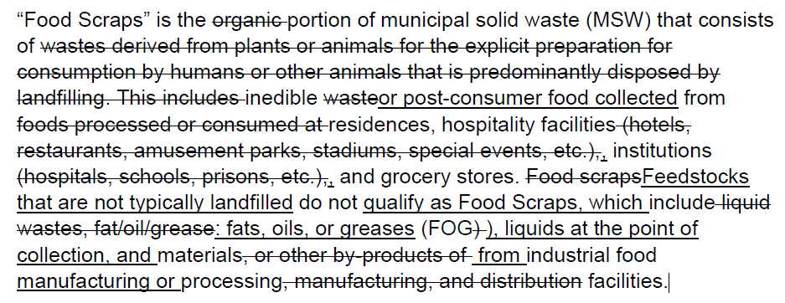

**Current CARB Proposed Definition**

“Food Scraps” is the portion of municipal solid waste (MSW) that consists of inedible or post-consumer food collected from residences, hospitality facilities, institutions, and grocery stores. Feedstocks that are not typically landfilled do not qualify as Food Scraps, which include fats, oils, or greases (FOG), liquids at the point of collection, and materials from industrial food manufacturing or processing.

**Anaergia Suggested Redline**

“Food Scraps” is the portion of municipal solid waste (MSW) that consists of inedible or post-consumer food collected from residences, hospitality facilities, institutions, commercial establishments, distribution centers, manufacturing facilities, and grocery stores. All food scraps are assumed to follow the State-wide average landfill disposal rate of [97.5%]. This definition excludes fats, oils, or greases (FOG)..

*Note: Definition should not cherry pick which sources count as landfill destined. All food waste should be treated the same and follow the statewide fraction destined to landfill. All food waste regardless of source goes to landfill to some degree. Therefore, apply the statewide average % destined to landfill for all sources combined (Statewide total). This definitions would exclude food from manufacturing plant that does go to landfill and visa versa include post consumer food waste in a trash can that does not go to landfill (i.e. SSO going to compost).*