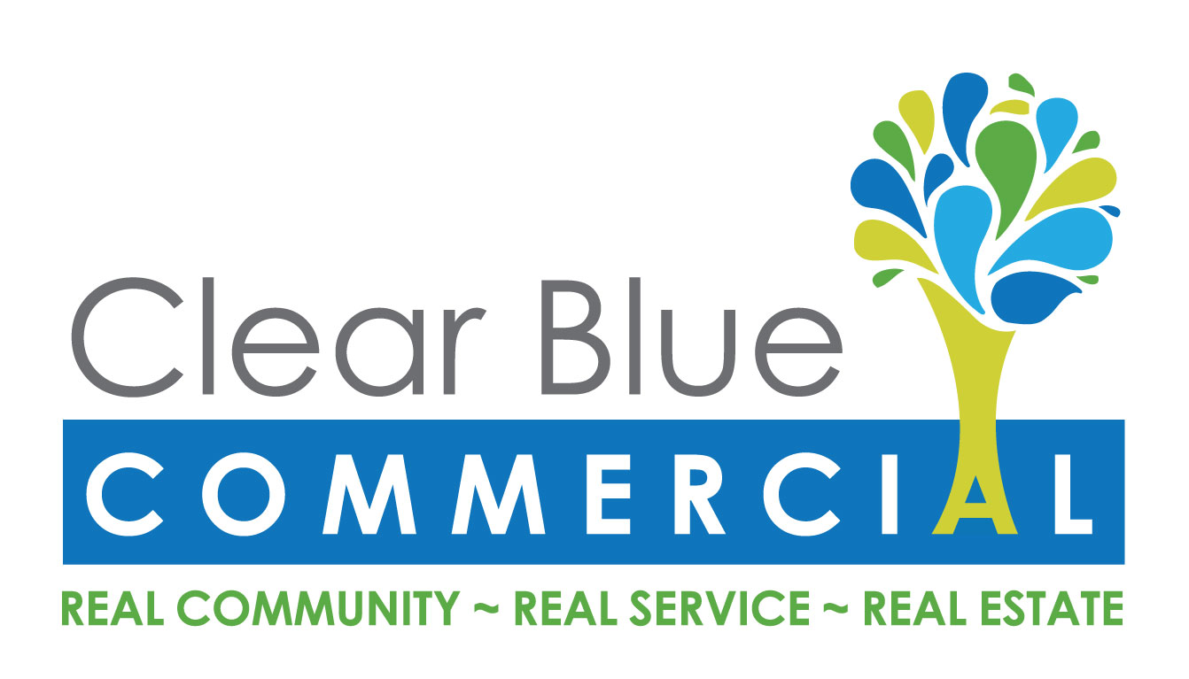

To Whom it May Concern;
Subject: Inclusion of a Small to Medium Business Category in the GGRF Investment Plan
Clear Blue Commercial is a California Certified Green Business, recognized by the County of Sonoma. We received technical assistance from our local Green Business Program to become recognized by our local government. As a result, we saved water, electricity, increased recycling, switched to greener chemistries, all of which reduce greenhouse gas emissions and provide multiple environmental and economic benefits.
We could still do more with additional assistance and rebates. Small businesses are a large part of the economy of this State. Most of us do not have environmental staff to focus on conservation and greening our business but if we are provided technical assistance, we are eager to become Certified Green to save resources, save money and attract customers. The California Green Business Program is a successful one-stop shop for small to medium sized businesses like mine to go green and quantify their efforts, and get a return on investment.
We highly recommend any small business go through the program, and believe that many small businesses making changes like we did can have a big impact. We strongly encourage your Board, the Governor’s office, and the State legislature to consider including a small business element in your investment plan.
Thank you.
Lilly Fogleman
Assistant Property Manager
License # 01976924

