**SAN FRANCISCO BAY AREA RAPID TRANSIT DISTRICT**

2150 Webster Street, P.O. Box 12688

Oakland, CA 94604-2688

(510) 464-6000

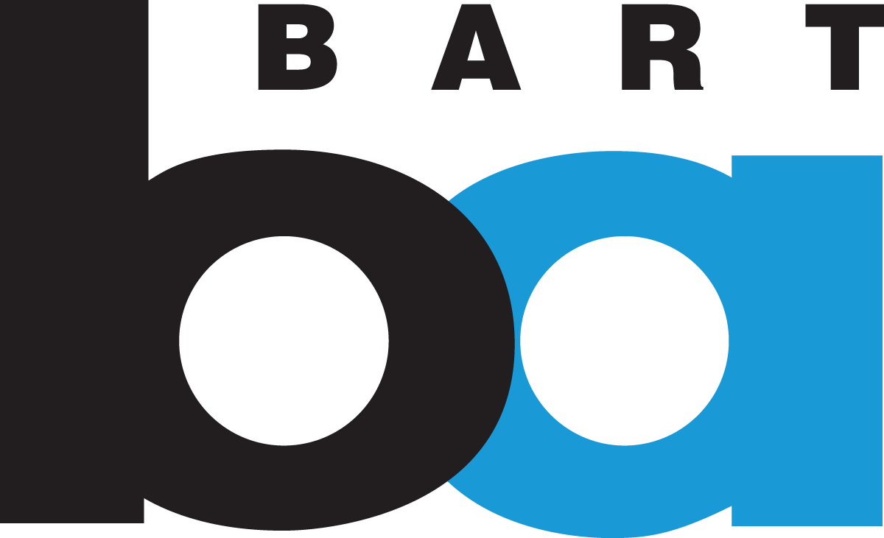

**2024**

Bevan Dufty

president

Mark Foley

vice president

Robert Powers

general manager

DIRECTORS

Debora Allen

1st district

Mark Foley

2nd district

Rebecca Saltzman

3rd district

Robert Raburn, Ph.D.

4th district

Melissa Hernandez

5th district

Elizabeth Ames

6th district

Lateefah Simon

7th district

Janice Li

8th district

Bevan Dufty

9th district

**www.bart.gov**

August 27, 2024

Chair Liane Randolph and Members of the Board

California Air Resources Board  
1001 I Street  
Sacramento, CA 95814

RE: August 12th Amendments to the LCFS Program

Dear Chair Randolph and Members of the Board,

The San Francisco Bay Area Rapid Transit District (BART) appreciates the opportunity to comment on the proposed amendments to the Low Carbon Fuel Standard (LCFS) program published on August 12, 2024. BART applauds CARB staff’s proposal to remove the pre-2011/post-2010 delineation for Fixed Guideway System crediting thus recognizing that electric rail – no matter when it was constructed – significantly reduces Vehicle Miles Traveled (VMT) and emissions. BART also supports the amendments that will strengthen the price of LCFS credits because BART relies on revenues from the sales of those credits to help fund its system.

BART owns and operates an electrified fixed-guideway transit system, along with electric vehicle charging at its parking facilities. We have participated in the LCFS as an opt-in entity since 2016. The LCFS program is a powerful tool to meet the state’s climate goals by incentivizing use of fuels with lower carbon intensity and switching to modes of travel such as public transit. The LCFS is one of California’s best instruments to get passengers out of cars and reduce VMT.

Almost 160,000 passengers ride BART each weekday and over 75,000 daily on weekends. We operate in five counties -- San Francisco, San Mateo, Alameda, Contra Costa, and Santa Clara -- with 131 miles of track and 50 stations. The vast majority of BART trains are electric, with 100% of its electricity supplied by zero-carbon resources including solar, wind, and hydroelectric generators. Every weekday of 2023, BART prevented 47,117 car trips and reduced California greenhouse gas (GHG) emissions by 608,036 lbs. CO2e.

We strongly support the staff’s proposal to provide equal treatment to all fixed guideway systems for the purposes of LCFS crediting. Transit systems all over the state are facing severe fiscal issues and the additional LCFS credits are vital to help rail agencies continue to provide service with diminished local funding sources. Given the very small percentage of total LCFS credits that fixed guideways generate, this change will have no discernible impact on credit prices while significantly helping with BART’s current fiscal difficulties.

BART also supports the proposed amendments that will strengthen the price of LCFS credits such as increasing the stringency of the program and capping certain kinds of biomass. The recent steep decline in credit prices has noticeably impacted BART’s budget, which is still hundreds of millions of dollars in deficit. Transit systems around the country have not recovered from the COVID passenger decline, with the Bay Area being most impacted. BART is coping with severe fiscal issues facing a substantial budget shortage beginning in fiscal year 2027.

Public transit is essential to California’s achievement of its climate goals. BART applauds CARB staff’s proposals that will support transit across the state including the equal treatment for all fixed guideway systems and the amendments that will strengthen the price of LCFS credits.

Sincerely,

Yuliya Shmidt

Manager of Energy

[yuliya.shmidt@bart.gov](mailto:yuliya.shmidt@bart.gov)

(510) 287-4835