World Energy Comments on the 2024 LCFS T1 Calculator for HEFA

The new T1 Calculator for HEFA is a great step forward in the calculation of CI results for the increasing number of options for additional feedstock pathways. We like its transparency of data and calculations.
However, there are two model elements that we want to provide comments.
Tailpipe Emissions - Non-CO2 Emissions
This element is seen in the Pathway Summary worksheet where all the carbon intensity (CI) elements for each feedstock pathway are displayed and summed together to become the CI for each of the feedstock pathways. In the category of Tailpipe Emissions (Row 37),Non CO2 emissions, the value for every pathway in a test calculation (using our 2021-2022 World Energy historical operating data) is 3.497 (cell E37) , which is sourced from the CA-GREET4.0 tab in cell E38, labeled Tailpipe Emissions as well.
This number is consistent with the provided document “Technical Support Documentation for Lookup Table Pathways” where on page 13 it describes Tailpipe Emissions as “The tailpipe emissions are based on CARB’s EMFAC2021 (v1.0.2) model7 for Methane (CH4) and Nitrous Oxide (N2O). For CO2, it is calculated based on Carbon in Diesel. The results are shown in Table B.3:”
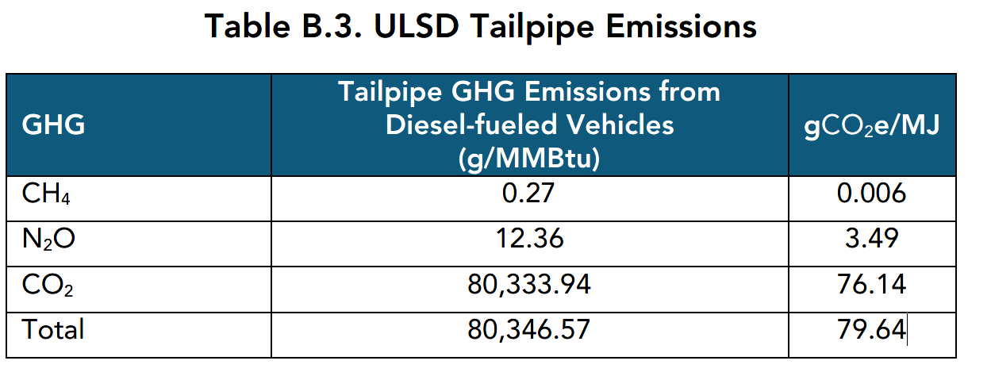
The sum of the two non-CO2 GHG gases (CH4 and N20) is 3.496 gCO2e/MJ (very close to the T1 calculator value)
However, in this same document on page 16, there is a description of Tailpipe Emissions for Jet Fuel that says “The tailpipe emissions are taken from CA-GREET4.0 for Methane (CH4) and Nitrous Oxide (N2O). For CO2, it is calculated based on Carbon in Conventional Jet Fuel. The results are shown in Table C.2:”
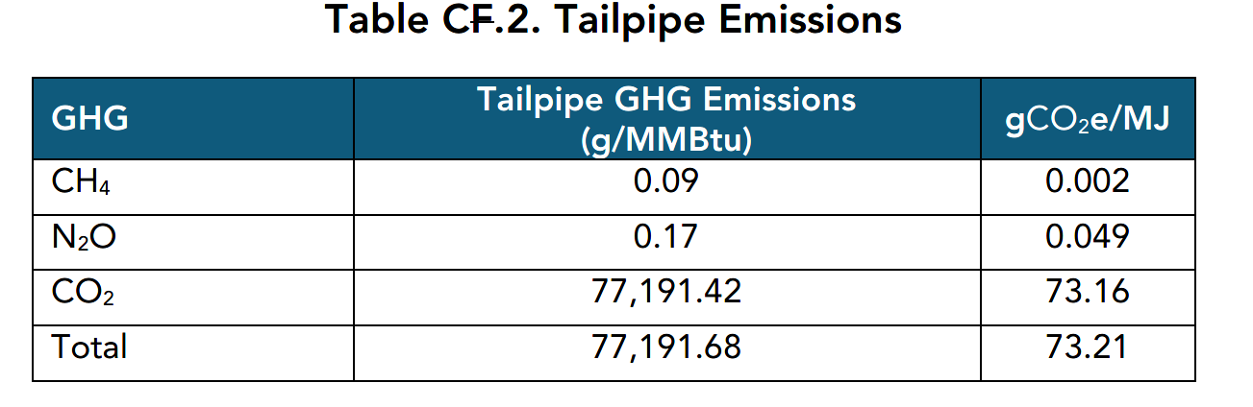
In this case the sum of the two non-CO2 gases (CH4 and N20) is .0051gCO2e/MJ, which is 3.492 gCO2e/MJ less than the value that is displayed for Tailpipe Emissions in the T1 calculator for each pathway.

Similarly on page 7 of the same document is a discussion of Tailpipe Emissions for CARBOB, which is the category of fuel component that would include renewable naphtha from HEFA.
It states “Since CARBOB is a blendstock and not a final finished fuel, vehicle tailpipe emissions represent the portion of California Reformulated Gasoline (CaRFG) emissions allocated to CARBOB. The tailpipe emissions are based on CARB’s EMFAC2021 (v1.0.2) model7 for Methane (CH4) and Nitrous Oxide (N2O). For CO2, it is calculated based on Carbon in CARBOB. The results are shown in Table A.4:”
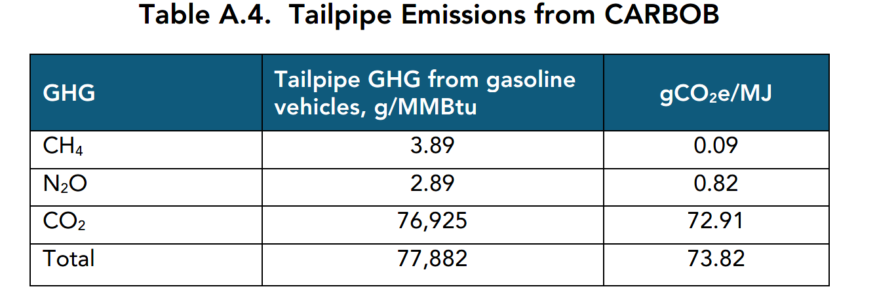
In the case of renewable naphtha, the non CO2 GHG emissions (CH4 and N20) totals .91 gCO2e/MJ, which again is overstated in the T1 HEFA calculator by 2.587 gCO2e/MJ.
Because of the significant differences in the Tailpipe Emissions for different fuel products, we believe it is necessary to insert additional columns for each fuel pathway (by feedstock and product) to properly account for the differences in the non CO2 components of GHG emissions by product.

Hydrogen Emission Factor
The hydrogen CO2 emissions component emission factor 13,588 gCO2e/kg shown in the Pathway Summary worksheet cell F27 and sourced in the CA-GREET4.0 tab cell E25 (labeled Default SMR to G.H2). This represents a14% increase in CO2e emissions per kg above our current Tier 2 pathway hydrogen CO2e emissions. We suspect this may be the result of an overly high pressure hydrogen gas stream that would be suitable for vehicle transportation (maybe 700 bar - 10,000 psi?), but is not the pressure we use for pipeline distribution from the SMR to the HEFA facility, which is 120 psi.
If there is a higher compression energy and associated CO2 emissions, it should be adjusted downward for a HEFA pipeline hydrogen supply.
Thank you for developing these useful tools to simplify reporting and CI calculations.
You can reach us for further discussion at the numbers below:
Gary Grimes 949-903-4112 (PDT in CA)
Greg Buczynski 905-541-3664 (EDT in Ontario,CA)

