**Subject: Concerns Regarding CARB’s LCFS Policies on Renewable Diesel and Sustainable Aviation Fuel and the 20% Cap**

Dear CARB Executive Officer,

Although the California Air Resources Board’s (CARB’s) Low Carbon Fuel Standard (LCFS) amendments are moving in the right direction, I am writing to express my concern regarding the potential limits of the stringency and environmental effectiveness of “20% cap” amended policy on renewable diesel when using virgin food oils, such as soybean and canola oil feedstock.

The following are my specific points on the 20% cap, that is followed in the postscript to this letter containing excerpts from my Tier 2 Comments to CARB:

* The proposed 20% cap even for a single California refiner, raises significant concerns, regarding whether this cap applies to individual refineries or across multiple facilities operated by the same company. If it applies company-wide, this could allow companies with multiple refineries in California to effectively double their use of virgin food oils, leading to a substantial increase in the one company’s use of soy or canola oils for renewable diesel production.
* CARB’s 20% cap on virgin food oils is not considering the possibility that despite a potential future cap at the two existing California renewable diesel refineries, there could be an overall increase in the total statewide growth of renewable diesel production using soy and canola oil, because renewable diesel can be produced 15 major petroleum refineries in California, not merely two, as currently.
* The “per company” 20% cap on virgin soy and canola oil feedstock for renewable diesel production does not account for the same refinery’s (potential) simultaneous production of Sustainable Aviation Fuel (SAF) using the same soy and canola oil feedstock, thus increasing the refinery’s total cumulative use of food-based feedstocks.
* The 20% cap does not place any pressure (or requirement) on the refineries to substitute any portion of their existing fossil fuel-produced hydrogen with green hydrogen (made, instead, using solar-powered hydrolysis).
* The arbitrary 20% cap does not take into account the actual embedded CO2 in the farm-to-wheel lifecycle of renewable diesel (or SAF) produced from virgin food oil versus renewable diesel (or SAF) produced from waste food oils, fats and greases.
* The 20% cap amendment for soy and canola oil feedstock is not applicable for companies already certified before the amendment takes effect (and where more than 20% of their reported biodiesel and renewable diesel in 2023 was already derived from virgin soybean or canola oil), the new provision would take effect on January 1, 2028, to allow time for feedstock supply contracts to be adjusted.
* The Environmental Impact Report for the world’s two largest renewable diesel projects revealed that the refineries availability of high-GHG natural gas-derived hydrogen is more rate limiting than the availability of the virgin food oil stock itself.
* California already uses 47% of all soy grown for biodiesel and renewable diesel, combined, while waste lipid feedstock supplies are expected to be constrained, indefinitely, so that the amount of total virgin food oil used will be larger than waste food oils. (Soybean oil rapidly gaining ground as renewable diesel feedstock. Successful Farming. Chuck Abbot (2023) https://www.agriculture.com/soybean-oil-rapidly-gaining-ground-as-renewable-diesel-feedstock-8419071)

Thank you for considering my concerns.

Sincerely,  
Charles Davidson  
Hercules, CA  
[charlesdavidson@me.com](mailto:charlesdavidson@me.com)

**PS: My Tier 2 LCFS public comments to CARB are relevant to my comments on the proposed LCFS amendments:**

**The Unsustainability of Virgin Food Oil-Based Renewable Diesel Biofuels: Questions for the California Air Resources Board. Charles Davidson. (6/2024) charlesdavidson@me.com**

**Introduction**

**The California Air Resources Board**’s approach to renewable diesel biofuels, particularly those made from virgin food oils, is fundamentally flawed. CARB’s carbon neutrality claim for tailpipe CO2 emissions arbitrarily eliminates three-quarters of the full lifecycle emissions of these biofuels from regulatory consideration. This profound greenhouse gas accounting ledger exclusion, for the *renewable diesel tailpipe CO2 emissions exemption allowance*, artificially lowers its *regulatable* GHG footprint, while masking its true environmental impact.

Additionally, CARB markedly underreports renewable diesel’s refinery-level *per barrel* hydrogen requirements and per barrel CO2 GHG emissions, as clearly evidenced by the Contra Costa County Environmental Impact Report data, published after CARB approval.

CARB’s renewable diesel policy over-relies on virgin food oils and raises severe sustainability and food security concerns, given the high demand for limited waste oil feedstocks and the low per-acre yield of oil from food-based crops, like soybean oil (4).

These issues necessitate a thorough reevaluation of CARB’s policies to ensure that subsidies and incentives are reserved for truly sustainable biofuel feedstocks, such as waste-based oils, that provide genuine long-term environmental benefits.

**Conclusion:**

If CARB established a new biofuel policy that eliminated renewable diesel’s *tailpipe CO2 emissions exemption allowance* and also accurately accounted for *refinery-level per barrel* CO2 GHG emissions, the refineries would *lose LCFS accreditation* for making virgin food oil-sourced renewable diesel.

**Analysis of CARB's Policy on Renewable Diesel Biofuels**

CARB's Stance on Carbon Neutrality: CARB asserts that “the tailpipe CO2 emitted from vehicles during biofuel combustion is considered carbon neutral, in accordance with IPCC and U.S. EPA GHG inventory guidelines, as the carbon released was uptaken from the atmosphere within a short timeframe by the plant that produced the oil”. (1)

In this case, CARB’s cyclic net zero policy overlooks the significant carbon sequestration potential of natural landscapes while hiding the true environmental impact of virgin food-based renewable diesel (when production is expanded globally to merely serve the California fuels market). While petroleum extraction has huge problems of high-GHG flaring events and unregulated methane leakage, in addition to abandoned wells, taking farmland out of food production or removing a forest that had been a carbon sink is not a cost-effective or efficient method to reduce transportation CO2 GHGs. According to Statas Advisors in 2022, the amount of CARB LCFS credits combined with Federal credits is $3.32 per gallon subsidization. (5)

What other options are available to reduce transportation GHGs and limit the expansion of food-to-fuels conversion process. Electrification of trains and the heavy-duty trucking fleet. Or, subsidize green hydrogen production and research that is used in making renewable diesel or SAF, by employing solar-powered hydrolysis. Or, by subsidizing algal biofuels production and research. More aggressive monitoring and regulation of gas field methane leakage.

CARB’s current policy, based on 1995 IPCC guidelines, posits that “CO2 emissions from biofuel combustion should not be counted in the transportation sector’s greenhouse gas inventory to avoid "double counting" since it is already accounted for in the Agriculture, Forestry, and Other Land Use (AFOLU) sector”. (2)

CARB's approach to avoiding "double counting" leads to conflicting accounting methods under its current policy. This pertains to CARB’s certifying virgin food oil-based renewable diesel as “carbon neutral”, via the tailpipe CO2 emissions exclusion allowance (from vehicular combustion) and providing it with LCFS low-carbon subsidies.

**Questions for CARB**

1. **Resource Scarcity and Sustainability:** Two refineries in Contra Costa, Marathon and Phillips 66, plan to produce a total of 1.5 billion gallons of renewable diesel annually, mainly using virgin food oils such as soy, despite claims of intending to use waste oils. Considering the competitive global demand for limited waste oil feedstocks, the low oil yield from soybeans, only 57 gallons per acre per year (4) and the potential diversion of U.S. soybeans or the exploitation of virgin lands in South America, a pertinent question arises (3):

How does the California Air Resources Board (CARB) justify the certification of renewable diesel derived from virgin food oils as a low-carbon fuel eligible for substantial subsidies, despite the pressing issues of resource scarcity, food security, and sustainability concerns?

1. **Arbitrary Tailpipe CO2 Emissions Discount:** Given that tailpipe CO2 emissions account for 70-80% of the total lifecycle greenhouse gases content for both petroleum and renewable diesel, one might wonder:

How does the California Air Resources Board (CARB) justify the Low Carbon Fuel Standard’s *tailpipe CO2 greenhouse gas exemption allowance* for renewable diesel produced from virgin food oils, which ideally should be reserved for waste-based feedstocks that would otherwise generate *high-GHG methane in landfills.*

1. **Inaccurate Carbon Sequestration Claims:** Consider that a mature forest can accumulate several hundred tons of carbon per acre over a century, compared to the mere yield of only 57 gallons of soybean oil per acre used for biofuel feedstock and combusted annually, but never sequestered. (5)
2. Given this (and without needing to consider the industrial-scale application of fertilizers and petrochemical herbicides needed for growing genetically-modified refinery soybean oil feedstock) one must question:

How does the California Air Resources Board (CARB) justify the "75%" carte blanche tailpipe CO2 emissions exemption allowance for renewable diesel, in light of the fact that while there is marginal carbon sequestration on an annual basis, over an entire century, soybean cultivation for biofuels results in absolutely no carbon sequestration (as forested lands)?

5. **CARB’s Misplaced Priority:** CARB's heavily subsidized support for using virgin food oils as feedstock for renewable diesel overlooks the key advantage of subsidizing the conversion of waste oils to renewable diesel: the elimination of high-GHG landfill methane emissions. Therefore, one might ask:

How does CARB reconcile its subsidy allocation for renewable diesel derived from virgin food oils, considering there is no landfill methane diversion benefit as there is with waste oil?

1. **Renewable Diesel Refinery Emissions and Higher Per Barrel Carbon Intensity:** The Environmental Impact Reports (EIRs) for the Contra Costa County refineries' shift to renewable diesel production reveal that the process nearly doubles the hydrogen requirements and CO2 greenhouse gas emissions per barrel compared to the two refineries’ traditional heavy petroleum diesel. Given this information:

How does CARB justify disregarding renewable diesel’s substantial increase in *refinery-level* per barrel hydrogen needs and *per barrel* carbon intensity, compared to during the refineries’ previous petroleum refining operations?

**REFERENCES:**

1. 1) **CARB. LCFS (Basics-notes).** p.19. <https://ww2.arb.ca.gov/sites/default/files/2020-09/basics-notes.pdf>
2. 2) CHAPTER 2 STATIONARY COMBUSTION 2.3.3.4 **2019 Refinement to the 2006 IPCC Guidelines for National Greenhouse Gas Inventories** 2.1CHAPTER 2 STATIONARY COMBUSTION Volume 2: Energy 2019 Refinement to the 2006 IPCC Guidelines for National Greenhouse Gas Inventories Authors Amit Garg (India) and Melissa M. Weitz (USA) <https://www.ipcc.ch/report/2019-refinement-to-the-2006-ipcc-guidelines-for-national-greenhouse-gas-inventories/>
3. Overcapacity Looms as More and More US Refiners Enter Renewable Diesel Market. Stratas Advisors. (June 11, 2020) <https://stratasadvisors.com/Insights/2020/06112020LCFS-RD-Investment>
4. **A Cap on Vegetable Oil-Based Fuels Will Stabilize and Strengthen California’s Low Carbon Fuel Standard.** Jeremy Martin, Senior Scientist and Director of Fuels Policy. Union of Concerned Scientists (2024). <https://blog.ucsusa.org/jeremy-martin/a-cap-on-vegetable-oil-based-fuels-will-stabilize-and-strengthen-californias-low-carbon-fuel-standard/#:~:text=A%20Cap%20on%20Vegetable%20Oil-Based%20Fuels%20Will%20Stabilize,oil%20fuels%20and%20investing%20in%20alternatives%20to%20combustion> [In 2022 half of the bio-based diesel consumed in the United States was consumed in California, which accounts for just 12 percent of US population and just 7 percent of the nation’s overall diesel (bio-based and fossil diesel combined). The factors that concentrated half of US bio-based diesel in California are only getting stronger, as more renewable diesel production capacity comes on-line in California, and California raises the targets for the LCFS.]
5. Biodiesel. DIVISION OF AGRICULTURE R E S E A R C H & E X T E N S I O N University of Arkansas System Division of Agriculture, Little Rock. DR. SAMMY SADAKA, P.E., P.Eng. FSA1050-PD-3-2017RV. https://www.uaex.uada.edu/publications/PDF/FSA-1050.pdf
6. Life Cycle Greenhouse Gas Emissions of Biodiesel and Renewable Diesel Production in the United States. Hui Xu*, Longwen Ou, Yuan Li, Troy R. Hawkins, and Michael Wang Environmental Science & Technology 2022, 56, 12, 7512-7521 (Policy Analysis) Open Access Publication Date (Web):May 16, 2022 DOI: 10.1021/acs.est.2c00289

**GHG Calculations Based upon the Environmental Impact Reorts (EIRs) from the Phillips 66 Refineries renewable diesel projects:**

The nominal total refinery CO2 GHGs and decreased throughput from 105,000 bpd (w 120K capacity) down to 67,000 bpd for renewable diesel (Rodeo Renewed Project 55K plus, I assume, the Nustar Soybean Oil Project, 12K bpd).

Note: The Phillips 66 refinery’s large per barrel increase CO2 greenhouse gasses is based upon the simultaneous 1) 99% similar total refinery CO2 GHGs before, using petroleum and after, producing renewable diesel and 2) the large increase in fossil fuel hydrogen production and 3) a decreased feedstock throughput from 105,000 bpd (w 120K capacity) with petroleum down to 67,000 bpd for renewable diesel. (ie, The Rodeo Renewed Project 55K, plus the Nustar Soybean Oil Project, 12K bpd).

Rodeo Renewed Project Draft Environmental Impact Report County File No. CDLP20-02040 State Clearinghouse No. 2020120330 October 2021

105,000 bpd (pre-project w petroleum) / 67,000 bpd (post project)

= 1.56 = ~56% Increase in per barrel CO2 GHGs

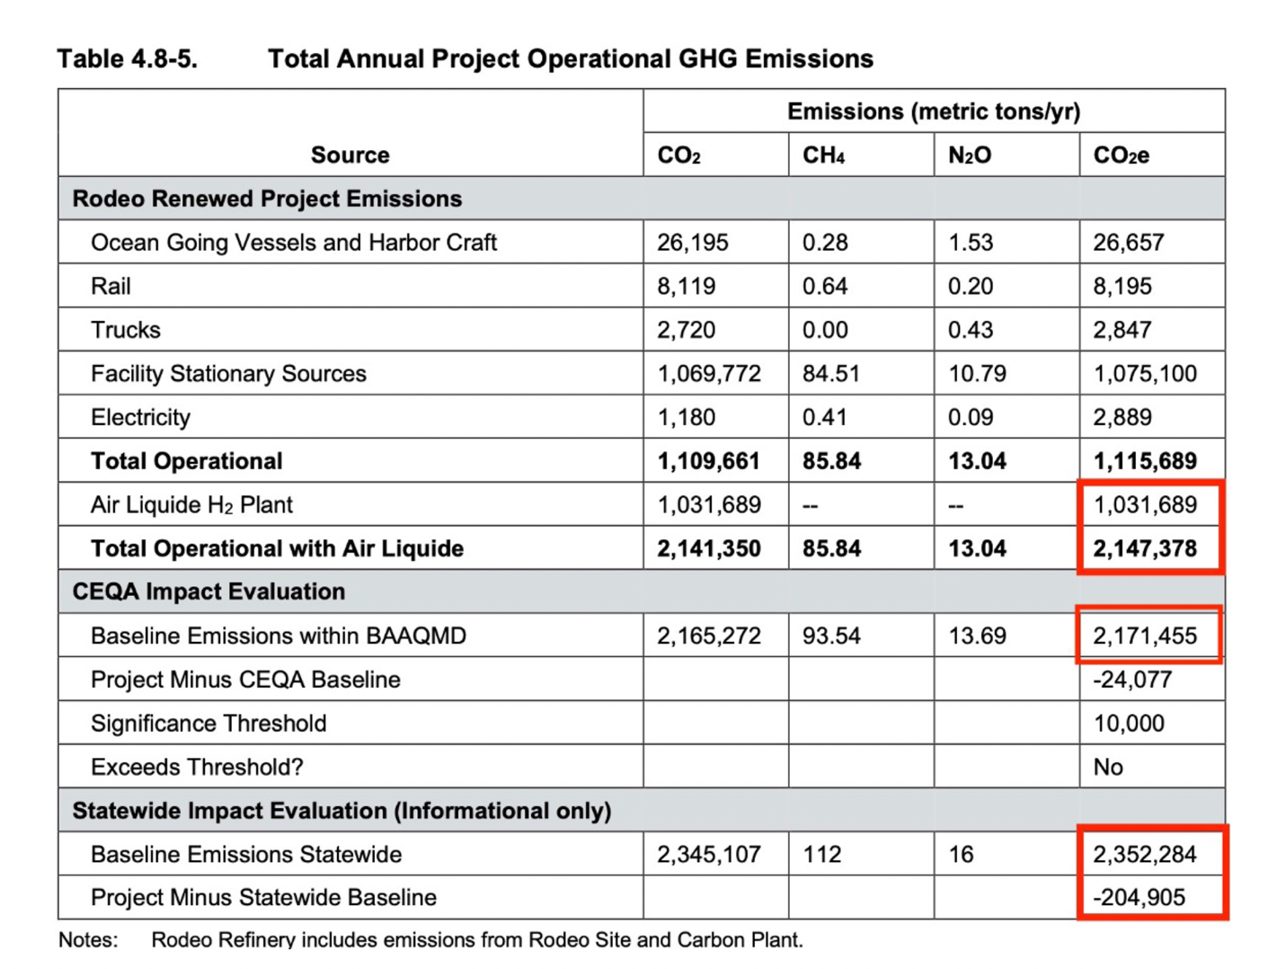

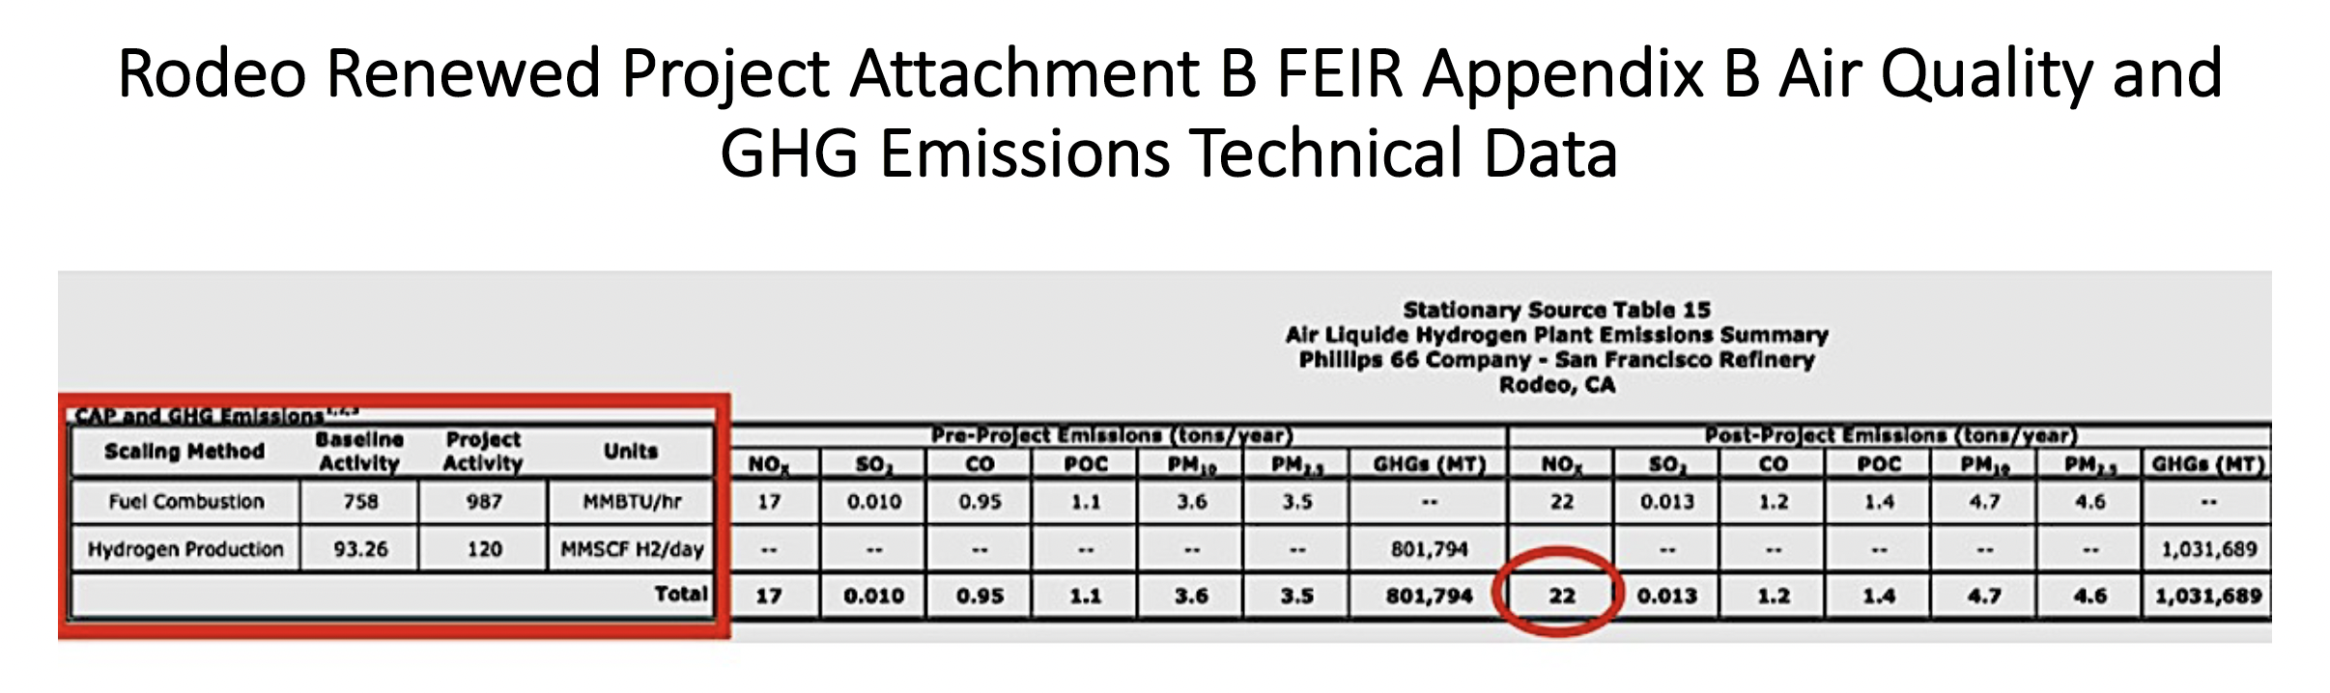

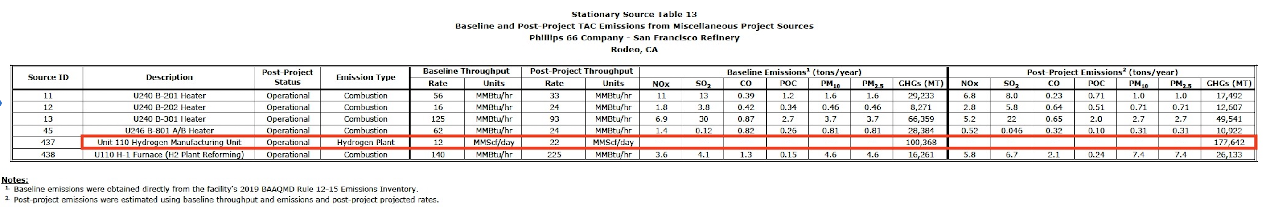

**Martinez Refinery Renewable Fuels Project" Draft ENVIRONMENTAL IMPACT REPORT Vol I State Clearinghouse No. 2021020289 OCTOBER 2021.**

Increase in CO2 per barrel at the refinery:

Pre-Project (Petroleum):

160 * 365 / 2170

= 26.9124423963134

Post Project: 48 * 365 / 1145

= 15.3013100436681

Post-Project per barrel CO2 GHG increase in 26.9 / 15.3

= 1.75 = ~ 75% increase (at the refinery, per barrel of feedstock)

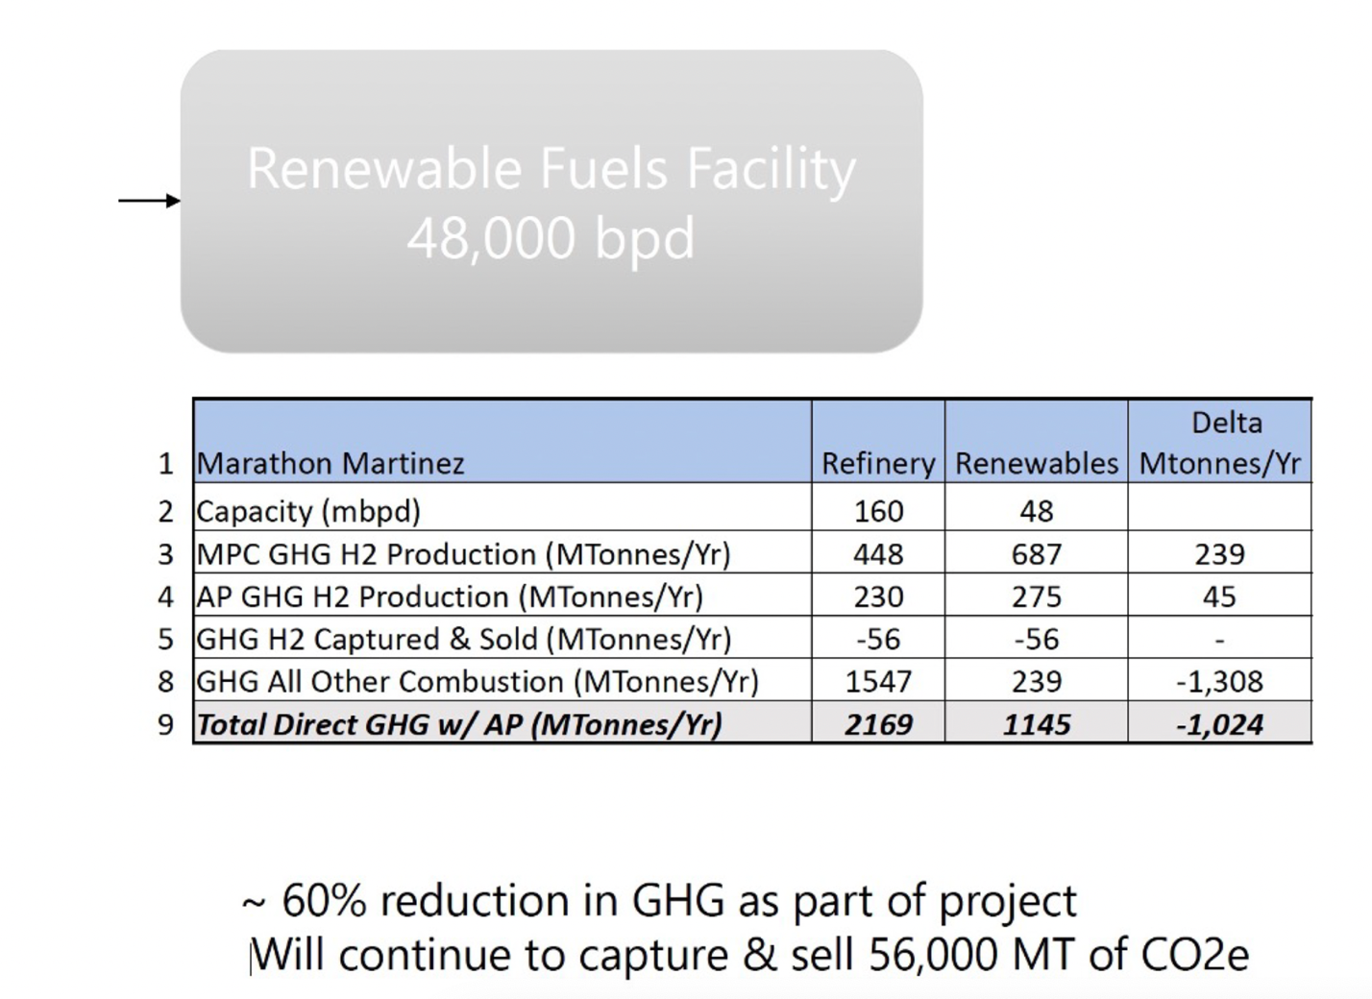 Life Cycle Greenhouse Gas Emissions of Biodiesel and Renewable Diesel Production in the United States. Hui Xu et al.

Table 3-8 Inputs and Outputs of Renewable Diesel II

Plants (Ib or Btu per lb of renewable diesel II)

|  |  |
| --- | --- |
| Inputs and Outputs | ASPEN Simulation Results as GREET Input |
| Inputs | |
| Soy oil (lb) | 1.174 |
| Hydrogen (Ib) | 0.032 |
| Natural gas (Btu) | 84.05 |
| Electricity (Btu) | 93.83 |
| Outputs | |
| Renewable diesel II (Ib) | 1 |
| Propane fuel mix (Btu) | 1095.5 |

Life Cycle Greenhouse Gas Emissions of Biodiesel and Renewable Diesel Production in the United States. Hui Xu et al.

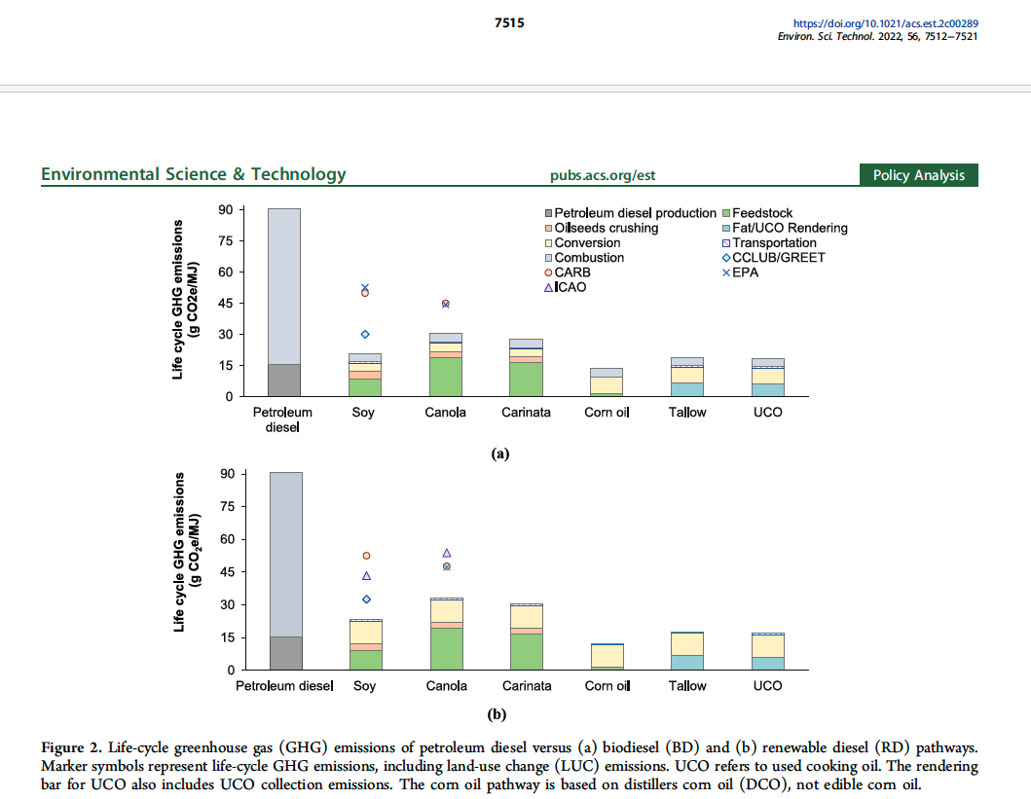

Biodiesel. DIVISION OF AGRICULTURE R E S E A R C H & E X T E N S I O N University of Arkansas System. Sammy Sadaka DR. SAMMY SADAKA, P.E., P.Eng., is assistant professor Extension engineer with the University of Arkansas System Division of Agriculture, Little Rock FSA1050-PD-3-2017RV