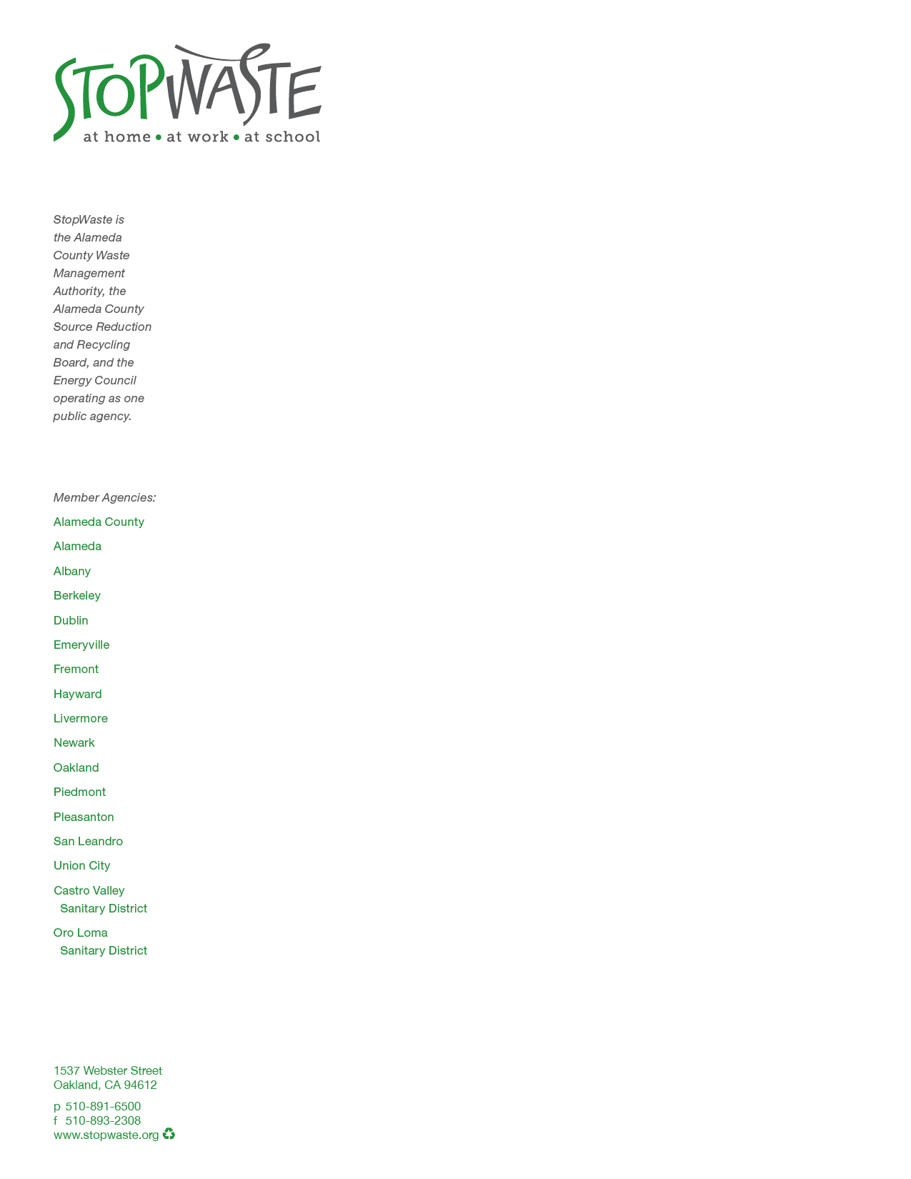

October 30, 2015

Mr. Richard Corey

Executive Officer

California Air Resources Board

P.O Box 2815

Sacramento, CA 95812

RE: Draft Short Lived Carbon Pollutant Strategy

Dear Mr. Corey,

On behalf of our Agency, I would like to take this opportunity to support the inclusion of a strategy to reduce and ultimately eliminate organics from landfills as part of ARB’s plan to reduce short lived carbon pollutants (SLCPs), specifically methane. We are pleased to see that the draft strategy makes a strong case for the importance of reducing several SLCPs including methane, given its high global warming potential.

We are in strong support of reducing methane emissions by eliminating organics in landfills. Our County banned plant debris from the landfill in 2009 and the implementation of that has been quite successful. All our jurisdictions offer weekly organics collection service, including food scraps for our residential and commercial customers.

We appreciate the multi-pronged effort that we see at the state level to address both the need to reduce organics from landfill and the need to increase the use of compost and mulch on agricultural and urban lands to fully realize the multiple environmental benefits of using compost and mulch.

Combining regulatory and financial assistance to increase compost processing capacity, together with a phased in ban of organics at the landfill will help the state and our jurisdictions meet their diversion goals and greenhouse gas reduction goals. Support from the ARB and other state regulatory agencies, as is envisioned in the Short Lived Carbon Pollutant Strategy, is essential to achieve local and state climate change goals. Given the impact of short lived climate pollutants, we encourage ARB to move forward with its efforts to eliminate organics from the landfill and reduce landfill methane emissions as expeditiously as possible. We look forward to further collaboration on this issue.

Sincerely,



Gary Wolff

Executive Director