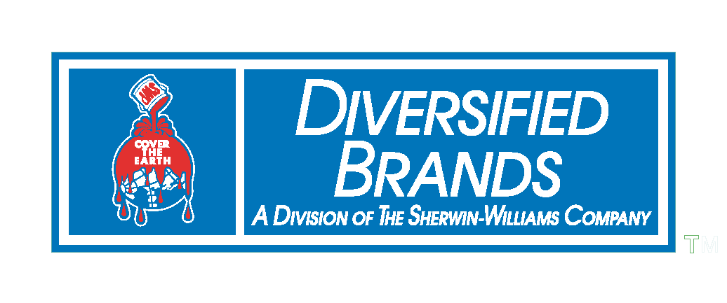

September 20, 2013

Clerk of the Board
California Air Resources Board
1001 I Street
Sacramento, CA 95814

Subject: Sherwin-Williams Diversified Brands Comments on ARB’s 2013 Amendments to the Consumer Products and Aerosol Coatings Regulations

Clerk of the Board:

Sherwin-Williams Diversified Brands (S-W DBD) appreciates the opportunity to review, comment and participate in the development of the 2013 Consumer Products and Aerosol Coatings Regulation development.

For the companies involved in this rule development, it was very challenging and an arduous process. After 20 plus years of VOC regulation, finding additional reductions is now very difficult. The science now indicates future VOC reductions will have miniscule, if any, air quality benefits. The economic costs of further VOC reductions in the consumer product industry will be untenable. We urge the ARB to create a task force to partner with industry to find alternative solutions to traditional command/control regulation or further VOC reductions. There are numerous opportunities in new technology with the potential to make significant improvements in air quality that represent a much better use of capital than reformulating consumer products again. Expanded use of natural gas vehicles is one example with great potential.

We submit the following comments in hopes they will assist the ARB in further refinement of the regulations. The specific comments contained herein express our overall support and agreement with the subject rules.

Consumer Products Regulation

Definitions

Sherwin-Williams supports the revised definitions in the consumer products regulation. We urge the ARB to consider the appropriate date for the definitions to become effective. Should a new definition require or result in a product change the effective date must match accordingly.

Aerosol Adhesives

We believe these new limits will prove feasible.

Aerosol Multi-Purpose Solvent and Paint Thinner

We do not oppose the 10% VOC Limit in 2016.

South Coast Limits for Non-Aerosol Multi-Purpose Solvent and Paint Thinner

We continue to oppose the SCAQMD standard of 25 g/L (and associated test method) as we believe this does not provide any additional benefit over the ARB VOC Percentage Limit and its existence will only cause confusion.

Aerosol Coatings Regulation

Definitions

We support the revised definitions. Again, we urge the ARB to consider the appropriate date for the definitions to become effective. Should a new definition require or result in a product change the effective date must match accordingly.

Revised Limits

We support the revised limits. However, it is important to note, the limits for the general categories are technology forcing and demonstration of commercial feasibility may not be certain until new compliant formulas have been created and marketed.

Alternative Control Plans

We continue to advocate for the inclusion of an Alternative Control Plan to this regulation.

Effective Date of 2010 MIR Values

The new table of MIR values represents state of the art science. We urge the ARB to adopt those values as soon as possible for compliance with current and future limits. We also urge the ARB to exercise discretion should the use of the new MIR values cause a perceived compliance issue on paper due to the use of the new MIR values with the existing limits.

Summary and Conclusions

Sherwin-Williams appreciates the professional and considered approach to the development of these rules by the ARB staff. We believe the proposed regulations represent the combined expertise and input from both the ARB staff and industry. We will continue to work cooperatively with the ARB to assure the final regulation achieves the maximum air quality benefits possible while providing clear and feasible requirements.

Your time and consideration of our input is much appreciated.

Best regards,

Gregory L. Johnson
Director Legislative Affairs
Sherwin-Williams Diversified Brands

